

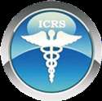


LAPAROSCOPIC, ROBOTIC SURGERY AND ENDOSCOPIC TRAINING PROGRAMME

International Accreditation by :

•World Association of Laparoscopic Surgeons
•International College of Robotic Surgeons
•International Accreditation Organization

L
c
s

World Association of Laparoscopic Surgeons

International College of Robotic Surgeons

D

International Accreditation Organization

CYBER CITY, DLF PHASE-II, GURGAON, INDIA Phone: +91(0)1242351555 Mobile: +91(0)9811416838, 9999677788
E-mail: contact@laparoscopyhospital.com | www.laparoscopyhospital.com



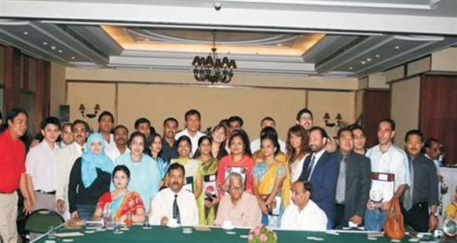

Thanks for your interest in laparoscopic training at WORLD LAPAROSCOPY HOSPITAL (WLH), Gurgaon, NCR Delhi. WLH has

revolutionized the way of treatment, training and research of Minimal Access Surgery. Laparoscopic “Hands On” courses are primarily intended for surgeons and gynaecologists who wish to acquire in depth basic practical knowledge and advanced structured training of laparoscopic and robotic surgery. There is ample
opportunity to learn laparoscopic surgeries first in animal lab, followed by exposure in operation theatre on live cases. This course is scientifically designed according to international protocol of laparoscopic education proven to learn Minimal Access Surgery.
At the end of program, surgeons and gynaecologists should be competent to carry out laparoscopic surgeries themselves on their patients.At WLH more than 8,000 surgeons and gynaecologists have been trained from every corner of the world.

Honourable Mr. George Fernandes, then Defence Minister of India (2001 - 2004) Chief Guest of certificate ceremony

Laparoscopic training offered by WORLD LAPAROSCOPY HOSPITAL has an International recognition by World Association of Laparoscopic Surgeons (WALS®).
Laparoscopic courses at World Laparoscopy Hospital meet the guidelines established in the SAGES Framework for Post-Residency Surgical Education and Training. The University Combined Fellowship and Diploma in Minimal Access Surgery (F.MAS + D.MAS) and Fellowship in Minimal Access Surgery (F.MAS) course designed and offered by World Laparoscopy Hospital is endorsed by the

Society of American Gastrointestinal Endoscopic Surgeons (SAGES).

2
COURSE DIRECTOR :
- Chairman, World Laparoscopy Hospital, Gurgaon, India
- Professor, Head of Minimal Access Surgery, TGO University, India
- First University Qualified Master Minimal Access Surgeon of India (M.MAS)
- Editor in Chief, World Journal of Laparoscopic Surgery (WJOLS)
- General Secretary, World Association of Laparoscopic Surgeon (WALS)
- General Secretary, International College of Robotic Surgeons (ICRS)
- Member, European Association for Endoscopic Surgery (EAES)
- Member, European Association for Transluminal Surgery (EATS)
- Member, Society of American Gastrointestinal and Endoscopic Surgeons (SAGES)
- Member, Society of Laparoendoscopic Surgeons (SLS)
Dr. R.K. Mishra. MBBS, MS, • Member, Society of Robotic Surgery (SRS)
MRCS, Dip. LAP, FICRS, FIMSA • Member, Clinical Robotic Surgery Association (CRSA)
- Fellow of International Medical Sciences Academy (IMSA)
- Member, Indian Association of Gastrointestinal Endosurgeons (IAGES)
- Member, Association of Surgeons of India (ASI)
- Member, Indian Medical Association (IMA)

Dr. R. K. Mishra is one of the most experienced professor of laparoscopic and robotic surgery who has trained more than 8,000 surgeon and gynecologist from more than 108 countries in last 17 years. He has vast experience of teaching laparoscopic and da Vinci robotic surgery. He is Professor of Minimal Access Surgery in TGO University and his endeavor of starting unique university program was started in Ninewells Hospital and Medical School, U. K. with Professor Sir Alfred Cuschieri. Dr. Mishra has taken his Diploma in Laparoscopic Surgery from University of Strasbourg, France and Master degree in Minimal Access Surgery (M.MAS) from University of Dundee, United Kingdom. During his work in United Kingdom Dr. Mishra has discovered the optimum shadow casting illumination technique to improve the task performance of laparoscopic surgery and his research is now used by eleven laparoscopic instrument companies to make ideal shadow casting telescope. This original research of shadow in laparoscopy was published in Archive of Surgery.

Prof. R.K. Mishra is among few fortunate who has been conferred degree of Master in Minimal Access Surgery by Sir James Whyte Black (Nobel Prize Winner in Medicine, 1988) and the most prestigious Chancellor in the history of University of Dundee, United Kingdom. After mastering Laparoscopic Surgery, Dr. Mishra has further refined his robotic surgery training at Harvard Medical School, Boston, USA. After returning to India from U.K. in 2001 he worked at Indraprastha Apollo Hospital. New Delhi. He also felt commercialization of half cooked laparoscopic training of just 2 to 4 days, credentialing at an exorbitant cost. These training program were in the hand of industry who make laparoscopic instruments. Keeping in mind the need of time and being the first qualified Master Minimal Access Surgeon, he started giving training of Minimal Access Surgery.

Dr. R.K. Mishra's way of providing real laparoscopic training had no parallel in the whole world and that convinced majority of the international organization of minimal access surgery that real laparoscopic training to young and practicing surgeons is possible if like-minded people join hands and work towards achieving this goal. According to Dr. Mishra if you have to make the community of Minimal Access Surgeon then catch them young. Due to his dedication World Laparoscopy Hospital is center of excellence in minimal access surgery.
2

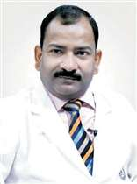
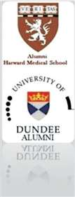


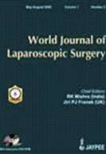
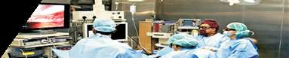
Prof. Mishra has published several articles in different journals of World. His few popular published laparoscopic surgery articles are:
- Optimum Shadow-Casting Illumination for Endoscopic Task Performance
- Laparoscopic Versus Open Appendicecomy for the Treatment of Acute Appendicitis
- Role of Robotic Surgery in the Treatment of Mirizzi Syndrome
- Changing role of laparoscopy in the management of patients with cirrhosis
- Initial clinical experience using a novel laparoscopy assistant
- Comparison of Human Camera Holder with PMAT Camera Holder
- Scarless Cholecystectomy with Standard Laparoscopic Instruments in Selected Patients
- Human Fibrin Glue in Laparoscopic Inguinal Hernia Repair: An Alternative to Invasive Mesh Fixation: A Review of Literature
- Single-Port Laparoscopic Placement of Peritoneal Dialysis Catheter
- Different Port Closure Techniques in Laparoscopy Surgery
- Immunological Response of Post cholecystectomy: Single Incision Laparoscopic Surgery (SILS) vs. Natural Orifice Transluminal Endoscopic Surgery (NOTES).
- The Camera-holding Robotic Device in Laparoscopy Surgery
- Tissue Glue in Laparoscopic Inguinal Hernia Repair: A Retrospective Comparative Analysis.
- Different Techniques of Tissue Retrieval from Abdominal Cavity during Minimal Access Surgery
- Differences between Thunderbeat, LigaSure and Harmonic Scalpel Energy System in Minimally Invasive Surgery
- Comparing Extracorporeal Knots in Laparoscopy using Knot and Loop Securities
- Comparing Task Performance and Comfort during Nonpulmonary Video-assisted Thoracic Surgery Procedures Between the Application of the Baseball Diamond Concept
- Which Endoscopic way is true to predict the tubal Patency Test of Infertile Patient - Trans abdominal or Transvaginal
- Is there an ideal port position for laparoscopic urological procedures

Prof. Mishra is a prolific author who has published his research findings in journal articles, abstracts, textbooks, book chapters, and in editorials. In addition to publishing his own research, he is much in demand as an editor for scientific publications. Prof. Mishra is Editor - in - Chief of World Journal of Laparoscopic Surgery, an international peer reviewed publication of minimal access surgery. His dozens of article published in various laparoscopic journals all over world including of the recent article published in Annals of Surgery, Surgical Endoscopy, Current Medical Journal of India, Journal of Minimal Access Surgery of India and World Journal of Laparoscopic Surgery. His recent article about Complications of Laparoscopic Surgery has brought to light many errors commonly overlooked during surgery. The World Journal of Laparoscopic Surgery now appears in a combined print / online format and one of the most popular laparoscopic journal of world. The World Journal of Laparoscopic
Surgery is available online at www.worldjls.org It is dedicated to publishing worthy scientific and clinical articles and informing issues significant to the surgical profession. The popularity of World Journal of Laparoscopic Surgery can be imagined that at present there are 5000 subscriber of this journal from ever corner of the world. Reflecting on the activities of World Association of Laparoscopic Surgeons, surgeons and gynecologists of all over World are privileged to experience in the past from this excellent journal of World Association of Laparoscopic Surgeons. Throughout his career Dr. Mishra has also contributed to numerous chapters in undergraduate and postgraduate books and published over forty original articles in major peer review journals.

4
Prof. Mishra is author of many of the best-seller books in Laparoscopy and the most popular is Text Book of Practical Laparoscopic Surgery. This book is now available in its 3rdedition and globally with the ISSN (International Standard Book Number 81-8448-241-8. This book is published by World's leading Medical Publisher McGraw-Hill Education - Europe. This is best-seller book of laparoscopic surgery
in more than 52 countries. This handsome book in laparoscopic surgery, gives a full description of all tricks and tips in performing a variety laparoscopic procedures. This book contain all colored plastic finish 602 Pages, 1500 color Illustrations. Four DVD's with 20 Power point's and 206 laparoscopic Videos are with this book. This book provides an invaluable study aid for all general surgeons, pediatric surgeon and gynecologists who wants to learn art and science of laparoscopic surgery. Concisely written overviews of each topic covered on the minimal access surgery combined with the illustration and videos with a new and innovative approach is surprising.

Textbook of Laparoscopic Surgery is translated in many languages. Prof. Mishra who mentors surgeons and Gynecologists from across the globe has received Spanish Golden Eagle award from The Republican Society of Spain for his Textbook of Laparoscopic Surgery now published in Spanish Language. The Foreword of this book is written by world leader of laparoscopic surgery Prof. Steven D.
Wexner (USA), past president of SAGES and by Dr. Ray L. Green President of World Association of Laparoscopic Surgeons, USA. The Publisher of book of first edition was Jaypee Brothers Pvt. Ltd. and international publisher of third edition of this book is McGraw-Hill. This book is one of the best-seller book available in laparoscopic surgery through America's largest online book seller AMAZON. Mishra Knot was published in World Journal of Laparoscopic Surgery in 2007 and since then hundreds of surgeon all over world is using Mishra's Knot.

His book Mastering Laparoscopic Suturing and Knotting is available globally with the ISSN (International Standard Book Number 81-8448-562-X. This book is also published by
India's leading Medical Publisher Jaypee Brothers Medical Publishers (P) Ltd. This is best-seller book of laparoscopic suturing and knotting techniques and is available in more than 96 countries worldwide. Laparoscopic Intra corporeal and Extra corporeal knot tying in minimal access surgery is an advanced skill. Mastering this skill is a difficult process with a long learning curve under the supervision of expert laparoscopic surgeon. Intra corporeal as well as extracorporeal suturing and knotting is essential to advanced laparoscopy and is a
rate-limiting step in many procedures. This book is supplemented by very high quality DVD which shows all the important clinical aspect of laparoscopic knotting and suturing in video. After watching this video and carefully going through the text of principle of laparoscopic suturing and knotting, every surgeon will realize how much easy it is to tie with keeping all the principles in mind.
Another popular book of Prof. Mishra is "Laparoscopic Hernia Repair". This book provides information that will be extremely useful in the performance of routine and advanced laparoscopic hernia surgery, as well as when particular situations or difficult moments are encountered during minimal access surgical hernia repair procedures in day
to day clinical practice. All types of hernia (TEP. TAPP, Diaphragmatic and Hiatus hernia) is described in this book. This book of laparoscopic hernia repair is complete in all respects. It will give the perfect understanding of the
5

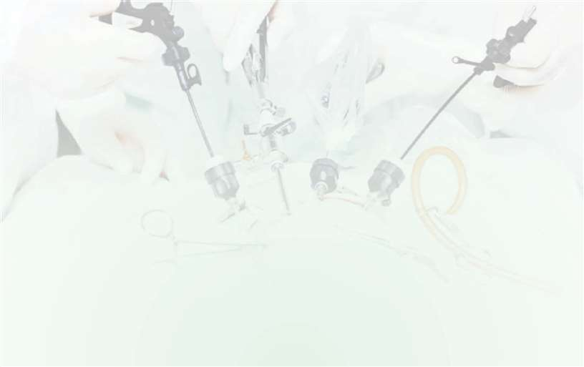
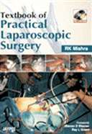
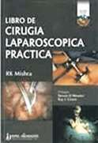
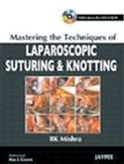
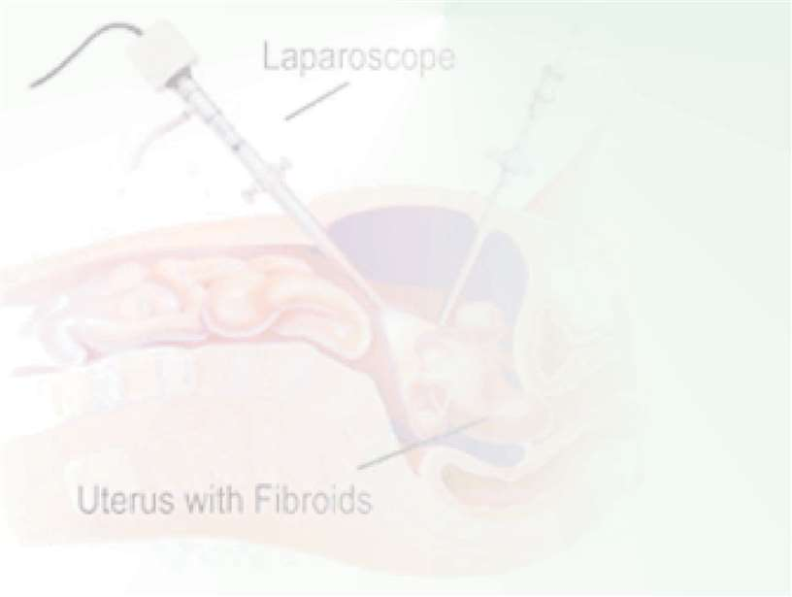
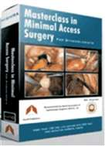
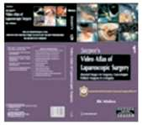
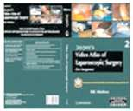
laparoscopic hernia surgery to the practicing surgeons, proper solutions of technical difficulties and above all confidence to face the complication. Unique chapter on hernia surgery with the help of fibrin glue and da Vinci robotic hernia Surgery is included which has comprehensive coverage on da Vinci surgical
Systems, Robot control, and Robot applications in cases of advanced surgery. Extensively illustrated with high resolution photographs which are self-explanatory and greatly enhance the understanding of various techniques of laparoscopic hernia surgery. This book is very useful for any laparoscopic surgeon who wants to perform hernia surgery with confidence. Two DVD's with many Power point's and laparoscopic hernia surgery videos are with this book.

Another great production of Dr. Mishra is Jaypee's Video Atlas of Laparoscopic Surgery in three volumes. Set I contains Jaypee’s Video Atlas of Laparoscopic Surgery (Essential Surgery for Surgeons, Gynecologists, Pediatric Surgeons and Urologists) Many hundreds of surgeon and gynecologists have now already benefited from almost two hundred hours
of detailed study and original teaching material on DVD / video. Prof. Mishra's personal and easy-to-follow step by step style makes this probably the most effective laparoscopic teaching method available as high quality video DVD. DVD Album I contain all the Essential skills of Minimal Access Surgery. Laparoscopic Live Lecture with detail step wise presentation by Power point's, Video Demonstration of real laparoscopic
surgery and Case Presentation of complications, indications and contra indications of all minimal access surgical procedures on 36 High quality DVD's Volumes.

The Volume 1 is Essential for both surgeon and gynecologist. Volume 2 is dedicated for General Surgery and Volume 3 is dedicated for gynecologists who want to learn laparoscopic surgery in depth. In that DVD there is recorded golden live lectures, video demonstration, case presentation and demonstration of operative technique
with high quality videos of world's one of the most talented Professor of Minimal Access Surgery and made it available for you on a set of 36 DVD's. The live recording of Laparoscopic Lecture/Demonstration and Video presentation is available in three volumes.

Jaypee's Video Atlas of Laparoscopic Surgery in three volume Set II contains Jaypee’s Video Atlas of Laparoscopic Surgery for general surgeon, Pediatric Surgeon and Urologist. The content of this video atlas comprises of all the analytical and technical information that would teach a Fellowship and Diploma Candidate of Laparoscopic Surgery at World Laparoscopy Hospital, over a period during surgical residency program. It is not presented in a referenced didactic form. Rather the style is a more personal explanation of the thought process and surgical principle that Dr. Mishra uses in his day to day practice. After viewing the videos, one will quickly note the commitment to make this album highly scientific. The clean atlas format and videos are in Power Point form with its numerous illustrations and figures with citations in systematic step by- step manner. The high quality video was deliberate choice of a concession to the busy surgeons and gynecologists and it is highly acclaimed by the scholars of minimal access surgery. The DVD with its introductory “booklet” will allow readers and viewers to go
directly to that part of the operative technique that interests them.

In DVD set III of Jaypee's Video Atlas of Laparoscopic Surgery, Prof. Mishra has attempted to present all major laparoscopic procedures in Gynecological specialty including Hysteroscopy and urogynecology. Some of the less frequently performed laparoscopic procedures are not illustrated owing to the lack of material or space. In

6
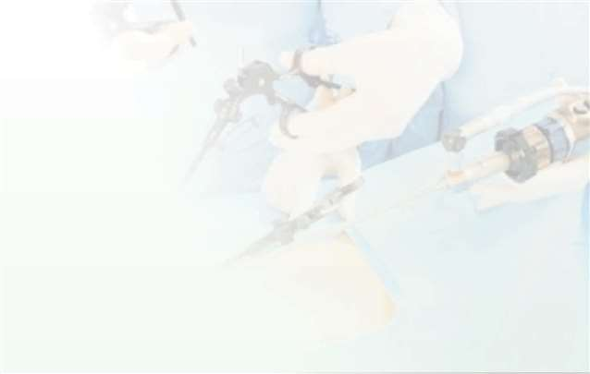
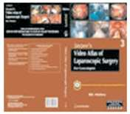
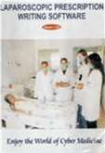
addition to the commonly performed major minimal access surgical procedures, Prof. Mishra has also illustrated many advanced procedures currently performed only at specialized centers throughout the world. He has tried to highlight important technical points for each step of the procedures in order to steer the reader away from potential complications. Prof Mishra has attempted to design this video album in a high-quality, comprehensive Atlas and hope that the reader appreciates its distinctiveness and merit. These Video atlas has been designed for the purpose of providing a detailed overview of the major procedures performed by the minimal access surgeons including surgeon, gynecologist, pediatric surgeon and urologist,
using full color video DVD of live surgical footage with spoken commentary. Creating the basis of this video atlas exclusively from actual surgical procedures, offers the reader a advantage point similar to that seen by the operating surgeon.

He has presented his scientific findings in society papers and exhibits at professional national and international meetings. Prof. Mishra is one of the very first surgeons who has started NOTES (Natural Orifices Trans Luminal Endoscopic Surgery) in India. He is the member of European Association of Transluminal Surgery. He was the invited faculty during India's largest conference on NOTES, PSG Surgeon 2008 which was organized by PSG hospital at Coimbatore. The reputation of World Laparoscopy Hospital places this unique institute among the top laparoscopic training facilities in the world to start Fellowship course in da Vinci Robotic Surgery and Single Incision Laparoscopic Surgery.

Prof. Mishra has started first time in the history of UAE, 10 days fully recognized Laparoscopic Training course with 70 hours CME recognized by Department of Health and medical services Government of Dubai and European Union of Medical Specialists. He is also faculty of Ethicon Institute Of Surgical Education, New Delhi. He is the visiting faculty and Honorary Professor of many leading institution of the world like Iranian Medical University, Tehran, Iran, King Abdulaziz Medical City, Jeddah, Kingdom of Saudi Arabia, Iranian Hospital, Dubai; Aljela Hospital, Tripoli, Libya, Gulu Independent Hospital, University of Gulu, Uganda. King and Edward Hospital, Kenya, Istanbul Goztepe Education and research hospital, Istanbul, Turkey
.Prof. Mishra has been an invited faculty at over 200 local, National and International meetings and has been actively involved in teaching Minimal Access surgery techniques to
other surgeons both in the India and abroad since 2001.

Dr. R.K. Mishra is recipient of hundreds of awards. He is recipient of Super Idol award for his achievement which will truly inspire others at life with an appreciative paradigm. The award of Super Idol adheres to a unique process of selection where the Network18 Editorial Board drawn from the editorial masterminds of CNN-IBN, IBN7, IBN- Lokmat deliberate to icons, keeping in mind their sterling contribution to humanity. Dr RK Mishra, has been named the recipient of the Global Laparoscopic Trainer award, an annual international award that recognizes one surgeon in the world whose career exemplifies the outstanding performance in Minimal Access Surgery. As an innovative surgeon and researcher this award and prize of Gold medal was given to Prof.Dr. R. K. Mishra He is also recipient of Global Medical Education Award by vice-chancellors of eight apex universities during National Open and Distance Education Summit 2007 in the presence of Honorable Shri P.R. Kyndiah, Union Minister for Tribal Affairs, Government of India. Dr R K Mishra has received Lord Ashdown Award in 2001, while pursuing his Master Degree in Minimal Access Surgery from Ninewells Hospital and Medical School, University of Dundee. Prof. Mishra who mentors surgeons has received Spanish Golden Eagle award from The Republican Society of Spain for his Textbook

7

of Laparoscopic Surgery. He is recipient of Lord Ashdown award for his valuable teaching contribution in the field of Minimal Access Surgery. For his dedicated service in the field of laparoscopic surgery LIONS CLUB Annamamalai Nagar has honored Prof. Mishra with "THE LIFE TIME ACHIEVEMENT AWARD and BEST DOCTOR AWARD." For his outstanding work for the underprivileged section of society and extraordinary efforts in promoting the health needs of the India, Dr. Mishra has received Purvanchal Gaurav Award by Prvanchal Ekta Manch, New Delhi.
Prof. Mishra was the organizing secretary of four International conferences on recent advances in minimal access surgery organized by World Association of Laparoscopic Surgeons. He is a highly-esteemed and respected professional in this field, and his advances in this discipline have benefitted an incalculable number of people. All his international conference on Minimal Access Surgery was approved by ministry of health and family welfare, Government of India and financially supported by medical council of India. More than five hundred delegates from 65 countries were present in these international conferences. These International conferences were unique in whole world because it was covering seven subspecialty of Laparoscopic Surgery from all across the globe.
Prof. Mishra's is expert in software programming. He has in depth knowledge of Visual Basics, C++, HTML, Dot NET, SQL database systems, PHP and Java. Prof Mishra has developed a unique Laparoscopic Prescription writing software and it is so easy to learn and use that any qualified surgeon or gynecologist can quickly be able to generate legible patient consent, Postoperative note, discharge card and medication prescriptions by only few clicks. This software can generate Laparoscopic Prescriptions with as few as three keystrokes. Most of the O. T. Note, postoperative general advice, dietary advice and medications with life style interaction will be pre-defined, with the ability to add on-the-fly. In this outstanding software developed by Prof.Mishra. Prescription Renewals can be quickly generated from previous prescriptions or from previously prescribed medications. Status of patient preoperative and postoperative tests are automatically available. The Drug Integration and Safety of Drugs are also automatically decided by this unique software. This software is one of the best-seller and present in almost all the famous medical library of the world. This software indicates which laparoscopic management recommendations are supported by clinical evidence, so you can implement them with total confidence.
Dr. Mishra lives in Gurgaon, India with his two sons, one daughter, and his lovely wife Sadhana. Tenacious, hardworking, and completely devoted, Dr. Mishra life work has been to practice, research, study, and drive innovation and excellence in his chosen field of Minimal Access Surgery and Laparoscopy. He has hobby of driving and at present he is President of Rolls Royce Indian Owners Club. He is musician also and has a great passion to play keyboard. He is a good billiard player and he is a member of World Pool-Billiard Association.

8
DEDICATED EXPERIMENTAL OPERATIONAL THEATRE
The experimental operating room at WORLD LAPAROSCOPY HOSPITAL training centre is a unique teaching unit comprising 15 HD experimental surgical working stations linked by a high-speed image transmission system.
We take only 30 students in one batch so that they can work comfortably. Each working station is composed of an operating table, a digital laparoscopic camera coupled with a 250W LED cold light source, broadband thermal insufflators, high frequency electro surgical generator and a vacuum suction-irrigation system. Each station features 5 and 10 millimetre optics with 0° and 30° view angles telescope.
Our lecture theatre is linked by an interactive multimedia teaching system with high resolution Dual HD Projector, which displays different kind of images, videos, such as external views using a camera incorporated in socialistic, endoscopic views of the chief expert's table and images from a multimedia computer presenting all surgical procedures in laparoscopic surgery.
Surgical dress is provided at the time of experiment and O.T. exposure. In order to comply with real surgical conditions, participants are assisted by a theatre nurse. In addition, an expert laparoscopic surgeon supervises operating tables to facilitate learning acquisition.
There will be extensive didactic session with detailed instructions followed by a supervised intensive, Hands-On session in our state-of-the-art skills laboratory with Harmonic Scalpel, Ligasure, Monopolar and Bipolar. The participant will first complete a structured curriculum on our virtual laparoscopy simulator designed to perfect depth perception, eye-hand coordination of dominant and non-dominant hand skills. The participant will then be instructed on the various suturing as well as intra-corporeal and extra-corporeal knot tying techniques including regular needles and Endostitch with ample time to practice in our state-of-the-art skills laboratory until proficiency is attained on animate.
Laparoscopy Program as well as exposure to endoscopic stapling devices, hand assisted laparoscopic surgery, laparoscopic vascular control techniques in all specialities, laparoscopic bowel division and anastomosis is also covered in the training programme. This course includes a half-day hands-on training in our animal lab, which can be tailored to the surgeon’s particular needs. The programme is best suited for the surgeons, gynaecologists and urologists with very limited laparoscopic experience who wishes to start performing a certain laparoscopic procedure and wishes to have an intense individualized training experience.
9
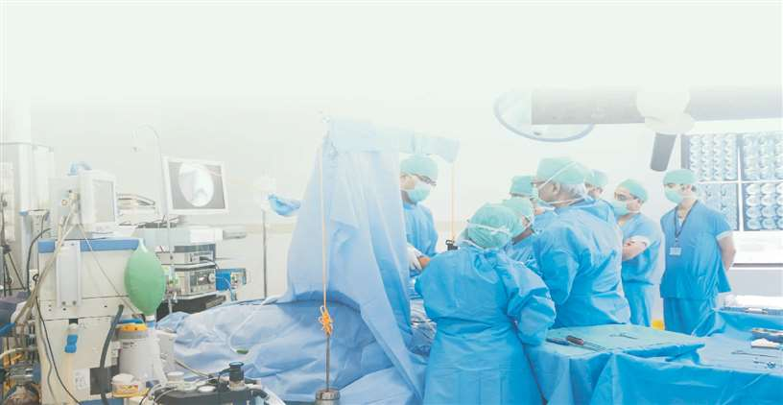
Practical Training Infrastructure at World Laparoscopy Hospital
Fellowship and Diploma in Minimal Access Surgry
UNIVERSITY RECOGNIZED INTEGRATED FELLOWSHIP AND DIPLOMA IN MINIMAL ACCESS SURGERY (F.MAS + D.MAS) COURSE FOR GENERAL SURGEONS, UROLOGISTS AND GYNAECOLOGISTS
Internationaly Recognised Programme
World Laparoscopy Hospital is only Institute in Asia which imparts University Recognized Integrated Fellowship and Diploma in Minimal Access Surgery. One of the biggest advantage of this course is free Robotic Surgery is also included. It comprises of in-depth "Hands On" training of Minimal Access Surgery. Diploma Certificate in Minimal Access Surgery (F.MAS + D.MAS) will be issued by TGO University after successful completion of this course. F.MAS + D.MAS course is conducted from 1st of every month for continuous Four Week.The content of core modules has been revised to provide a comprehensive foundation. The sequence of delivery of modules will be logical and lead to the successful assimilation of enough theoretical and practical knowledge to allow the assigned project to be developed.

The F.MAS + D.MAS Programme is more advanced and comprehensive than the F.MAS programme. It is ideal for surgeons and gynaecologists who are totally new to the concept of laparoscopic surgery. The programme has yield satisfactory response from surgeons and gynaecologists, many of whom recommend about our unique programme in their country. In the initial 2 weeks, it comprises of the core basic course (common with the F.MAS course), followed by ADVANCED minimal access surgery procedures in the latter two weeks.

- CLINICAL ATTACHMENT :
The spectrum of clinical observation is NOT restricted to the observation of surgical procedures, but includes out-patient and ward based activities, to facilitate understanding of presentation, diagnosis, selection, consent and outcome related to safe minimal access surgery. Candidates will be able to observe minimal access surgery on a regular basis. This would be also facilitated by utilizing the theatre link for regular observation which will be timetabled and supervised. Encouragement will be given to allow them to observe minimal access techniques in other specialties, particularly where this would add to their knowledge and understanding.

- LITERATURE REVIEW:
One of the first tasks to be completed is a literature review of a subject of the participants choice. The subject for review should be relevant to minimal access surgery, and will be selected by the individual student at the start of the course. Guidance will be given to those who are uncertain as to their choice. A preliminary literature search will form part of the research methodology module. Peer group presentations will take place in the third week of the term, and a draft write up completed by fourth week. Literature reviews will be archived in World Laparoscopy Hospital and will be available on the Department internet.

A register of attendance will be kept. These meetings will form the basis of a regular student report, or learning diary, that must be kept regularly up to date for the CME credits. The resource area of the institute is equipped with Wi-Fi internet connectivity and subscribes to many online journals which are used for reference in preparing the research article.

SUBMISSIONS :
All assignments, including the project, will be submitted to the Course Director, who will then distribute these to the appropriate persons for marking. Assignments should be submitted in electronic form as E-mail or CD. It is the responsibility of the individual student to retain a backup copy. In the case of non-written assignments, such as presentations, the relevant computer files should be submitted. All submissions will be archived in electronic format. Please discuss any difficulties with the Course Director. A prize will be awarded each year, for the best literature review published.

COURSE FEE:
The Course fee for Integrated Fellowship and Diploma in Minimal Access Surgery from World Association of Laparoscopic Surgeons is 7,800 US Dollar for overseas candidate and 2,45,000 Rupees for Indian Doctors. Please note that living expenses (Food, Travel, Stationary, and Laundry etc.) are NOT covered in the course fee. There will be no any extra charge to utilize hospital resources like internet, laparoscopic instruments, O.T. Dress, library, Videos; CDs.
10
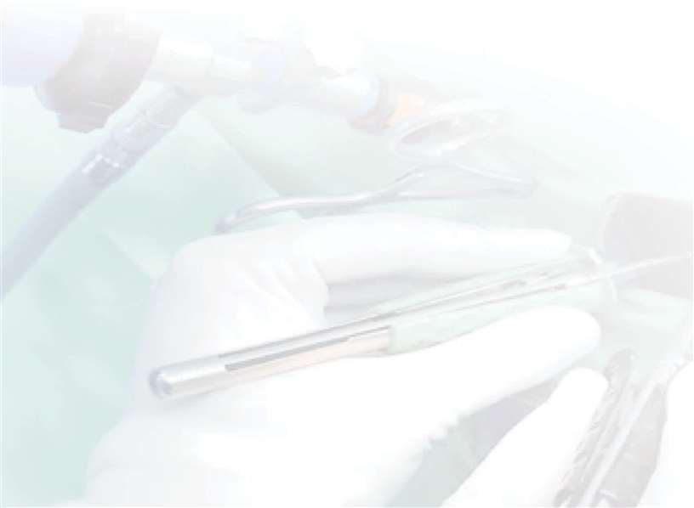
Surgeon & Urologist should be able to perform following ADVANCED surgery after F.MAS + D.MAS Course:
- Laparoscopic Cholecystectomy 16. Laparoscopic Gastric Bypass and MGB
- Laparoscopic Appendicectomy 17. Laparoscopic Management of Hydatid Cyst
- Laparoscopic Repair of Inguinal Hernia 18. Laparoscopic Exploration of CBD (TAPP and TEP) 19. Laparoscopic Nephrectomy
- Laparoscopic Repair of Para umbilical Hernia 20. Laparoscopic Varicocelectomy
- Laparoscopic Repair of Incisional Hernia 21. Laparoscopic Assisted Orcheopexy
- Laparoscopic Repair of Duodenal Perforation 22. Laparoscopic Pyeloplasty
- Laparoscopic Splenectomy 23. Retroperitoneoscopic Nephrectomy and
- Fundoplication & Gastric Banding Ureterolithotomy
- Intestinal Anastomosis &Thoracoscopy 24. Simple Single Incision Laparoscopic Surgery
- Laparoscopic Sleeve Gastrectomy 25. Movie Making and Video Editing
26. Digital Prescription Writing technique
- Laparoscopic low anterior resection for rectal 27. Procedure for Prolapse and Haemorrhoid
cancer (Stapled Haemorrhoidectomy)
- Laparoscopic Sigmoidectomy For Benign and 28. Upper GI Endoscopy
Malignant Disease 29. Simple da Vinci Robotic General Surgeries
- Laparoscopic Repair of Rectal Prolapse 30. Laparoscopic Movie Making and Video Editing
- Thoracoscopic Procedures like Sympathectomy, 31. Digital Prescription Writing technique HellersMyotomy, Pericardiocentesisetc
- Laparoscopic Repair of Hiatus Hernia
Surgeons can learn the gynecological procedures also if they are interested.
Gynaecologists should be able to perform following ADVANCED surgery after F.MAS + D.MAS Course:
- Diagnostic Laparoscopy and Laparoscopic 20. TVT and TOT & TVTO for Stress Urinary Sterilization Incontinence
- Laparoscopic Management of Ovarian Cyst 21. Laparoscopic Vesico-Vaginal Fistula Repair
- Laparoscopic Salpingo-Oophorectomy 22. Laparoscopic Lymphadenectomy for
- Laparoscopic Management of Tubal Pregnancy Gynecological Malignancies
- Laparoscopic Assisted Vaginal Hysterectomy 23. Laparoscopic uterine nerve ablation (LUNA)
- Laparoscopic Cervical Circlage for chronic pelvic pain
- Laparoscopic Total Hysterectomy 24. Laparoscopic Recanalization Surgery
- Supracervical Laparoscopic Hysterectomy 25. Laparoscopic Fimbrioplasty
- Radical Laparoscopic Hysterectomy 26. Laparoscopic Presacral Neurectomy
- Laparoscopic Re-canalization Surgery 27. Laparoscopic Management of Severe
- Diagnostic Hysteroscopy Endometriosis
- Operative Hysteroscopy (Metroplasty, 28. Operative Hysteroscopy (Submucous Myomectomy) Myomectomy, Metroplasty& TCRE)
- Hysteroscopic TCRE and application of Essure II 29. Simple Single Incision Laparoscopic Surgery
- Laparoscopic Burch Suspension 30. Laparoscopic Movie Making and Video Editing
- Laparoscopic Myomectomy 31. Digital Prescription Writing technique
- Laparoscopic Intestinal and Tubal Anastomosis 32. Colposcopy
- Laparoscopic Sacro-Colpopexy 33. Simple da Vinci GynecologicalRobotic Surgery
- Radical Laparoscopic Hysterectomy
- Laparoscopic Pelvic Floor Repair
11
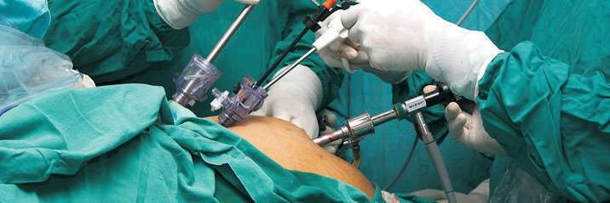
We provide following study materials for surgeon taking part in course
- DVDs containing laparoscopic videos of all the important minimal access surgical procedure.
- Comprehensive Text Book of Laparoscopic surgery for Surgeons and Gynaecologists.
- Passwords for member surgeons to avail continued free online support on www.laparoscopyhospital.com.
- On spot post training help for member surgeons to start the laparoscopic surgery at their own hospital.

AWARD OF F. MAS AND D. MAS
The award of the INTEGRATED FELLOWSHIP AND DIPLOMA IN MINIMAL ACCESS SURGERY from World
Association of Laparoscopic Surgeons (WALS) will be conferred on satisfactory completion of:
- All assignments,
- A practical skills OSCE,
- The submission of an article and project report of an appropriate standard.
CME accreditation and D. MAS Certificate will be issued in the last day of training programme of the course. Surgeons can learn the gynecological procedures also if they are interested. F.MAS certificate is awarded on 14th day of training.
12
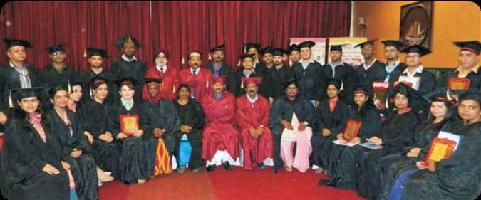
Fellowship in Minimal Access Surgery
University Recognized Fellowship in Minimal Access Surgery (F. MAS) Course for General Surgeons, Urologists & Gynaecologists

The F.MAS Programme is for two weeks and comprises of rigorous "Hands On" training of all essential and advanced laparoscopic procedures. Free study material to complement practical knowledge is provided with the course. Fellowship course is conducted every month starting from 1st of the month. After completion of laparoscopic training course and on recommendation of fellowships committee of World Association of Laparoscopic Surgeons, TGO University and WALS will jointly award Fellowship in Minimal Access Surgery. Post training online support for one year in case of any difficulty is provided through world’s largest most updated collection of study material (Videos, Articles, PowerPoint presentations and many more) kept for members only through our secure private member area.

COURSE FEE : The course fee is 1,55,000 Rupees for Indian surgeons and 4,500USD for overseas surgeon & NRI.

Note: Course fee include all the lab material, cost of consumables during practical, all the study materials, lunch and refreshment. However, boarding and lodging cost is NOT included in this fee.

Certification Ceremony of the 50th batch of Trained Surgeons and Gynecologists from World Laparoscopy Hospital with
Dr. Harsh Vardhan, Health Minister (2014) of Delhi, India.

We provide following study materials for surgeon taking part in course:
- DVDs containing laparoscopic videos of all the important minimal access surgical procedure.
- Comprehensive Text Book of Laparoscopic surgery for Surgeons and Gynaecologists.
- Passwords for member surgeons to avail continued free online support on www.laparoscopyhospital.com.
- On spot post training help for member surgeons to start the laparoscopic surgery at their own hospital.

Surgeon should be competent to perform following surgery after completion of F. MAS

•Diagnostic Laparoscopy, Diagnostic Thoracoscopy
•Laparoscopic Cholecystectomy
•Laparoscopic Appendicectomy
•Laparoscopic Repair of Inguinal Hernia
•Laparoscopic Repair of Hiatal Hernia
•Laparoscopic Repair of Para umbilical Hernia
•Laparoscopic Repair of Incisional Hernia
•Laparoscopic Repair of Duodenal Perforation
•Techniques to do laparoscopy with
previous abdominal scar
•Procedures for Prolapse and Piles
•Suturing and Knotting of any visceral injury
•Simple Thoracoscopic Procedures
•Laparoscopic Management of Undescended Testes
•Laparoscopic Management of Varicocele
•Retroperitoneoscopic Nephrectomy
•Retroperitoneoscopic Ureterolithotomy

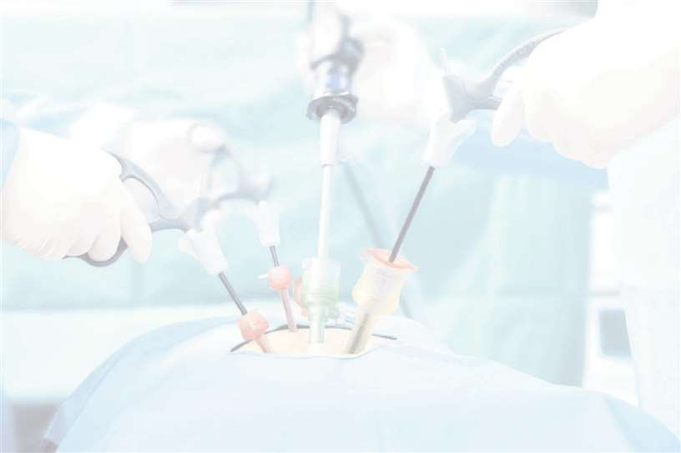

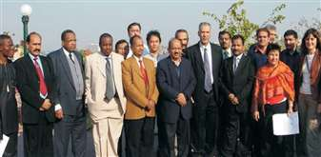
13

Gynaecologists should be competent to perform following surgery after completion of F. MAS
•Diagnostic Laparoscopy and Laparoscopic Sterilization
- oscopic Management of Ovarian Cyst
Lapar
- oscopic Salpingo-Oophorectomy
Lapar
- oscopic Management of Tubal Pregnancy
Lapar
- oscopic Management of Stress Incontinence
Lapar
- oscopic Assisted Vaginal Hysterectomy
Lapar
- oscopic Total Hysterectomy
Lapar
- acervical Laparoscopic Hysterectomy

Supr
•

oscopic Re-canalization Surgery

Lapar
•
Diagnostic

Hysteroscopy

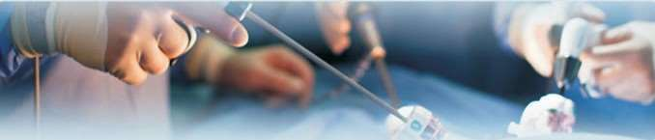
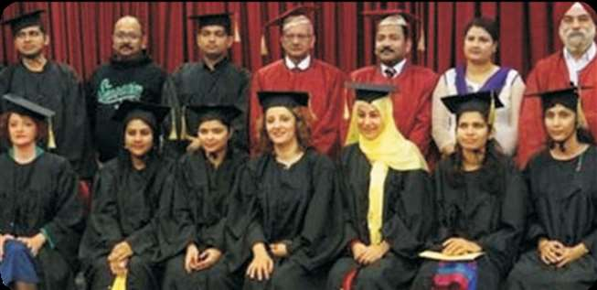
Award of F.MAS
Certificate of Fellowship in Minimal Access Surgery and CME accreditation training will be given after objective written evaluation on the last day of training from World Association of Laparoscopic Surgeons (WALS) and TGO University.

14

COMPARISON BETWEEN F.MAS + D.MAS AND F.MAS

Surgical Procedures For Surgeon's Covered
2 Week F.MAS
Training
4 Week F.MAS+D.MAS
Training
Surgical Procedures Gynaecologist's Covered
2 Week F.MAS Training
4 Week F.MAS+D.MAS
Training

LAPAROSCOPIC INSTRUMENT DESIGN, ERGONOMICS OF LAPAROSCOPY, ACCESS TECHNIQUE, DISSECTION TECHNIQUES, TOP GUN DRILL EXERCISES, TISSUE RETRIEVAL TECHNIQUES, TISSUE APPROXIMATION, TECHNIQUES, LASER WELDING, HARMONIC SCALPEL, LIGASURE, PLASMASECT, V SAMPLE, MORCELLATION TECHNIQUES AND PORT CLOSURE TECHNIQUES. DEMONSTRATION OF 3 CHIP HD CAMERA TECHNOLOGY AND DIFFERENCE BETWEEN 1920 X 1080 INTERLACED AND PROGRESSIVE HD TECHNOLOGY.
LAPAROSCOPIC INSTRUMENT DESIGN, ERGONOMICS OF LAPAROSCOPY, ACCESS TECHNIQUE, DISSECTION TECHNIQUES, TOP GUN DRILL EXERCISES, TISSUE RETRIEVAL TECHNIQUES, TISSUE APPROXIMATION, TECHNIQUES, LASER WELDING, HARMONIC SCALPEL, LIGASURE, PLASMASECT, V SAMPLE, MORCELLATION TECHNIQUES AND PORT CLOSURE TECHNIQUES. DEMONSTRATION OF 3 CHIP HD CAMERA TECHNOLOGY AND DIFFERENCE BETWEEN 1920 X 1080 INTERLACED AND PROGRESSIVE HD TECHNOLOGY.
DIAGNOSTIC LAPAROSCOPY, STERILIZATION & TPT
LAPAROSCOPIC ASSISTED VAGINAL HYSTERECTOMY
LAPAROSCOPIC MANAGEMENT OF OVARIAN CYST
LAPAROSCOPIC SUTURING AND KNOTTING - HANDS ON TRAINING
LAPAROSCOPIC TROUBLE SHOOTING AND TECHNIQUES OF AVOIDING MISTAKES AND ERRORS IN MINIMAL ACCESS SURGERY
PASSWORD OF LAPAROSCOPY HOSPITAL PRIVATE MEMBER AREA TO DOWNLOAD 300 GB OF FREE STUDY MATERIAL INCLUDING VIDEOS, ARTICLES, EBOOKS & POWER POINTS
SALPINGOTOMY, SALPINGO- OOPHORECTOMY & LAPAROSCOPIC MANAGEMENT OF ECTOPIC PREGNANCY
LAPAROSCOPIC ANIMAL DISSECTION

LAPAROSCOPIC CHOLECYSTECTOMY LAPAROSCOPIC HERNIA REPAIR
LAPAROSCOPIC MANAGEMENT D.U PERFORATION &VARICOCELECTOMY


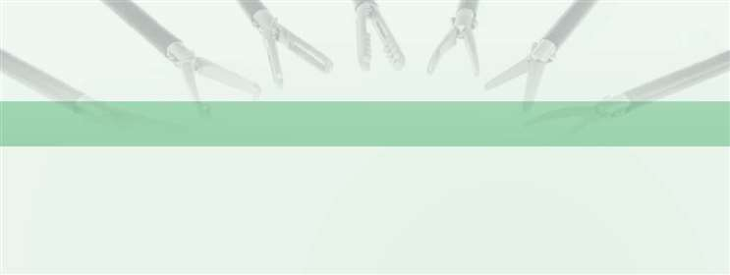
LAPAROSCOPIC SUTURING AND KNOTTING - HANDS ON TRAINING

LAPAROSCOPIC TROUBLE SHOOTING
& TECHNIQUES OF AVOIDING MISTAKES & ERRORS IN MINIMAL ACCESS SURGERY

PASSWORD OF LAPAROSCOPY HOSPITAL PRIVATE MEMBER AREA TO DOWNLOAD 300 GB OF FREE STUDY MATERIAL INCLUDING VIDEOS, ARTICLES,
EBOOKS AND POWER POINTS

PROCEDURE FOR PROLAPSE AND HAEMORRHOID
(STAPLED HAEMORRHOIDECTOMY)

LAPAROSCOPIC ANIMAL DISSECTION
6 TYPES OF KNOT

3 Days
9 TYPES OF KNOT

6 Days

15
6 TYPES OF KNOT

3 Days
9 TYPES OF KNOT

6 Days

Surgical Procedures For Surgeon's Covered
2 Week F.MAS
Training
4 Week F.MAS+D.MAS
Training
Surgical Procedures Gynaecologist's Covered
2 Week F.MAS Training
4 Week F.MAS+D.MAS
Training


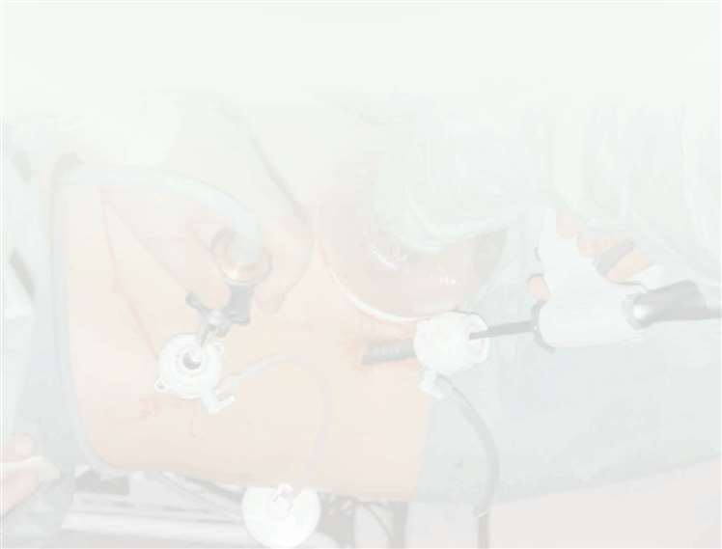

LAPAROSCOPIC SPLENECTOMY
DIAGNOSTIC HYSTEROSCOPY
LAPAROSCOPIC BURCH SUSPENSION
LAPAROSCOPIC MYOMECTOMY
LAPAROSCOPIC INTESTINAL AND TUBAL ANASTOMOSIS
LAPAROSCOPIC SACRO-COLPOPEXY
RADICAL LAPAROSCOPIC HYSTERECTOMY, LAPAROSCOPIC CIRCLAGE
LAPAROSCOPIC PELVIC FLOOR REPAIR
TVT AND TOT & TVTO FOR STRESS URINARY INCONTINENCE
NATURAL ORIFICES TRANSLUMINAL ENDOSCOPIC SURGERY (NOTES)
LAPAROSCOPIC VESICO-VAGINAL FISTULA REPAIR
LAPAROSCOPIC LYMPHADENECTOMY FOR GYNECOLOGICAL MALIGNANCIES
LAPAROSCOPIC UTERINE NERVE ABLATION (LUNA) FOR CHRONIC PELVIC PAIN
LAPAROSCOPIC RECANALIZATION SURGERY
LAPAROSCOPIC FIMBRIOPLASTY
LAPAROSCOPIC PRESACRAL NEURECTOMY
LAPAROSCOPIC MANAGEMENT OF SEVERE ENDOMETRIOSIS
OPERATIVE HYSTEROSCOPY (SUBMUCOUS MYOMECTOMY, METROPLASTY& TCRE)
HANDS ON SINGLE INCISION LAPAROSCOPIC SURGERY

LAPAROSCOPIC NEPHRECTOMY

RETROPERITONEOSCOPIC NEPHRECTOMY AND NEPHROLITHOTOMY

FUNDOPLICATION & GASTRIC BANDING

INTESTINAL ANASTOMOSIS &THORACOSCOPY
LAPAROSCOPIC SLEEVE GASTRECTOMY AND GASTRIC PLICATION

LAPAROSCOPIC LOW ANTERIOR RESECTION FOR RECTAL CANCER

LAPAROSCOPIC SIGMOIDECTOMY FOR BENIGN AND MALIGNANT DISEASE

LAPAROSCOPIC REPAIR OF RECTAL PROLAPSE

NATURAL ORIFICES TRANSLUMINAL ENDOSCOPIC SURGERY (NOTES)

LAPAROSCOPIC GASTRECTOMY

LAPAROSCOPIC REPAIR OF HIATUS HERNIA

THORACOSCOPIC PROCEDURES LIKE SYMPATHECTOMY, MYOTOMY, ETC.

LAPAROSCOPIC GASTRIC BYPASS

LAPAROSCOPIC MANAGEMENT OF HYDATID CYST

LAPAROSCOPIC EXPLORATION OF CBD

TRANSLUMINAL ENDOSCOPIC MICROSURGERY (TEM)

HANDS ON SINGLE INCISION LAPAROSCOPIC SURGERY

16

Surgical Procedures For Surgeon's Covered
2 Week F.MAS
Training
4 Week F.MAS+D.MAS
Training
Surgical Procedures Gynaecologist's Covered
2 Week F.MAS Training
4 Week F.MAS+D.MAS
Training

LAPAROSCOPIC MOVIE MAKING AND VIDEO EDITING
LAPAROSCOPIC MOVIE MAKING AND VIDEO EDITING
DIGITAL PRESCRIPTION WRITING TECHNIQUE AND AUTO PRESCRIPTION, DISCHARGE CARD, CONSENT FORM AND O.T NOTE GENERATION FOR GYNAECOLOGISTS WITH FREE SOFTWARE WORTH 200 USD WITH LIFETIME UPGRADE. VERY USEFUL FOR MEDICO LEGAL PURPOSES
HANDS ON COLPOSCOPY TRAINING
HANDS ON DA VINCI ROBOTIC SURGERY TRAINING
CERTIFICATES AWARDED

DIGITAL PRESCRIPTION WRITING TECHNIQUE AND AUTO PRESCRIPTION, DISCHARGE CARD, CONSENT FORM AND
O.T NOTE GENERATION FOR SURGEON WITH FREE SOFTWARE WORTH 200 USD WITH LIFETIME UPGRADE. VERY USEFUL FOR MEDICO LEGAL PURPOSES

HANDS ON UPPER GI ENDOSCOPIC TRAINING

HANDS ON DA VINCI ROBOTIC SURGERY TRAINING

CERTIFICATES AWARDED
F.MAS F.MAS
+ D.MAS
+ CERTIFICATE OF DA VINCI ROBOTIC SURGERY TRAINING
F.MAS F.MAS
+ D.MAS
+ CERTIFICATE OF DA VINCI ROBOTIC SURGERY TRAINING

Course Fee
1,55,000
RUPEES FOR INDIAN & 4,200 USD FOR OVERSEAS
2,45,000
RUPEES FOR INDIAN & 7,200 USD FOR OVERSEAS
TUITION FEE (INCLUSIVE LAB CHARGES, STUDY MATERIAL, LUNCH, REFRESHMENT AND ONLINE FREE STUDY MATERIAL OF WORTH 3,000 USD)
1,55,000
RUPEES FOR INDIAN & 4,200 USD FOR OVERSEAS
2,45,000
RUPEES FOR INDIAN & 7,200 USD FOR OVERSEAS


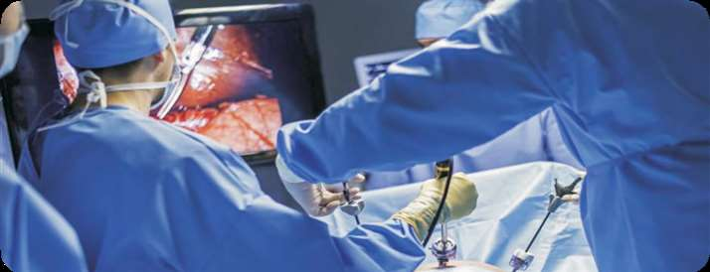

17

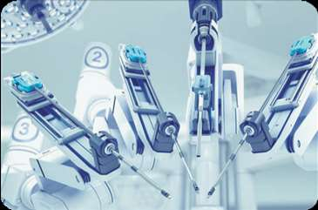

Fellowship of International College of Robotic Surgeons (FICRS)
University Recognized Robotic Surgery Fellowship Recognized by World Association of Laparoscopic Surgeons and International College of Robotic Surgeons
ROBOTIC SURGERY HANDS ON TRAINING COURSE
Hands On Course on da Vinci® Surgical System ROBOTIC TRAINING is (Four days intensive training).
For surgeons who have also previously trained on da Vinci ®, and would like to work on their technique, we offer a procedure refinement course on a porcine model. We also offer an advanced Gynecology Urologic, Kidney, and General surgery Super Users Course for advancing your technique. This course includes didactics, and a live procedure.

To understand the fundamental principles used in robotic-assisted laparoscopic reconstructive and extirpative procedures
•To become familiar with the function and operation of the da Vinci® Surgical System.
•To become familiar with the ergonomics All participants will be trained in the
of the da Vinci® Surgical System robot following:
& the available robotic instrumentation. •How to do proper operative room setup.
•To understand the selection process for •How to do patient preparation and patient position, surgical team position positioning.
and surgical approaches. •Fundamentals of da Vinci® Surgical
•To become familiar with the technique of System components & instrumentation. robotic-assisted intracorporeal suturing •Training of intra-corporeal suturing and and knot tying. knot tying.
•o learn "tricks of the trade" to make •Learn micro dissection by robot.
T
laparoscopic reconstructive procedures •Learn "tricks of the trade" tips for more efficient without much complication. efficient surgery.
18

COURSE AGENDA OF FICRS
Day One
9:30am - 9:45 am Registration
Program overview/objectives of Robotic Training

10:00am - 11:30 am Introduction of Robotic Surgery its Advantage and Disadvantage, Patient selection, Indication and Contraindication.

11:30am - 12:00 pm Coffee

12:00pm - 1:30 pm Ergonomics, Explanation of Patient Cart, Vision Cart & Master
Console, Instrument designing and Working Principles of
da Vinci® Surgical System

1:30pm - 2:30pm Lunch

Ergonomics, optical 3 D HD designing & Working Principles of Robotic
2:30pm - 4:00 pm Remote Sensor Technology,and Docking of the Canula with the Robotic Arm of da Vinci® Surgical System. Insertion and change of the instruments.

Day Two
10:00am - 10:30 am Baseball Diamond Concept of Port Position used in Robotic Surgery and Docking Principle of da Vinci Robot for various surgery

11:30am - 12:00 pm Coffee

12:00pm - 1:30 pm Hands-On practice of Intracorporeal Robotic Surgeons Knot on da Vinci Robot

1:30pm - 2:30 pm Lunch

Hands-On practice of Iintracorporeal Robotic Tumble Square Knot,
2:30pm - 4:00 pm Robotic Dundee Jamming Knot, Robotic Continuous Suturing and Robotic Aberdeen Termination Suturing Practice.
19
Day Three

Hands-On Live Surgery Practice for Surgeons and Gynecologists
10:00am - 11:30 am according to specialty of Surgeon, Gynecologist, Urologist and
Cardiothoracic Surgeon

11:30am - 12:00 pm Coffee

Hands-On Live Surgery Practice for Surgeons and Gynecologists
12:00pm - 1:30 pm according to specialty of Surgeon, Gynecologist, Urologist and Cardiothoracic Surgeon - OT Session

1:30pm - 2:30pm Lunch

Hands-On Live Surgery Practice for Surgeons and Gynecologists according
2:30pm - 4:00 pm to specialty of Surgeon, Gynecologist, Urologist and Cardiothoracic Surgeon - OT Session

Day Four

Fellowship Examination and Discussion of Paper. Software Demonstration
10:00am - 12:30 am of Davinci Robotic Surgery

1:30pm - 2:30 pm Farewell Lunch and Certification of Fellowship of International College of Robotic Surgeons
Award of FICRS
During the programme of da Vinci® Surgical System training, trainees will be evaluated from staffs of the Government Recognised University concerning working ability and MCQ test. At the end of the programme, they will receive a certificate of attending.
20
Fellowship in Assisted Reproductive Technologies
University Recognized Fellowship Hands-On Training
Start date : 7thofEverymonth
Duration : 1week
Level : BeginnerandIntermediate
Course Fee : `70,000forIndianDoctors&1,700USDforOverseas Doctors. :
Location Campus,WorldLaparoscopyHospital,FullTime

Skill and precision is required for all Assisted Reproductive Technologies. The skill of ART are gained only through in-depth knowledge and experience. World Laparoscopy Hospital impart this knowledge through lectures, actual Hands-On training and demonstrations that ensure proficiency for every aspirant gynecologists at the end of course. Hands-On Fellowship Course for the interested Gynecologist and Embryologist. The main objectives of this programme is to update the scientific background and to promote the clinical and the technical skills of the gynecologist in assisted reproductive technology. Special arrangements of the timings is done for the candidates who are already taking the Fellowship or Diploma course and laparoscopic training at World Laparoscopy Hospital. The skill of IVF is achieved by successive sessions of lectures and hands-on training under expert supervision.

COURSE DESCRIPTION

Established in 2001 and one of the most popular institute of minimal access surgery training and being premier institute in the India, the course, in association with TGO University, uniquely provides theoretical and practical training in all aspects of human assisted conception including embryology, andrology, micromanipulation, endocrinology, cryobiology and infertility. Provision of course material and training is by expert who is highly active within speciality.

World Laparoscopy Hospital is world leader to offer the most advanced and globally competitive training in the field of Assisted Reproductive Technology. Courses of ART training at World Laparoscopy Hospital can be catered to individual needs.
COURSE DIRECTOR
Dr. Sarita Sukhija
MBBS, MD (Obs and Gyn)
Senior Consultant , IVF Specialist and Gynae Endoscopy Fellow Reproductive medicine, Cleveland clinic, USA
Fellow , Gynae endoscopy and reproductive medicine, Germany
21
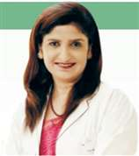
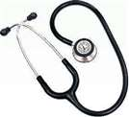

Objectives of the IVF Training Course
TOPICS COVERED

- To understand the basic knowledge of assisted reproductive technology.
- To be able to explain to patients and their families regarding the different aspect of assisted reproductive technology.
- To enable the candidate to handle the state-of-art equipment, its proper use and care.
- To have the basic skills customized for the candidate to suit their specific needs.
- To know the indications, contraindication, complications of different techniques of ART.
- To have enough skill for starting their own practice of assisted reproductive technology
- Basics of female neuroendocrine system, Understanding the hormones, Ovarian reserve.
- Basics of infertility, Male infertility, History taking & investigations.
- Ovulation induction in IUI, Secrets to success of IUI, Myths on IUI.
- Semen analysis equipments /media, Semen preparation techniques, Hands on semen preparation.
- Monitoring of stimulated cycles, TVS in infertility, USG hands on.
- Agonists, Antagonists, Protocols for IVF cycles.
- Ovum pick up, Equipments, Practical.
- Embryo transfer, Lecture, Practical.
- IVF/ICSI /Vitrification, Gametes handling /Media, Lab equipments /maintenance.
- Special conditions, Poor Responders, PCOS, Endometriosis.

Topics Covered During IVF Training

  - Introduction to In vitro fertilisation (IVF).
  - Ultrasound folliculometry, urinary LH surge detection.
  - Investigation and management of infertility.
  - IUI, (AIH).
  - IUI (Donor insemination).
  - Hands on semen analysis, semen washing, sperm freezing.
  - Hands On Semen Preparation for intrauterine insemination (IUI).
  - Tests for Ovarian reserve.
  - Different stimulation protocol and monitoring of controlled ovarian hyperstimulation.
  - Prevention of OHSS and its management.
  - Approaches to ovarian stimulation in PCO patients.
  - Role of Assisted reproductive technology (ART) in endometriosis.
  - Hands On Egg pick up, its protocol and trouble shoots.
  - Hands on culture dish preparation.
  - Gamete handling and insemination in embryology lab.
  - Hands on catheter loading of embryos and transfer using non gamete cells. Luteal support.
  - Protocols for thaw embryo transfer

Course Fees

Course Fees of Fellowship in Assisted Reproductive Technologies is 1700 USD for Overseas candidate and 70,000 Rupees for Indian Candidates.

Please note that living expenses (Food, Travel, Stationary, and Laundry etc.) are not covered in the course fee. There is no extra charge to utilize hospital resources like internet, IVF instruments, O.T. Dress, Library, Videos, CDs.
Certification
At the end of the programme, candidate will receive Certificate of Fellowship in Assisted Reproductive Technologies
For pleasant memorable stay of trainee of Fellowship in Assisted Reproductive Technologies we have hostel accommodation available at very nominal cost. Gurugram is one of the most expensive cities in India. DLF phase 2 is one of the most expensive in Gurugram. Keeping the comfort and security of doctors in mind we have subsidized Doctor's Hostel. It is 3 Star facility where you will feel valued and cared from the moment you arrive even alone or with your spouce or family. Please note that accommodation is reserved on first come first served basis and it is advised to reserve your room prior to arrival. In case you want very economical budget accommodation we can arrange it for you.



22

GI Endoscopy "Hands-On" Fellowship Course

Start date Duration Level Course Fee Location

: 16th to 19th of Every month
: 4 days Fellowship in Upper and Lower GI Endoscopy
: Beginner and intermediate
: ` 70,000 for Indian Doctors & 1,700 USD for Overseas Doctors. : Campus, World Laparoscopy Hospital

The intensive Hand on course is for 4 days consisting of Basic Upper and Lower GI Endoscopy Course from 16th to 19th of every month. Candidate can opt for four days course of only upper or lower GI endoscopy if they want.

Dr. Arvind Kumar Khurana
Dr. Arvind Kumar Khurana , MBBS, MD (Medicine), DNB (Medicine), DM (Gastroenterology), FRCP.
Senior Consultant Gastroenterologist & Head Department Gastroenterology.

DIRECTOR
COURSE OBJECTIVE

The main objectives of this programme are to update the basic scientific background and to promote the clinical and the technical skills of the candidates. These are achieved by successive sessions of lectures and Hands-On training under expert supervision. Successful trainees in GI endoscopy acquire their skills through a program of hands-on experiential training under the mentorship of expert endoscopic trainers

  - To understand the basic knowledge of Upper GI and Lower GI endoscopy.
  - To be able to explain to patients and their families regarding the upper endoscopy process and acquire informed consent properly.
  - To be able to handle endoscope properly, including reprocessing and maintenance of the endoscope.
  - To have the basic skills for diagnostic gastroscopy.
  - T o k n o w t h e i n d i c a t i o n s , contraindication, complications and how to handle the complications.
  - To have the basic skills for diagnostic Colonoscopy.
TOPIC COVERED
- Orientation to endoscopic instrument and accessories.
- Endoscopic cleaning and disinfection.
- Basic upper GI endoscopic technique.
- Preparation and premedication methods of patients.
- Indications, contraindications and complications of upper GI endoscopy.
- Tissue Biopsy and handling.
- Interpretation of upper GI endoscopic findings.
- Technique for endoscopic hemostasis.
- Overcoming upper GI endoscopic difficulties.
- Basic Lower GI endoscopic technique.
- Preparation and premedication methods of patients.
- Indications, contraindications and complications of Lower GI endoscopy.
- Tissue Biopsy and handling.
- Interpretation of Lower GI endoscopic findings.
- Technique for endoscopic hemostasis.
- Overcoming Lower GI endoscopic difficulties.


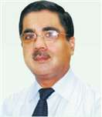

23

The trainees will have an opportunity to practice the following procedure only in Lab and Demonstration

  - Esophagoscopy
  - Gastroscopy
  - Duodenoscopy
  - Endoscopic variceal ligation
  - Colonoscopy
- Sigmoidoscopy
- Other procedures such as coaptation therapy, hemo-clipping, endoscopic dilation, polypectomy,
- Foreign body removal and PEG depend upon individual skill.

Course structure
Endoscopic training comprises of the rigorous 6 hours daily Hands On training of all essential upper and lower GI endoscopic procedures. This course is scientifically designed according to international protocol of endoscopic education proven to learn Minimally invasive endoscopic technique. Our minimally invasive endoscopic training will not end just imparting hands on skill but post training Online support is also provided. through world's largest and most updated Online library of endoscopic study material (Videos, Articles, Power Point presentations, eBooks) kept for members only on our dedicated server. We provide endoscopic study materials of worth 3000 USD free during course. Free endoscopic study material to complement practical knowledge is provided with the course. Course study material as teaching resources (textbooks, atlases, videotapes, electronic media) into the training program provided free with the course.
Entry requirements
Admission is on first come first serve basis but if the applicant are more for same month candidate has to take Online entrance exam. Candidates must hold M.B; B.S or equivalent and at least 3 years post-registration experience in General surgery or Medicine or degree of M. S or M. D for Indian candidates.
- Doctors should have valid medical registration.
- Overseas Doctor should have equivalent qualification.
- Exam of Fellowship has to be cleared.
Fees
The course fee for Upper and Lower GI endoscopy is 70,000 Rupees for Indian surgeons and 1700 USD for overseas surgeon and NRI.
Course Fee
The course fee is 1700 USD for Overseas candidate and 70,000 Rupees for Indian Candidates. Accommodation is available and the Tariff is subsidized. Hospital has its own deluxe bus to bring surgeons to hospital. Please note that living expenses (Food, Travel, Stationary, and Laundry etc.) are not covered in the course fee but working lunch, snacks tea and coffee will be provided whole day during course, free of cost. There is no extra charge to utilize hospital resources like internet, endoscopic instruments, O. T. Dress, Library, Videos, CDs. Learn more about the accommodation.
Certification
Certificate of Training will be awarded by WALS. CME certificate is awarded by World Laparoscopy Hospital.
Accommodation:
For pleasant memorable stay of trainee doctors we have hostel accommodation available at very nominal cost. Hospital has its own transport facility to bring surgeons to hospital.

24

International Certificate Course in Arthroscopic Surgery

Three Days Intensive Course

Torn Anterior Cruciate Ligament

Hands On Intensive Arthroscopic Surgery Course for Orthopedic Surgeons

This course includes live surgery, workshops and discussion groups on Arthroscopic surgery consist of

  - Theoretical teaching
  - Practical training on anatomical specimen

The first day of lectures, basic knowledge on arthroscopic knee, shoulder, elbow, wrist, hip and ankle pathology and treatment is presented. During lunch break a hand on course on meniscus suturing and knots. Second and third day cadaveric workshop in the morning and in the afternoon was accompanied by special topics lectures attendees performed arthroscopies on arthroscopic stations, two per station, each pair under guidance of the instructor. Diagnostic arthroscopy, meniscus suturing, ACL and PCL, single or double bundle was performed on the knee, and subacromial decompression, rotator cuff repair and Bankart repair were performed on the shoulder by all attendants.
Course Date:
Please Confirm Fees from
Web: www.laparoscopyhospital.com Email: contact@laparoscopyhospital.com

Certification
Certificate of Training will be awarded by Government Recognized University

Evaluation
During the programme, trainees will be evaluated from staffs of the TGO University concerning working ability and MCQ test. At the end of the programme, they will receive a certificate of attending.

Practical Session
Experimental lab training
- Normal examination
- Menisectomy / Meniscal suture
- ACL repair (BTB, Hamstring)
- Arthrolysis
- Chondral defect

Fees
Please Confirm Fees from
Website: www.laparoscopyhospital.com or Email: contact@laparoscopyhospital.com

Information and registration
There is initial registration charge of 10,000 rupees.
Rest of the fee will be payable at the time of joining the course.
This initial Registration charge will be deducted from the total fee.

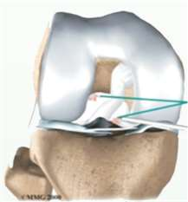

This program helps orthopedic surgeons to adapt to the real world of Minimal Access Surgical Orthopedic Care

25

FREQUENTLY ASKED QUESTIONS
Although WORLD LAPAROSCOPY HOSPITAL is known worldwide for providing the best training courses, it is important to explain why our centre is best.

Q. Why WORLD LAPAROSCOPY HOSPITAL Training Programme?

- Lord Ashdown Award for Best Laparoscopic Training Institute of the World.
- Within 17 year more than 8,000 surgeons and gynaecologists from almost all the countries of the world have been successfully trained.
- Basic concepts behind laparoscopic surgery is emphasized together with ADVANCED specialized
laparoscopic procedures are also covered according to preference of participants.
- Live demonstration in operation theatre together with maximum “Hands On” exposure in well equipped laparoscopic Lab. Regular courses every month from the first of month.
- No need to attend two or three day’s course for separate surgery as offered by other institutes.
- Certificate internationally accredited by World Association of Laparoscopic Surgeons (WALS) ®.
- Course Endorsed by Society of American Gastrointestinal Endoscopic Surgeons.
- The CME accreditation is given 6 hour per day. This accreditation is valid throughout the world.
- Training directed by super specialist Laparoscopic Surgeon qualified Master in Minimal Access Surgery from NINEWELLS HOSPITAL AND MEDICAL SCHOOL, UNITED KINGDOM.
- Only institute in the world which is autonomous and training content is not influenced by any advertiser,
sponsor, laparoscopic companies, laparoscopic product offering, or third party.
- Minimum Fee Structure (Subsidized by WALS) ® as compared to any other internationally accredited institute of the world.
- Free study material worth 20,000 rupees including Video CDs and Comprehensive Text Book of
Laparoscopic Surgery for Surgeons and Gynaecologists.
- Largest Collection of High resolution Free Laparoscopic Videos available on the website for Alumni
- Our website www.laparoscopyhospital com is recommended as one of the best laparoscopic educational resources by Royal College of Surgeons, Edinburgh, U.K.
- Our only competitor in world is IRCAD France which gives training only for 5 days in auditorium and lab.
You cannot even see the face of real operation theatre. The fee for just this 5 days dummy training in France is 5000 €(Euro) without any study material and without any post training support. Our training is for 28 days "Full Hands On" with Fellowship and diploma. One year post training support and access to our private member area of website to download unlimited Laparoscopic videos, picture and article free of cost.
- Only Institute in the World provide real Hands On Robotic Surgery Training.
26
REGISTRATION FOR COURSE
PAYMENT OPTIONS

THERE ARE THREE METHODS OF PAYMENT:

- PAYMENT BY CREDIT CARD
Our Payment Gateway is on secured server has 128 bit security and CVM verification of card account. Verified by Visa and Master Card Secure Code security. All major credit cards processed.

- BY PAYMENT DRAFT
DRAFT SHOULD BE IN FAVOUR OF "LAPAROSCOPY HOSPITAL" PAYABLE AT "GURGAON" AC/NO: 066010200013217, AXIS BANK, UDYOG VIHAR BRANCH, GURGAON

- PAYMENT BY WIRE TRANSFER
WIRE TRANSFER SHOULD BE IN FAVOUR OF "LAPAROSCOPY HOSPITAL" PAYABLE AT "GURGAON" AC/NO: 066010200013217, AXIS BANK, UDYOG VIHAR BRANCH, GURGAON

IFSC CODE: UTIB0001527 (USED FOR RTGS AND NEFT TRANSACTIONS), BRANCH CODE: LAST SIX CHARACTERS OF IFSC CODE REPRESENT BRANCH CODE. MICR CODE: 110211106

ADDRESS OF BANK:
GROUND FLOOR, ENKAY TOWER, VANIJYA NIKUNJ, UDYOG VIHAR PHASE -5, NH-8, GURGAON - 122016, HARYANA, INDIA

CONTACT NUMBER OF BANK: +91-99998 64448

- PAYMENT BY CASH
WE PREFER CASH PAYMENT IF IT IS CONVENIENT FOR YOU. THE CASH EITHER YOU CAN PAY IN INDIAN RUPEES, EURO, POUND OR EQUIVALENT US DOLLAR

- PAYMENT BY PAYPAL

- PAYMENT BY WESTERN UNION MONEY TRANSFER
IN SOME OF THE COUNTRY THE CREDIT CARD AND WIRE TRANSFER FACILITY IS NOT THERE. IN THIS CASE YOU CAN SEND THE INITIAL ADMISSION FEE BY WESTERN UNION MONEY TRANSFER
(www.westernunion.com/globalportal.asp).

PLEASE SEND BY THE NAME OF ''SADHANA MISHRA'' IF YOU ARE USING WESTERN UNION
27

ACCOMMODATION IN PACIFIC HOTEL
For pleasant memorable stay of trainee doctors we have hostel accommodation available at very nominal cost. Gurgaon is one of the most expensive cities in India. Finding the right accommodation is very important for international doctors who come for "Hands On" Laparoscopic Training. Keeping the comfort and security of doctors in mind we have subsidized Doctor's Hostel. It is 3 Star facilities where you will feel valued and cared from the moment you arrive even alone or with your spouse or family. Please note that accommodation is reserved on first come first served basis and it is advised to reserve your room prior to arrival.
FA C I L I T I E S
- Dedicated for Doctors of World Laparoscopy • Premium boutique toiletries and Deluxe Hospital Washroom with 24 hour hot and cold water
- Free Morning Tea, Breakfast and News Paper in • Super Deluxe rooms are spacious with king room size bed or twin beds
- 24 hours In-Room Dining is an experience within • Suite has two rooms with an area of 635 Sq. Ft. with the comfort and convenience of the guest room or balconies, drawing room.
suite • Doctors can do their own Laundry or can also avail
- Special Female waitress to attend female doctors the paid laundry service available in the hostel and doctors who come with family premises
- Certified Islamic Halal Food is also available for • Pacific Lounge: - Beautifully designed Lounge with Muslim Doctors seating arrangement for 30 People where Tea,
- Air-conditioning with individual temperature Coffee, Hard & Soft Beverages & Snacks can be control served
- Guest Lift to all floor including banquet and • Continuous shuttle service facility to World Restaurant Laparoscopy Hospital
- Wooden flooring furnished with sofas • Pickup and drop from Delhi International Airport
- Electronic safe and door locks • Safe & secure environment - 24 hours night vision
- Cupboard, luggage stand and attached changing CCTV surveillance of entry / exit & corridors (with room recording)
- Dial telephone international call facility • UPS facility with 24 hour Power Backup
- Executive work desk and study table • 24 Hour Security guard
- 32" LCD HD TV • Easy access to Super Markets and Mall
- 24 hour Hi-speed Wi-Fi internet access
- Well stocked mini-bar with freeze
- Tea/coffee maker
- Hair dryer
- Mineral water replenished on a daily basis
HOTEL TARIFF
Doctor's Hostel of World Laparoscopy Hospital.
Address : Sector -15, Part –II, Gurgaon 122001. NCR Delhi, India.
Super Deluxe Room :
265 Square Feet Area of Room (Tariff 2200 rupees/day) including breakfast.

ACCOMMODATION IN WORLD LAPROSCOPY HOSPITAL
28
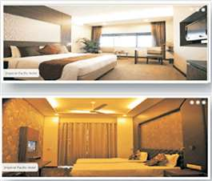

LH

Application For Laparoscopy Training
L
c
WORLD LAPAROSCOPY HOSPITAL
INTERNATIONALLY RECOGNISED BY WORLD ASSOCIATION OF LAPAROSCOPIC SURGEONS (WALS), THE SOCIETY OF AMERICAN GASTROINTESTINAL ENDOSCOPIC SURGEONS (SAGES) AND TGO UNIVERSITY, NEW DELHI, INDIA.

WORLD LAPAROSCOPY HOSPITAL
CYBER CITY, DLF PHASE-II, GURGAON, INDIA
Phone: +91(0)1242351555 Mobile: +91(0)9811416838, 9999677788
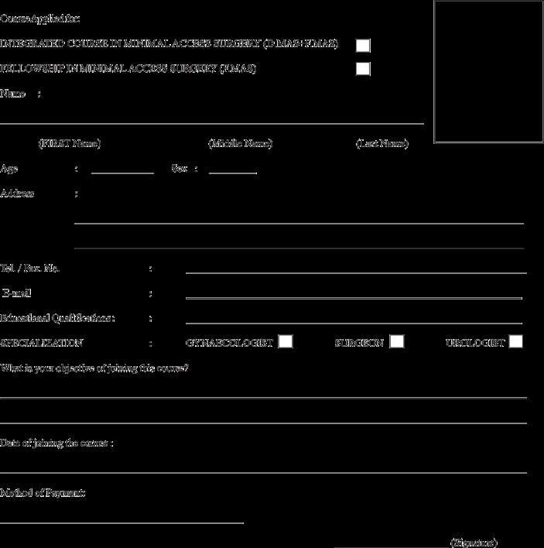

E-mail: contact@laparoscopyhospital.com | Web: www.laparoscopyhospital.com


For more detail please contact:

WORLD LAPAROSCOPY HOSPITAL

Cyber City, DLF Phase II, Gurgaon, NCR Delhi, 122 002, India PHONES: For Training: +91(0) 9811416838, 9999677788
For Treatment: +91(0) 9811912768
For General Enquiry: +91(0)124 - 2351555 Email: contact@laparoscopyhospital.com Web: www.laparoscopyhospital.com

