WORLD LAPAROSCOPY HOSPITAL
Cyberciti, DLF Phase II, NCR Delhi, Gurgaon, 122 002, India
Phone: +91(0)12- 42351555 Mobile: +91(0)9811416838, 9811912768,
Email: contact@laparoscopyhospital.com
Click here for training detail

Open Access Technique for primary trocar

This technique was developed by Hasson in 1974. Open access technique is similar to mini laparotomy and the cannula is introduced inside abdominal cavity with blunt trocar under vision. The absolute certainty of placement of the Veress needle is not possible because it is a blind entry. Many of the laparoscopic injuries that occur do so at the time of veress needle insertion. Failure to achieve an adequate pneumoperitoneum is the most common reason for procedural failure.
Some surgeons are unhappy with the use of the blind technique and there are circumstances where it is inappropriate due to following reason.
  - Definite, small risk of injury with blind technique irrespective of experience
  - Increasing number of surgeons performing laparoscopy without experience
  - Particularly useful in previous abdominal surgery or underlying adhesions
  - Useful in muscular man and children with strong abdominal wall
  - Gynaecologists or surgeon lacking sufficient upper arm strength to elevate the abdominal wall of patient
An open technique, which involves creating a mini laparotomy into which a special cannula is inserted, may be adopted. This procedure is not without its own complications and also requires skilled execution if these are to be avoided.
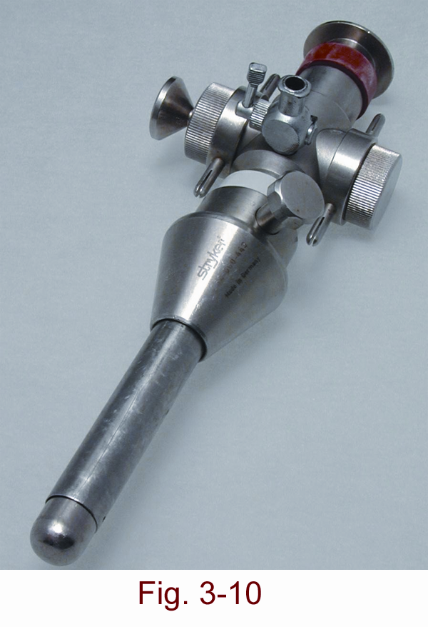
The Hasson trocar system was initially developed for laparoscopy in patients who have had a previous laparotomy. After seeing benefit of open access technique many surgeons started using open access technique routinely in all their patients. An access wound was made using traditional open techniques and the Hasson trocar & canulla was designed to help both fix the port and seal this larger wound round the port. It requires the use of sutures to prevent slippage of port. In Laparoscopy Hospital, we have changed from the Veress needle access technique to what is referred to as the Scandinavian technique. This involved making a small entry wound directly through the scar tissue of the umbilicus and then dilating this up by passage of a blunt, preferable conically tipped trocar and cannula.

Steps of Open Access Technique

A transverse incision is made in the sub umbilical region and the upper skin flap is retracted with a 4 inch Allis forceps. The lower flap is retracted using a small right angled retractor. Subcutaneous tissue is dissected till the linea alba and the rectus sheath is visualized. Stay sutures are taken on either side of the midline.

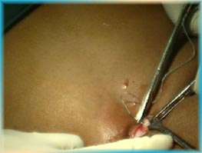

Transverse incision for Open Access
- Stay Suture is given both the end of transverse incision
- Both the stays are pulled up to make a bridge like elevation of rectus.
- Rectus sheath is incised in the midline along the line of linea alba pointing upwards.
- Incision should not penetrate the peritoneum otherwise any adhesion with the peritoneum may be and main purpose of open access technique is lost.
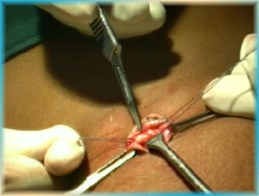
- A haemostat is stabbed into the peritoneum, holding the stays up.
- The give-way of the peritoneum can be felt as peritoneum is perforated and then the haemostat is opened to widen the opening.
- Surgeon should insert his finger to feel all around inside the abdominal cavity to feel any possible adhesion.
- Small tiny adhesion felt can be broken with gentle sweeping movement of finger.
- Blunt trocar-cannula should be inserted for the first port after visualizing the intra-peritoneal viscera.
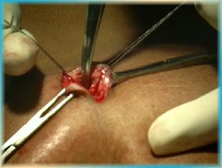
Digging of haemostat to puncture peritoneum
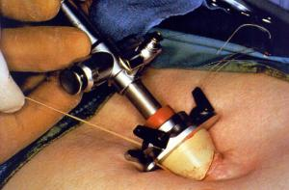
Hasson’s Cannula
- Care is taken not to make a big incision; cannula dilates the smaller incision to give an airtight fit.
- If incision is big a purse string suture should be apply to hold the port in proper position.

The scarred abdomen
Additional precautions are necessary during the access procedure in patients with abdominal scars. It may be inadvisable to insert the Veress needle below the umbilicus in a patient with a scar in this area (or an umbilical hernia). Insufflation through an unscarred such as subcostal region, or if this is scarred, the iliac fossae is better. A general guideline is to choose the quadrant of the abdomen opposite to that of the scar.
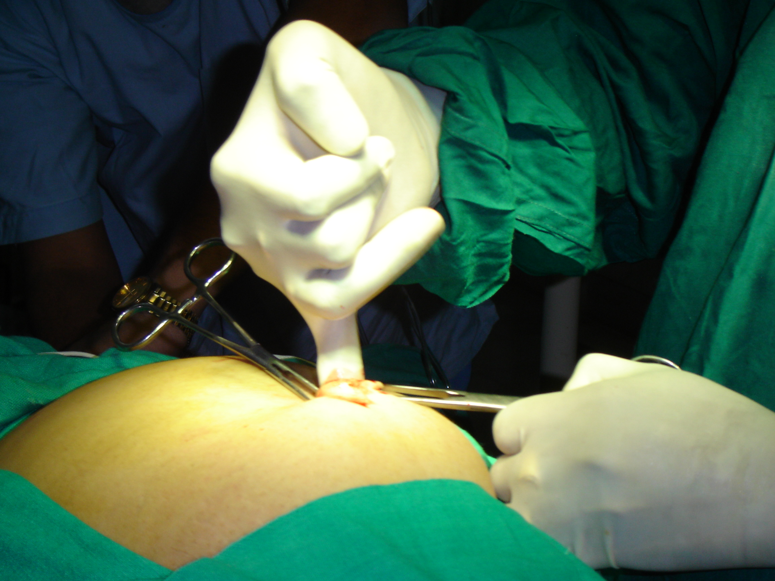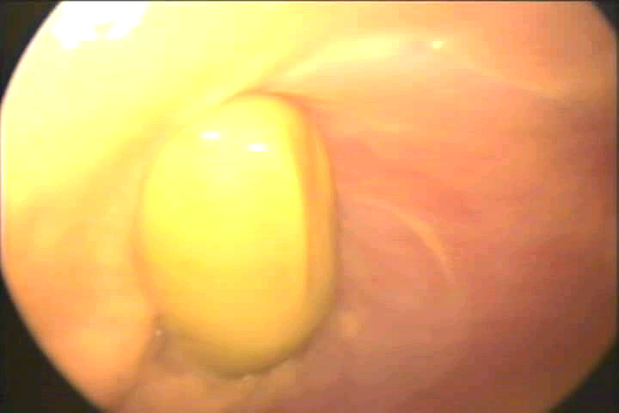
Finger insertion after open access will confirm adhesion

Contraindications of Umbilical Entry

- Previous midline incision
- Portal hypertension with reanalyzed umbilical artery with advanced cirrhosis of the liver
- Umbilical abnormalities viz. Urachal cyst, sinus, hernia
In cases where umbilical entry is contraindicated it is preferred to use left upper quadrate for entry of veress needle.

Pneumoperitoneum in Special Conditions
Diagnostic Laparoscopy may be performed under local anesthesia
  - I/V sedation should be given
  - Veress needle and trocar should be inserted perpendicular to skin
  - Slow insufflation 0.5L/mnt should be administered to prevent pain
  - Pressure should not exceed 8mm of Hg otherwise patient will feel pain
  - N2O is better gas if diagnostic laparoscopy is planned under local anaesthesia because it has a analgesic effect
Obese Patients
- In obese patient incision site should be trans-umbilical (base of umbilicus) for the insertion of veress needle, because it is the thinnest abdominal wall and even in obese patient the amount of fat in trans-umbilical region is less compare to other area of abdominal wall.
- After initial incision fat should be cleared up to anterior rectus.
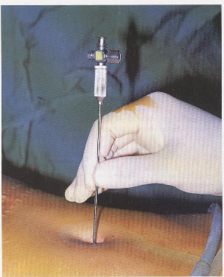
In obese Veress needle should be perpendicular to skin.
- Direction of veress needle entry in obese patient should be perpendicular to abdominal wall and patient should be in supine position not in trendelenburg position.

Entry in cases of morbid obesity
In mobid obese patient in supine position the umbilicus is well below the aortic bifurcation (Hurd 1991). Perpendicular entry of veress needle is necessary. At least 18 mmHg pressure is necessary to left the heavy abdominal wall in case of morbid obese patient.

Ultrasound visceral Slide
There is a simple preoperative test that can help to identify a safe region for Veress needle insertion in the scarred abdomen. The preoperative detection of anterior abdominal wall adhesions by ultrasonic scanning is a simple and reliable technique (Ref .Sigel B, Golub RM, Laurie A et al). and technique of ultrasonic detection and mapping of abdominal wall adhesions.
Once the Veress needle has been inserted, there should still be concern about the risk of causing damage with the trocar. The following techniques have been described for this situation:

Sounding Test
A fine spinal needle, attached to a saline filled syringe, is passed into the inflated abdomen. As the needle is slowly advanced, while aspirating, a stream of bubbles is seen in the saline until the needle tip contacts tissue. The needle is then withdrawn towards the surface and the process repeated several times, in different directions, thereby “mapping” the gas filled cavity and any solid structures.

Visually Guided Entry
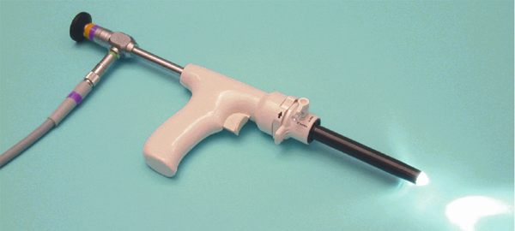
This technique uses cannula and 0 degree telescope to allow direct visualization of the entry tract. Specialist cannula such as Visiport or Optiview uses this principle, first described by Semm.
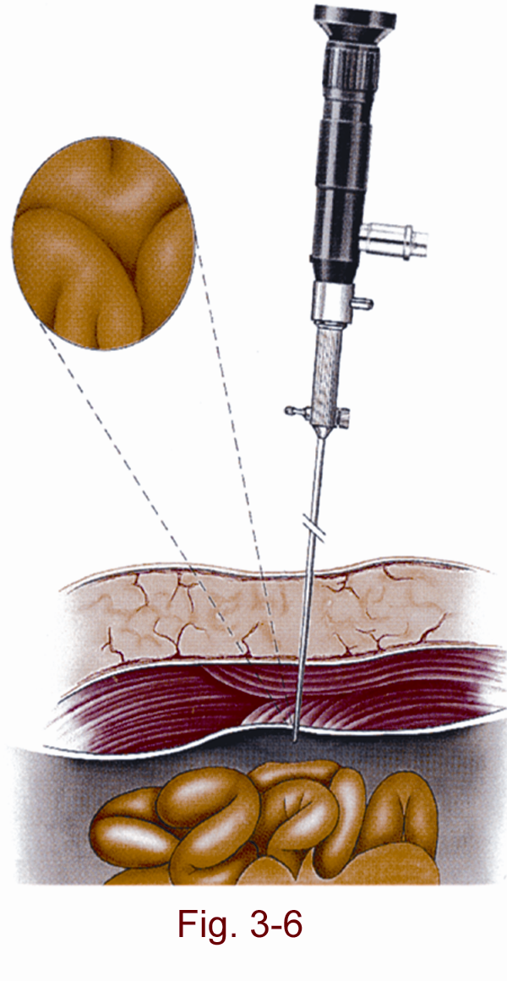
Some veress needle with inbuilt fibreoptic telescope are also used for direct visualization at the time of its introduction but quality of picture is not optimum for very safe access.

Postoperative Chest & Shoulder Pain after laparoscopy

Residual CO2 left inside the abdominal cavity sometime causes considerable discomfort like chest pain & and shoulder tip pain. The cause of this discomfort is that residual CO2 trapped in the sub diaphragmatic recesses and then irritate diaphragm. Irritation of diaphragm causes referred pain in chest & over shoulder tip. This pain is more when patient sits upright. To avoid this entrapment of CO2 it is good practice to put the patient in the trendelenburg position at the time of removing gas at the end of surgery. Only after removing the last telescopic canulla the trendelenburg position of the patient is discontinued.
Some surgeon leave some fluid like ringer lactate inside the abdominal cavity to divert gas away from sub diaphragmatic space but effect of this is controversial.
Subdiaphragmatic gas which remains inside is absorbed completely within 24 to 48 hour after surgery.

Gasless Laparoscopic surgery
Rather than creating pneumoperitoneum mechanical lifting of abdominal wall is possible.
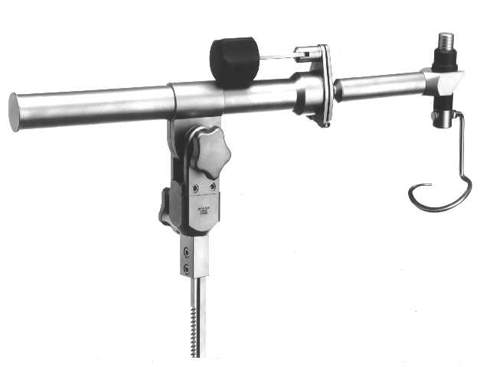
Gasless laparoscopic surgery does not have any added advantage except in the patient of high risk of pneumoperitoneum or sometime when leak of gas can not be stopped due to colptomy in LAVH or sometime in difficult hand assisted laparoscopic surgery with gas leak.
It has following disadvantages.
- Marked guttering effect of lateral abdominal wall result after lifting anterior abdominal wall
- Anterior abdominal adhesion can make instertion of these mechanical devise difficult and visualization almost impossible.
- It is a space occupying instrument which takes all the ergonomically good space of port position
- It only elevate anterior abdominal wall whereas gas creates workable space in whole abdominal cavity
- Sometime causes pressure necrosis of superior or inferior epigastric vessels.
For More Information Contact:
Laparoscopy Hospital
Unit of Shanti Hospital, 8/10 Tilak Nagar, New Delhi, 110018. India.
Phone:
+91(0)11- 25155202
+91(0)9811416838, 9811912768
Email: contact@laparoscopyhospital.com

Copyright © 2001 [Laparoscopyhospital.com]. All rights reserved.
Revised: .

