WORLD LAPAROSCOPY HOSPITAL
Cyberciti, DLF Phase II, NCR Delhi, Gurgaon, 122 002, India
Phone: +91(0)12- 42351555 Mobile: +91(0)9811416838, 9811912768,
Email: contact@laparoscopyhospital.com
Click here for training detail

Laparoscopic repair of inguinal hernia

Introduction
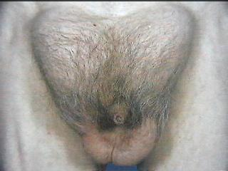

Inguinal hernias result from a hole or defect in the muscles, through which the peritoneum protrudes, forming the sac. Inguinal herniorrhaphy is one of the most common operations that general surgeons perform. Laparoscopic herniorrhaphy is being done at a time when laparoscopic cholecystectomy has shown definite benefits over the open technique. But unlike laparoscopic cholecystectomy, laparoscopic hernia repair is an advanced laparoscopic procedure and has a longer learning curve. In addition, TEP requires higher technical expertise for successful results.

It appears that the laparoscopic approach has several advantages:
  - Tension free repair that reinforces the entire myo-pectoneal orifice.
  - Less tissue dissection and disruption of tissue planes
  - Three ports are adequate for all type of hernias
  - Less pain postoperatively.
  - Low intra-operatively and postoperative complications.
  - Early return to work.
Any method of repair must achieve 2 fundamental goals:
- Removal of the sac from the defect
- Durable closure of the defect.
The ideal method in addition should achieve these with the least invasion, pain or disturbance of normal anatomy. Laparoscopic repair in expert hands is now quite safe and effective, and is an excellent alternative for patients with inguinal hernias. It is more complex and is not widely available. The public needs to be educated as to its advantages. All surgeons agree that for bilateral or recurrent inguinal hernias, laparoscopic repair is unquestionably the method of choice. The argument against its use for unilateral or primary inguinal hernias is unfounded if it is the best for bilateral or recurrent hernias.

Indications of Laparoscopic repair of hernia.

The indications for performing a laparoscopic hernia repair are essentially the same as repairing the hernia conventionally. There are, however, certain situations where laparoscopic hernia repair may offer definite benefit over conventional surgery to the patients. These include:
*Bilateral inguinal hernias
*Recurrent inguinal hernias
In recurrent hernia surgery failure rate is as high as 25 to 30 per cent if again repaired by open surgery. The distorted anatomy after repeated surgery makes it more prone to recurrence and other complication like ischemic orchitis. In recurrent hernia the laparoscopic approach offers repair through the inner healthy tissues with clear anatomical planes and thus, a lower failure rate. In laparoscopic bilateral repair with three ports technique there is simultaneous access to both sides without any additional trocar placement. Even in patients with clinically unilateral defect after entering inside the abdominal cavity there is 20-50 per cent incidence of a contra lateral asymptomatic hernia being found which can be repaired, simultaneously, without any additional morbidity of the patient?

Types of laparoscopic Hernia repair:
Many techniques were used to repair hernia like:
  - Simple closure of the internal rings
  - Plug and patch repair
  - Intraperitoneal onlay mesh repair
  - Transabdominal preperitoneal mesh repair (TAPP)
  - Total extraperitoneal repair (TEP)

Contra-indications of Laparoscopic repair of hernia.
- Non-reducible, Incarcerated Inguinal Hernia
- Prior laparoscopic herniorrhaphy
- Massive Scrotal hernia
- Prior pelvic lymph node resection
- Prior groin irradiation

The technique of transabdominal preperitoneal repair was first described by Arregui in 1991. In the Transabdominal Preperitoneal TAPP repair, the peritoneal cavity is entered, the peritoneum is dissected from the myopectineal orifice, mesh prosthesis is secured, and the peritoneal defect is closed. This technique has been criticized for exposing intra-abdominal organs to potential complications, including small bowel injury and obstruction.
The totally extraperitoneal (TEP) repair maintains peritoneal integrity, theoretically eliminating these risks while allowing direct visualization of the groin anatomy, which is critical for a successful repair. The TEP hernioplasty follows the basic principles of the open preperitoneal giant mesh repair, as first described by Stoppa in 1975 for the repair of bilateral hernias.
Patient selection:
The general anaesthesia and the pneumoperitoneum required as part of the laparoscopic procedure do increase the risk in certain groups of patients. Most surgeons would not recommend laparoscopic hernia repair in those with pre-existing disease conditions. Patients with Cardiac diseases and COPD should not be considered a good candidate for laparoscopy. The laparoscopic hernia repair may also be more difficult in patients who have had previous lower abdominal surgery. The elderly may also be at increased risk for complications with general anaesthesia combined with pneumoperitoneum.
If the patient is young or the hernia small, it does not matter how the hernia is repaired. Many surgeons agree that for bilateral or recurrent inguinal hernias, laparoscopic repair is unquestionably the method of choice.

RECOMMENDATIONS
PATIENT FIT FOR GA
BILATERAL – LS
RECURRENT – LS
UNILATERAL – LS/OS
STRANGULATED – OS

UNFIT FOR GA (SPINAL)
SMALL – LS/OS
LARGE – OS
LOCAL
OS
LS: Laparoscopic surgery
OS: Open Surgery

Trans-abdominal Pre-peritoneal repair of Inguinal Hernia
Port Position for TAPP.
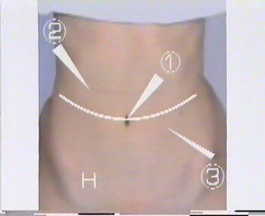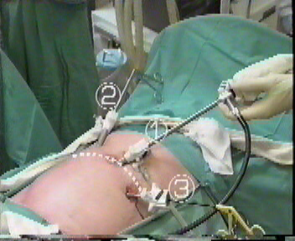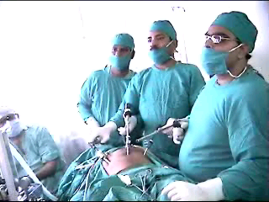
Port position
Trans abdominal Pre Peritoneal
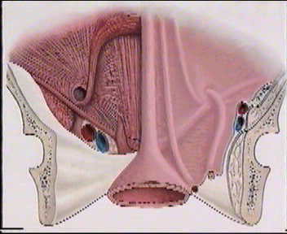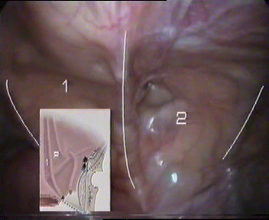
Anatomy
LIGAMENTS:
1. Median Umbilical Ligament-Obliterated Urachus
2 Medial Umbilical Ligament- Obliterated umbilical arteries
3. Lateral Umbilical Ligament- Inferior epigastric vessels.

First identify Medial Umbilical Ligament

Then Identify Lateral Umbilical ligament for Inferior epigastric vessels
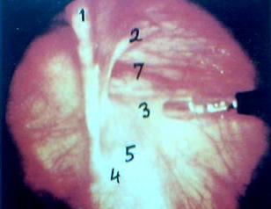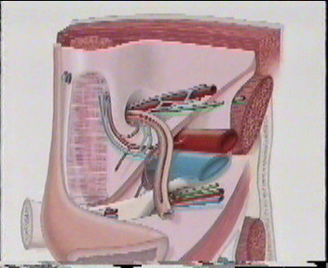
Anatomy
1. Medial umbilical ligament, 2.Inferiar Epigastric vessels, 3.Spermatic vessels, 4.Vas deferens, 5.External iliac vessels in “Triangle of Doom”, 7.Indirect defect,
1
2
7
3
4
5
1. Medial umbilical ligament, 2.Inferiar Epigastric vessels, 3.Spermatic vessels, 4.Vas deferens, 5.External iliac vessels in “Triangle of Doom”, 7.Indirect defect,
1
2
7
3
4
5
Triangle of Doom

Three important dangerous areas where stapling and electrosurgery should be avoided.

TRIANGLE OF DOOM

Iliac Vessels

TRIANGLE OF PAIN

GFN and LFCN

TRAPEZOID OF DISASATER

Abnormal Obturator artery.

Steps of TAPP:
- Preparation of the patient
- Creation of pneumoperitoneum
- Insertion of port
- Diagnostic laparoscopy and Dissection of the pre-peritoneal space.
- Dissection of Cord structures.
- Placement of the Mesh.
- Closure of Peritoneum.
- Ending the operation.
Preparation of patient
  - Receive a general anaesthetic
  - Get Inserted Gastric tube and Foley urinary catheter
  - Position the patient on the table
  - Place the patient in supine position.
  - Position the table as to tilt head 15 degree down.
  - Paint thoroughly the operative area of skin
  - Drape patient such as to expose 2/3 of lower abdomen.

Creation of Pneumoperitoneum.
  - Check Veress needle before insertion.
  - Check veress needle tip spring.
  - Confirm that gas connection is functioning.
  - Ensure flushing with saline does not block that needle.
  - Make a small incision just above the umbilicus.
  - Lift up abdominal wall and gently insert Veress needle till a feeling of giving away
  - Confirm position of needle by saline drop method
  - Connect CO2 tube to needle
  - Switch off gas when desired pneumoperitoneum is created and Remove the Veress needle

Insertion of Port
  - Extend incision on umbilicus.
  - Insert 11mm Trocar and cannula (if using disposable check blade tip is functioning).
  - Point Trocar toward pelvic cavity
  - Lift abdominal wall and insert Trocar and cannula with sustained pressure till reduction in resistance shows that you are inside peritoneal cavity.
  - Remove Trocar, leave the cannula.
  - Connect camera to telescope.
  - Connect light source
  - Do white balance.
  - Insert telescope.
  - Connect CO2 tube to telescopic port.
  - Two Lateral Port are Inserted two figures medially and inferior to each anterior superior Iliac spine.

Dissection of the pre-peritoneal space
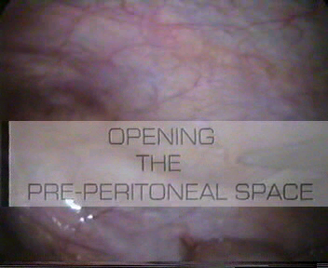
Incision begins just above and 4 cm lateral to the outer margin of the deep ring

Peritoneum incised medially almost up to the midline

Epigastric vessels should be safe guarded
Steps of TAPP
Opening the pre-peritoneal space

Dissection of the pre-peritoneal space
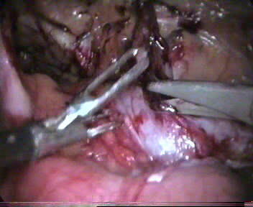
Steps of TAPP
Dissection of pre-peritoneal space
Dissect the peritoneal flap towards the iliac vessels inferiorly and towards anterior abdominal wall superiorly.
Cooper’s ligament, arch of transverses abdominus, conjoint tendon and Iliopubic tract should be seen.
Separate the elements of the spermatic cord from the peritoneal sac.
Dissection should be started with opening the peritoneum lateral to the medial umbilical fold in order to identify Cooper’s ligament. Stopa’s parietalization technique should be used for dissection of the spermatic cord from the peritoneum by separating the elements of the spermatic cord from the peritoneum and peritoneal sac.
The important landmarks of laparoscopic hernia repair are the pubic bone and inferior eipgastric vessels. Surgeon should use both blunt and sharp dissection and the sac is dissected off the anterior abdominal wall. Once the sac is separated the next step is separation of sac from cord structures and dissection for creation of proper lateral space for placement of mesh. Lateral limit of dissection is the antero-superior iliac spine while inferior limit laterally is the psoas muscle. Dissection should be avoided in the "triangle of doom" which is bounded medially by the vas deferens and laterally by the gonadal vessels. The tacker application and application of electrosurgery should be very careful at in the triangle of doom, triangle of pain and trapezoid of disaster. In case of massive complete indirect scrotal hernias, no attempt should be made to reduce the sac completely as it may increases the risk of testicular nerve injury and haematoma formation. Sac if some time not possible to reduce completely after being reduced partially or transected is ligated using an endoloop. In case of bilateral hernias, the procedure is repeated on the other side. A 15 x 15 cm mesh is placed which is fixed medially over the Cooper's ligament and pubic bone using a tacker or anchor. No lateral slit should be made in the mesh and it should not be fixed lateral to cord structures to prevent injury to lateral cutaneous nerve of thigh. The mesh in this position covers the direct, indirect and femoral defects.
Placement of the Mesh
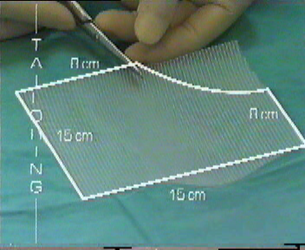
Few surgeon used to cut one corner of mesh.
- Cut the mesh in appropriate Size usually 15X15 Cm and one corner of Mesh should be tailored.
- Roll the mesh and load backward in one of the port.
- Unroll it when it reaches in peritoneal cavity
- Tailored corner of mesh should be positioned infero-medially.
- Fix the mesh by stapling first its middle part three figure above the superior limit of the internal ring.
Criteria for Laparoscopic Mesh
- Non Absorbable,
- Adequate size,
- Adequate memory,
With mesh duly stapled pneumoperitoneum is reduced to 9 mmHg
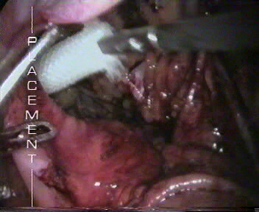
Closure of the Peritoneum
Peritoneum flap is replaced over the mesh and it is closed either by staple or suture.
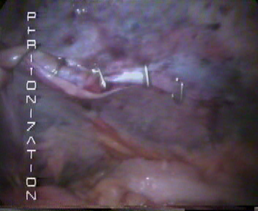
Peritonization
It is Important that mesh should be completely covered by the peritoneum. Ideally peritoneum should be opposed by overlap fashion and peritoneum defect is closed either by staples or by continuous suturing and Aberdeen termination.

Ending of the operation.

At the end of surgery the abdomen should be examined for any possible bowel injury or haemorrhage. All the instrument should be removed and then all the port. Telescope should be removed at last after releasing all the gas keeping in mind that last port should not be pulled without putting telescope or any blunt instrument in to prevent entrapment of bowel or omentum and formation of adhesion or intestinal adhesion. Wound should be closed with suture specially 10mm wound.

Totally Extra-peritoneal hernia repair:
The technique of totally extra-peritoneal repair (TEP) of inguinal hernia was described even before the TAPP technique, however, technical difficulties of working in closed space and anatomy with the limited working space hindered its popular acceptance. The effectiveness of this type of repair has been well established by the open operation of Stoppa.
Task analysis of TEP:
  - Preparation of the patient
  - Approach to preperitoneal space
  - Insertion of ports
  - Dissection of the pre-peritoneal space and cord structures
  - Placement and fixation of the Mesh
  - Ending the operation
Preparation of the patient
Preparation of the patient in totally preperitoneal Hernia repair is same as of the Trans abdominal hernia repair. Knowledge of the anatomy of the abdominal wall muscle and recognition of the transition zone that occur at the arcuate line of Douglas is very important for totally pre-peritoneal hernia repair.
Approach to Preperitoneal space.
In totally extraperitoneal repair of hernia main concern is to make an extraperitoneal space. The extraperitoneal space is made possible by the fact that the peritoneum in suprapubic region can easily be separated from anterior abdominal wall, hereby creating enough space for dissection.
An Incision is made just below the umbilicus and the anterior rectus sheath on the side of the hernia is opened. Two-stay suture on each leaf of rectus sheath is placed and the rectus muscle is retracted by two retractors downward towards symphysis pubis in an oblique fashion, we should never cross the posterior fascia of the rectus muscle while dissecting. By fingered or swab we should perform careful dissection, preperitoneal space will be found below the arcuate line of Douglas.
Insertion of Port
An 11mm port is introduced without its sharp tip with a laparoscope in an angle of about 30 degree. A small pre peritoneal pocket is created by manipulating laparoscope in sweeping manner.
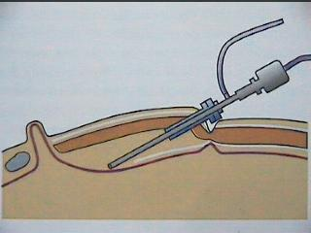
Sweeping movement of telescope
A balloon dissector should be introduced with telescope and balloon is inflated for further dissection of the pre-peritoneal space.

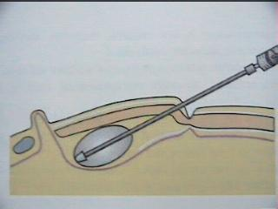
Balloon Dilatation is helpful in TEP
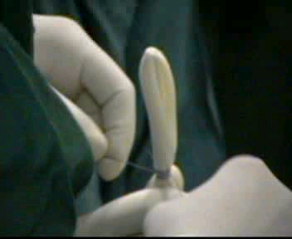
Finger of Gloves can be tied over suction irrigation instrument for making balloon dissector.
Insert two additional ports on one 5mm trocar on the midline at a midway distance between the umbilicus and symphysis pubis and another 10-12 mm Trocar two fingers below and medial to the right anterior iliac spine.
Dissection of preperitoneal space and cord structures in TEP.
I n totally extraperitoneal repair of hernia stopa’s parietalization technique is used for dissection of the spermatic cord from the peritoneum by separating the elements of the spermatic cord from the peritoneum and peritoneal sac should be done. Dissection should be continued until the peritoneum has reached the iliac vessels inferiorly. Mesh in appropriate size usually 15X15 Cm is used. Mesh should be rolled and load backward in one of the port. Mesh should be fixed by stapling first in its middle part three finger above the superior limit of the internal ring. In totally extraperitoneal repair we do not need much staple because peritoneum in not breached and once the gas from pre-peritoneal space is removed it will place the mesh in its proper position.

Ending of the operation:
At the end of surgery the abdomen should be examined for any possible bowel injury or haemorrhage. All the instrument should be removed and then all the port. We generally use vicryl for rectus and un-absorbable intra-dermal or Stapler for skin. Adhesive sterile dressing should be applied over the wound.
For More Information Contact:
Laparoscopy Hospital
Unit of Shanti Hospital, 8/10 Tilak Nagar, New Delhi, 110018. India.
Phone:
+91(0)11- 25155202
+91(0)9811416838, 9811912768
Email: contact@laparoscopyhospital.com

Copyright © 2001 [Laparoscopyhospital.com]. All rights reserved.
Revised: .

