WORLD LAPAROSCOPY HOSPITAL
Cyberciti, DLF Phase II, NCR Delhi, Gurgaon, 122 002, India
Phone: +91(0)12- 42351555 Mobile: +91(0)9811416838, 9811912768,
Email: contact@laparoscopyhospital.com
Click here for training detail

Laparoscopic repair of

Ventral Hernia

Ventral hernia results from a weakness in the musculoaponeurotic layer of the anterior abdominal wall. Many this type of hernia has root of development during the period of development like; omphalocele, gstroschisis and congenital umbilical hernia.
Recently the ventral hernias are reported more due to iotrogenic factor. Even after laparoscopic surgery if the 10 mm ports is not repaired properly there is always a chance of ventral hernia (Incisional hernia) development. Among the non- iotrogenic ventral hernias, diverication of revtus abdominis, umbilical, paraumbilical, spigelian and epigastric are more common. The laparoscopic technique for ventral hernia repair involves the placement of a tension free prosthetic bridge across the musculofacial defect rather than attempting to approximate the edge of defect. The hernia defect is covered by appropriate size of mesh once the content of the sac is reduced. Most of the time sac content is omentum. Some time oment is adhered so tightly that electrosurgical dissection with the help of bipolar is essential. Recently many newer type of mesh is available in which PTFE and polypropylene is more popular. There was always a fear of bowel adhesion and fistulation with use of polypropylene mesh but the clinical evidence of thousands of surgery has suggested that the omental adhesion is expected but bowel adhesion is not common and intraperitoneal placement of polypropylene mesh is quite safe.
Almost all type of ventral hernia can be repaired by minimal access surgical approach. Hernias like multiple defects (Swiss cheese hernias) are greatly benefited by this approach as all defects get directly visualised and appropriately covered by single mesh.
Contraindication of laparoscopic repair of ventral hernia are very large hernia with huge protrusion of skin which is thin enough and skin fold is necessary to correct by abdominoplasty. Dense intra-abdominal adhesions are also a relative contraindication of laparoscopic repair of ventral hernia.

Operative procedure:
Patient should be clearly informed that laparoscopic repairs will not going to help cosmetically if the skin is lax and hanging loosely. Bowel preparation is a good practice to have more room inside the abdominal cavity to handle instrument and tacker in laparoscopic repair of ventral hernia. After anaesthesia nasogastric tube is must to deflate the stomach completely because in most of the cases access should be through left hypochondria. Spleno-hepatomegaly is absolute contraindication of the access through left hypochondrium. Patient is placed in supine position without any tilt of the O.T. table so that bowel is distributed evenly.

Position of surgical team
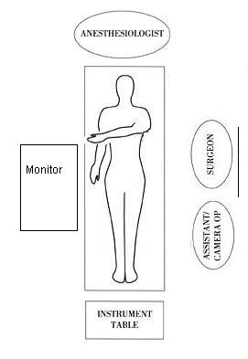
Surgeon stand left to the patient with camera operator on his left or right side depending upon the location of ventral hernia. If ventral hernia is below the umbilicus the camera operator stand right to the patient, and if the defect is above umbilicus camera operator should stand left to the patient. Monitor should be placed opposite to surgeon and instrument trolly should be towards leg of the patient.

Port Position:

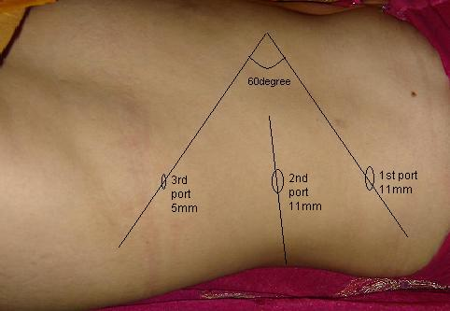

Technique of laparoscopic repair of ventral hernia is quite simple. First pneumoperitoneaum is created at a site away from the defect. Three port techniques are used for laparoscopic repair of ventral hernia. Once the pneumoperitoneum is created all other port is placed according to base ball diamond concept. The most preferred site of access is left hypochondrium in most midline and lower abdominal defect. First access should be through left hypochondria and then two other ports should be made so that proper triangle is formed. The distance between two ports should not be less than 5 cm. The telescope will first enter through left hypochondriac port but once dissection starts the telescope will come in the middle, so that the angle between two working port will become 60 degree. 10 mm 30 degree telescope is better to view anterior abdominal wall.
All content of the sac is reduced and any adhesion if present is cleared. Appropriate size of mesh is then inserted. The selection of size of mesh is important to prevent recurrence of hernia and it should be sufficiently big so that approximately 4cm healthy margin of defect of hernia should be covered all around. The mesh is fixed along margins and around the ring of defect of rectus to ensure a close approximation of mesh to abdominal wall. Care should be taken that mesh should not be corrugated and it should be in nice contact with anterior abdominal wall. Loosely held mesh hanging through the anterior abdominal wall will definitely increase the chance of adhesion with bowel. Tacker should be used to fix the mesh in position. Recently a technique of using proline suture to fix the mesh with anterior abdominal wall is used with the help of suture passer or looping technique with the help of veress needles canulla. The main idea of this method is to reduce the cost of surgery, but there is increased chance of infection and adhesion with this method. We also lack any long term randomized controlled trial to prove the outcome of this external suture technique to fix the mesh in ventral hernia repair.
For More Information Contact:
Laparoscopy Hospital
Unit of Shanti Hospital, 8/10 Tilak Nagar, New Delhi, 110018. India.
Phone:
+91(0)11- 25155202
+91(0)9811416838, 9811912768
Email: contact@laparoscopyhospital.com

Copyright © 2001 [Laparoscopyhospital.com]. All rights reserved.
Revised: .

