WORLD LAPAROSCOPY HOSPITAL
Cyberciti, DLF Phase II, NCR Delhi, Gurgaon, 122 002, India
Phone: +91(0)12- 42351555 Mobile: +91(0)9811416838, 9811912768,
Email: contact@laparoscopyhospital.com
Click here for training detail

Laparoscopic internal suturing
The technique for suturing needs to be modified depending on the instrumentation in use. A lot of work is currently being carried out on designs for new needle holders and automatic suturing. We present a straightforward technique that can be used with simple instruments.

Instrumentation

The needle
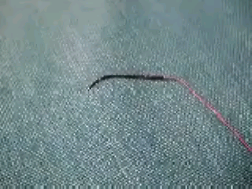
Endoski needle
Although conventional open surgical needles (half circle) can be used endoscopically, the endoski needle developed in Dundee is designed specifically for endoscopic use and is a hybrid of the straight and half circle needle. It carries an atraumatic suture and has a straight shaft and a terminal tapering curve (that corresponds to ¼ of a circle), giving it the shape of a miniature ski. The shaft is a modified rectangle, which becomes more and more rounded towards the tip so that the curved portion of the needle is round bodied. This combination allows for an easier grip of the shaft by the jaws of the needle holder and smooth passage of the curved portion of the needle through the tissues.

Needle Holders
In Laparoscopy Hospital we use two 5 mm Cuschieri needle holders. These have single action tapered jaws. The handles are spring loaded and the most recent versions have diamond coating for gripping the suture material without damage. A relaxed ‘open hand” grip is strongly recommended for these instruments. Please note that there are a wide variety of needle holders (or drivers). In practice, it is vital for each surgeon to become accustomed to a particular type and use that pair all the time, This is crucial for efficient and safe suturing,

Needle Control

Introduction into the body cavity
We recommend the use of the introducer tube to protect all ligatures and sutures from the cannula valve mechanisms.
The suture material on the endoski needle is trimmed to a suitable length. For a continuous suture this will be approximately 15 to 20cm.

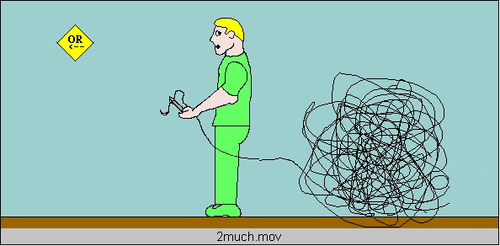

The suture length must never exceed 20cm as this will result in very difficult intra-corporeal suturing since the length is magnified (2.5 times) by the imaging system.
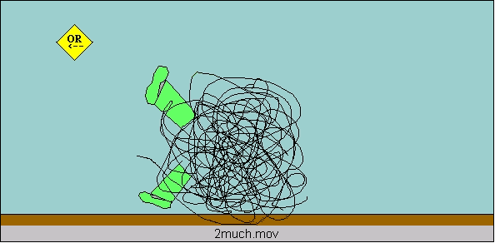
The needle holder is first passed through an introducer tube. The tail of the suture is held next to the tip of the needle and the suture picked up by the needle holder at its mid point. It is then withdrawn into the introducer tube until neither the needle nor the tail is visible. The introducer tube can then be passed through a port and the needle extruded from the tube. The suture is watched into the abdomen and placed on a convenient surface e.g. the flat, smooth anterior surface of the stomach.

To insert the needle
- Pass the needle holder through the reducing tube.
- Pick up the suture material with the needle holder at a point mid way from the tip of the needle and the tail of the thread.
- Withdraw the suture and needle inside the tube so that it is completely out of sight.
- Insert the tube through an appropriate port.
- Extrude the needle and suture from the tube by advancing the needle holder and position on a safe surface e.g. the anterior surface of the stomach.

Manipulation
- A trailing needle is a safe needle
- A held needle should always be in view.
- Tips of the two needle holders must always be in view
- Two needle holders must never cross each other by move parallel to each other from one side to the other.
The ability to maneuver the needle into the desired position in the needle holder jaw is one of the first skills you must acquire. It is well worth practicing the techniques for this as it will make all subsequent tasks much easier. This task causes much frustration until it can be achieved at will.
The first step is to arrange the needle to the required orientation on the tissues (preferably on a serosal surface and not fatty tissue). Recommended techniques to get the needle in the right attitude on the tissues include the “nudge”, the “push”, and the twist” techniques! This maneuver should be better demonstrated for learning.

Position
The needle must next be positioned correctly in the jaws of the needle holder. Ideally the needle is grasped in the right orientation by the tips of the jaws. It is a mistake to grasp the needle by the back of the jaws as this impairs precision needle driving through the tissues and also reduces the grasping force so that needle swivel is more likely.
For a right handed surgeon in a straight forward situation the needle is held in the right hand needle (RH) holder with the tip pointing to the left. The tip of the needle points upward and the shaft of the needle should make an obtuse angle with the shaft of the holder.
The key elements in achieving this are
- • The needle position on the tissues
- • The angle of approach of the holder
- • The pick up actions
Adjustments to the angle can be made using
- • Other needle holder
- • Surrounding tissue
- • Tensioned suture material

Passage through the tissues
Position the needle appropriately in the needle holder and identify the position of the first entry point. Place the tip of the needle at this position so that the sharp tip enters the tissue at right angles.
When approximately 1/2 of the curve of the needle has entered the tissue (corresponding to 2.0mm) the wrist is supinated and lifted slightly to passage the curved section of the needle through the tissues. When the point of the needle is seen to emerge at the exit point, the grasp is maintained and the needle end (not tip) is grasped by the other (assisting) needle holder before it is released by the dominant needle holder. For the second bite (in other tissue edge) the dominant needle holder can retrieve the needle directly from the assisting needle holder provided the needle is in a favorable position for direct transfer. Other wise it is more ergonomic to drop the needle and pick it up by the dominant holder. Once the two edges have been passaged, the needle is dropped and the suture pulled to the desired point by an instrument to instrument technique through the tissues. A trailing needle can do much less harm than one that is held rigid in the holder. A grasped needle must always be in view.

Tensioning
A continuous suture is initially tensioned by pulling through the suture material. Further tightening can be achieved by use of the dominant needle holder although one must be careful not to fray or damage the suture. The jaws are opened and placed on either side of the suture as it exits from the tissues but kept open. They can then be used to apply counter pressure on the tissues as the suture is pulled tight by the assisting needle driver. Tension in a suture line is then maintained by occasional locking sutures and the appropriate use of an assistant. In clinical practice tension on the suture line is kept by the assistant using a special suture holder that does not damage the suture. This has rounded jaws.

Microsurgical tying
This is a precise, choreographed set of actions. Each maneuver is designed to help make the whole process smooth and reproducible with economy of movement and structured choreography, so that suturing is efficient with minimum of wasted time. Note the following important points.
- The Passive and Active role of the holders
- The formation of the initial “C’
- Its relation to the tail of the suture
- The conscious assessment of position
- The use of the natural bias of the thread
- Appropriate rotations of the needle active and passive needle holder that must be manipulated in consort
- Note the importance of keeping the ends of the two needle holders in the operative field
- Note the importance of two-handedness for efficient suturing

Steps of Surgeons Knot
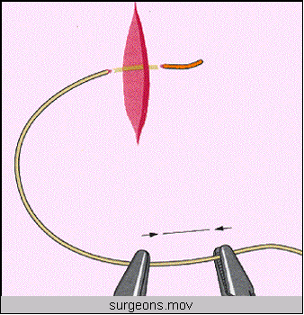
A “C” loop is made
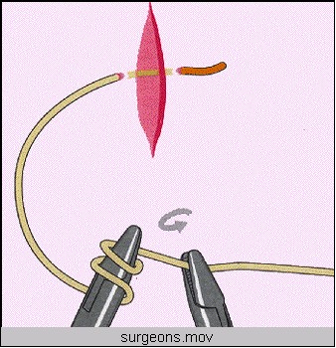
The instrument of the side of “C” should be kept above the “C” and two winds are taken with the help of right instrument.
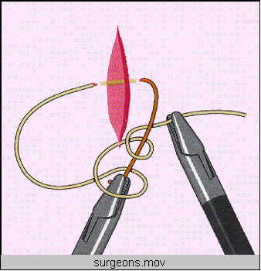
Winds are slipped in the line of left instrument
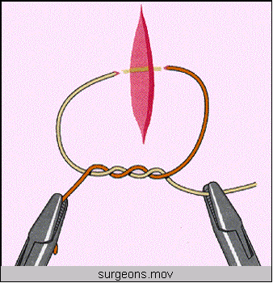
Knot is tightened with the help of both the instruments
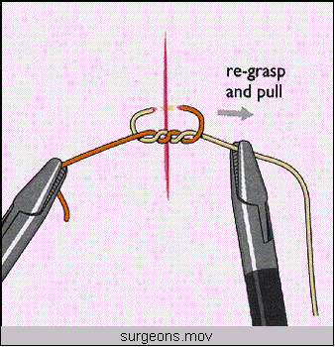
First knot of surgeons knot is complete
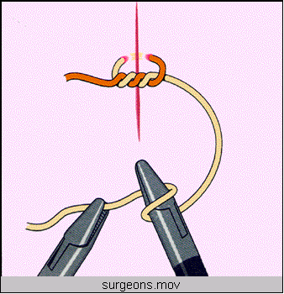
A reverse “C” is made and single wind is taken over the right instrument with the help of left instrument.
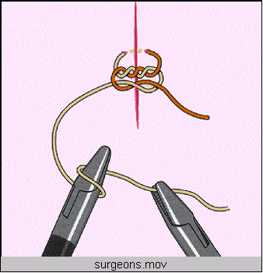
Again “C” loop is made and single winds are taken to complete surgeons knot.
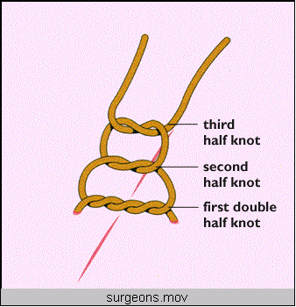
Surgeons knot contains double wrap on the first throw, followed by two opposing, alternating single throws.

Tumble Square knot:

This is a simple square knot which can be changed to slipping configuration by tightening of a same side of thread.
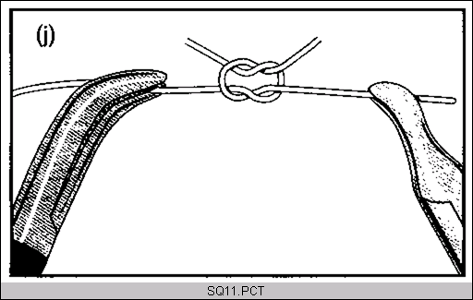
A square knot is tied
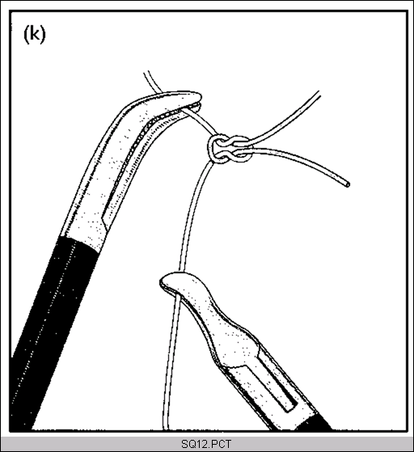
Same side of thread should be straightened with the help of two Maryland or needle holders.
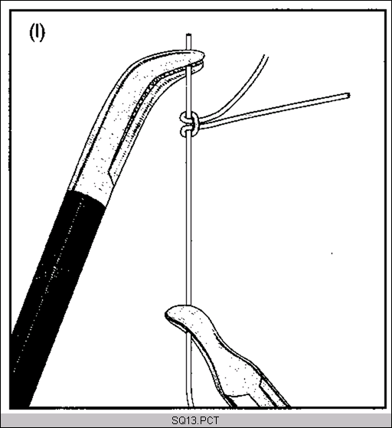
After straightening of same side of thread it is ready to slide

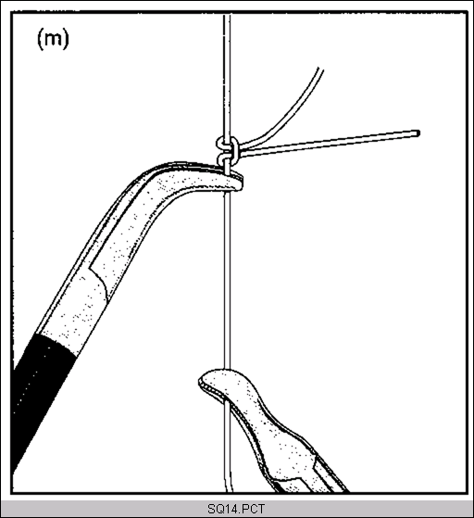
Closed jaw of Maryland forceps will slide the knot
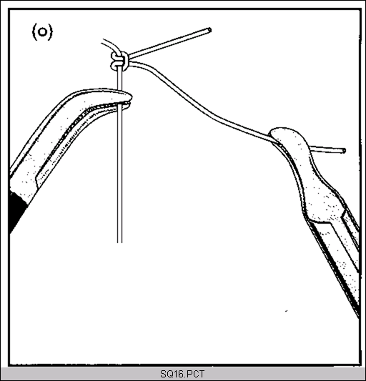
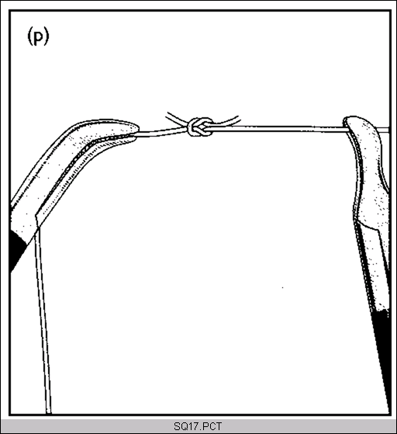

After tightening, the knot is locked again by pulling both the thread
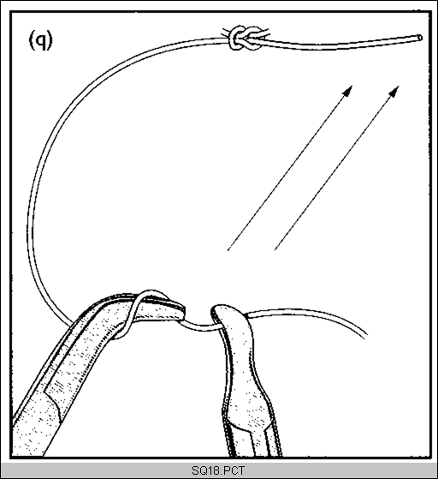
One more knot is tied to prevent slipping of tumble square knot.

Continuous suturing
It has been our practice to start a continuous suture with a Dundee Jamming Slip knot. An equally acceptable alternative is an internal tied knot if the surgeon is proficient.
A continuous suture can be finished in a number of ways. We recommend the Aberdeen termination, an internal tie to a convenient tail or a slipping loop tied to itself.

Dundee Jamming slip knot
This is a recommended way of starting a continuous suture. This knot has an external component but is completed, once inside the body cavity, after the first bites of tissue have been taken.
The external component has three steps
- • A simple slipping loop
- • Passage of the tail through the first loop,
- • Creating a second loop
- • Tensioning of the second loop
The second loop should slip only from the tail, the knot should not be tightened at this stage and the length of both the loop and of the tail should be at least 1 cm.
Once inside the knot is locked by passage of the standing part of the suture through the loop, which is then slipped to lock the knot.

Applications
Any continuous suture e.g. closure of viscerotomies following stapled anastomosis, sutured anastomosis such as cholecystojejunostomy, gastrojejunostomy etc. It can also be used as an interrupted suture when additional one or two hitches are advised for security (in our practice an internally tied knot would be used in preference for an interrupted suture).

Aberdeen termination
This is an adaptation of a termination commonly used in abdominal closure following open surgery. The continuous suture is finished by the formation of three interlocking loops. In order to simplify the maintenance of tension in the suture line the penultimate stitch can be locked. A further bite is then taken and the suture pulled through, though not completely. A small loop of suture is left, enough that the needle holder can be passed through it to pick up the standing part of the suture. A loop of this is then drawn through the first loop, which is tightened down onto the tissues. The needle holder is then passed through the new loop to repeat the maneuver three times.
It is important that each loop be tightened as you proceed. To do this, tension must be applied to the leg of the loop, which exits, from the tissues or the preceding loop.
The standing part and needle are delivered completely through the last loop. The standing part is held up and the suture tensioned with counter pressure from the jaws of the needle holder placed on either side of the suture. The suture is cut off leaving a reasonable length (approximately 1 cm).

Interrupted sutures

Interrupted Knots
Dundee Jamming Loop knot is used to create interrupted sutures. For additional safety a further hitch or two are recommended if it is to be used as an interrupted suture. More commonly interrupted intracorporeal sutures are made by the use of the Surgeon’s or the Tumbled Square knots.

Applications of Interrupted Sutures
Interrupted sutures have a multitude of uses. Simple examples are closure of the common bile duct after exploration and Fundoplication.

Stapled anastomosis
The use of disposable stapling guns has simplified a number of endoscopic procedures such as the division of vascular pedicles and gut anastomosis.
The equipment we use in Laparoscopy Hospital is that made by Tyco. There are other manufacturers. The Tyco staplers are of the following types:
• Circular Different sizes
• Linear cutting Different stapling lengths and staple sizes, re-loadable cartridges with different staple size
• Linear non-cutting
• Deflecting cutting Roticulator
The equipment will be demonstrated and the technique for a side to side anastomosis outlined. The following important points are emphasized:
- Port positions for stapling
- Stay sutures for tensioning
- Enterotomy positioning and size
- Positioning and angulations of the instrument prior to closure
- Checking suture line
- Complete closure of residual opening
End to end anastomosis can also be carried out by stapling closed bowel ends side by side.

Clinical Applications
An anterior or posterior, side to side anastomosis of stomach and jejunum done laparoscopically can be a satisfactory palliative procedure and is just one example of the use of this technique. Likewise a laparoscopic cholecystojejunostomy may to relieve jaundice and itching in patients with inoperable pancreatic cancer may be performed by stapling.

Sutured anastomosis
Sutured anastomosis can be carried out endoscopically, although the process is demanding in terms of skill and time. We use this as a task to allow you to assess the progress that you have made over the week and hopefully to give you confidence in your new abilities. However it is pertinent to note that staplers may not always be available, or appropriate, and even if a stapler is used, you require the skills to perform a sutured closure if the stapled anastomosis is not perfect.
Important points to remember are:
- • Port positioning
- • Use of and communications with your assistant
- • Positioning of sutures, especially at the corners
- • Spacing the sutures (remember the magnification)
- • Tensioning of sutures

Direction of suturing
It is important that you suture at the right height, ideally your elbows should be held adducted and at right angles. Keep you wrists loose and remember that you have two hands that must manipulate to help each other. The choreography is as follows:

- The suturing line is started with a ‘starter knot’ (surgeons or tumbled square knot).
- The two needle holders must be kept in view and used in concert with each other.
- Passage from right to left through the tissue edges (bites consisting of entry an exit points) with dominant needle holder.
- The needle is picked up from the exit point by the passive needle holder (NH).
- It is transferred to dominant needle holder for the next bite if the orientation is correct. Otherwise it is dropped and re-orientated in the needle holder. Once the suture has passed through the two edges, the thread is pulled trough, handing the suture one needle holder to the other.
- The distance between the suture bites must be approximately equal to the depth of the bites.
For More Information Contact:
Laparoscopy Hospital
Unit of Shanti Hospital, 8/10 Tilak Nagar, New Delhi, 110018. India.
Phone:
+91(0)11- 25155202
+91(0)9811416838, 9811912768
Email: contact@laparoscopyhospital.com

Copyright © 2001 [Laparoscopyhospital.com]. All rights reserved.
Revised: .

