WORLD LAPAROSCOPY HOSPITAL
Cyberciti, DLF Phase II, NCR Delhi, Gurgaon, 122 002, India
Phone: +91(0)12- 42351555 Mobile: +91(0)9811416838, 9811912768,
Email: contact@laparoscopyhospital.com
Click here for training detail

Laparoscopic dissection techniques

Dissection is defined as the separation of tissues with haemostasis. It consists of a sensory (visual and tactile elements) component and an access component involving tissue manipulation and instrument maneuverability. These are combined to achieve exposure i.e. developing a suitable space for seeing and handling target structures/

Precision and meticulous haemostasis is essential requirements in minimal access surgery. Endoscopic dissection, in contrast to dissection in conventional surgery, possesses several limitations. Three- dimensional direct vision is replaced by two dimensional indirect visions in laparoscopic surgery. Illumination and the video image quality are still limited despite recent advances in video systems such as digitization and 3-chip endocamera. Movement of the functional tip of laparoscopic instruments is restricted along with the kinematics response. The loss of tactile sensation in endoscopic surgery is yet another limiting factor

A variety of mechanisms have been used to divide tissue and enable haemostasis. They all involve some form of physical energy being applied to the appropriate tissue. The amount of energy required for dissection depends on the type and constituency of the tissue. The properties of tissues may vary in different directions and for different disease states. This in totality influences the choice of the modality for dissection.

The ideal dissection technique requires a modality that can accomplish meticulous haemostasis and will be tissue selective without causing inadvertent tissue damage. It must be safe for both patient and surgical team when in regular use and when inactive in storage. In this respect built-in safety measures are mandatory. An ideal dissecting modality should be efficient in both power delivery and in space requirement. The modality must be cost- effective. The initial expenditure needed to acquire and set- up the necessary equipment must be taken into account along with subsequent operational and maintenance costs.

In reality there is no single “ideal “dissecting modality for an entire procedure. In actual practice a combination of energy forms is applied with selection of the most appropriate one at each particular phase of the operation. This brief review examines the advantages, disadvantages and limitations of the various available modalities. It also addresses the issue of choice of the most suitable (ideal) modality that satisfies as near as possible the above outline criteria.

This requires extreme caution due to the relatively large portion of the instrument which is live. The use of electrical current will lead to coagulum formation, and arcing and ionization will quickly blunt the blades. It is advisable to restrict the use of diathermy to disposable single use scissors.

Endoscopic dissection and manipulation of tissue within a confined space requires a two handed approach: one assisting and one dissecting. A passive assisting instrument (usually a grasper) provides counter traction and exposure for the active dissecting instrument. The active instrument may be non-energized (e.g. scissors and scalpel) or energized with electricity (diathermy), ultrasound or light energy

The available modalities for dissection in minimal access surgery include:
- Blunt dissection
- Sharp scalpel and scissors dissection
- High frequency radio wave electrosurgery
- Radio frequency ablation
- Ultrasonic dissection
- High velocity and high pressure water -jet dissection
- Laser surgery (light)

Each of these dissection techniques has advantages and limitations.

Blunt dissection
Pledget
Instrument

Electrosurgery
Most convenient way of dissection in Minimal Access Surgery combined with most risky method of dissection
Most of the complication in Laparoscopic surgery is due to use of energised instrument (1-2%)

Sharp dissection
Knife
Scissors

Blunt Dissection
Instrument used
- Closed scissors tips used as blunt dissector
- Scissor points used to separate by spreading
- Grasper, straight and curved
- Inactive suction cannula
- Heel of inactive electro surgery hook or Berci spatula
- Pledget
Methods
  - Distraction
  - Separation
  - Teasing
  - Wiping
Sharp scalpel and scissors dissection

Sharp scalpel is used mainly for division by cutting. Although inexpensive (mechanical energy provided by surgeon) it is seldom used in laparoscopic surgery. The lack of haemostasis, the potential of injury from the tip when inserting through the port and the kinematics problems restricts its use to common bile duct division.

Scissors dissection
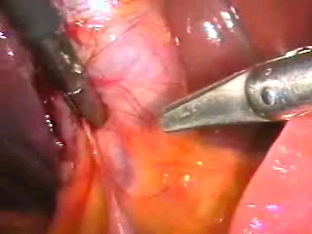
Scissor dissection

It is one of the most frequent methods in laparoscopic surgery. It offers the benefits of being cheap safe and precise operator determined action. However, been non-haemostasis renders it far from ideal as a dissecting modality.

Blunt dissection

The pledget swab is particularly useful for blunt dissection in Calot’s triangle during cholecystectomy. It is economical, simple to use and maintains a dry operative field while performing dissection. This type of dissecting modality is also utilized in haemostatically separating the rectum from the sacral attachment.

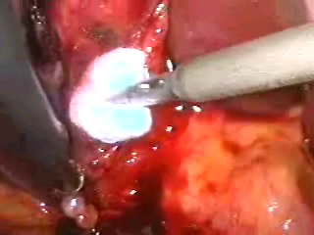
Pledget dissection
Endoscopic pledget dissection was first introduced in Dundee in 1987. A special endoscopic pledget or peanut swab 5.0mm ratcheted holder, manufactured by Storz (with strong jaws and inward facing tongs at the end of the jaws for security), is used in a manner similar to that employed in open surgery. The holder grasping the pledget is introduced inside a reducer tube through an 11.0mm cannula. The blunt dissection is safe and is used to open planes and expose structures especially when the anatomy is obscured by adhesions. The movement consists of forward and backward wipes accompanied by clockwise/ counterclockwise rotation of the pledget swab, it is also useful for controlled a small bleeder by compressions before this is secured by clipping or electro coagulation.
Removal must be carried out under vision to ensure that the swab is inside the reducer tube before withdrawal of the instrument, otherwise there is a real risk of losing the small pledget swab in the peritoneal cavity.
The pledget is an invaluable tool for the rapid dissection of loose areolar planes when it is wiped or pushed against the line of cleavage to separate the tissues.

In addition the pledget may be useful in maneuvers to control minor haemorrhage. The pledget can be placed over the bleeding point to apply pressure. When used on an oozing operative field it adsorbs some of the blood and may clarify the anatomical position.
It is important to have a routine to minimize loss of the peanut swab inside the abdomen:
- always use a reducer tube to insert and remove the swab
- Employ a fail safe system (ratchet and elastic band) to maintain the grip of instrument used for insertion.
- Keep the pledget in view from insertion to retraction into the introducer tube. Be sure it is retrieved into the introducer, not the cannular end.
In MAS if you can’t see, STOP!
Tissue stripping and tissue distraction are other safe and effective forms of blunt dissection. The later is applied for seromyotomy. Insignificant haemostatic capability is the main disadvantage of blunt dissection.
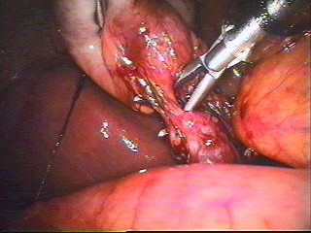
Tissue stripping and distraction

Electrosurgical Dissection

There are two basic principles of electricity:
- Electrical current flows to ground and
- It follows the path of least resistance.

Monopolar electrosurgery creates a complete electrical circuit from the active electrode, to the target tissue, to the dispersive return electrode, and back to the generator. Because surgeons now work through keyhole incisions and manipulate electrodes and instruments through long, narrow channels, it is more difficult than ever to prevent the electricity from traveling outside this path and burning or vaporizing non-targeted tissue.

High Frequency (HF) Electrosurgical dissection
HF electrosurgery is the application of HF currents (in the frequency range of 300 kHz up to several MHz) to coagulate, fulgurate, spray coagulates or ablates tissue. Knowledge of how this and other physical modes interact with biological materials is becoming increasingly important to the surgeon for safe and consistent surgery.

HF monopolar electrosurgery
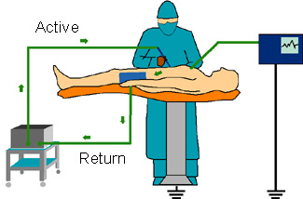
The circuit is composed of the generator, active electrode, patient, and patient return electrode.
The patient's tissue provides the resistance, producing heat.
Monopolar diathermy is used in endoscopic surgery for coagulation and for dissection (cutting). During monopolar diathermy current is conducted from the instrument through the tissues to a skin pad (neutral electrode) connected back to the generator. Heating occurs at sites of small cross section and low electrical conductivity. The instruments contact with the tissue has a small cross sectional area and the tissue is of relatively low conductivity (higher resistance or impedance) compared to the instrument material. A high current density occurs in the tissue in immediate contact with the instrument and heat is generated.
The effect of HF current on the tissues depends on:

- Temperature generated
- Shape and dimensions of the contact point (broader damage with broader contact)
- Time of activation (short bursts reduce depth and charring)
- Distance from the electrode
- Conductivity of the tissue (bleeding results in a change in conductivity)
- Power output from the generator (voltage)
- Amplitude and current wave form - time curve of the signal (cutting or coagulating settings)

Bipolar diathermy
A bipolar system is inherently safer as the interaction is restricted to the immediate vicinity of contact and the current does not pass through the patient but instead returns to the generator via the receiving pole after passage through the grasped tissue.
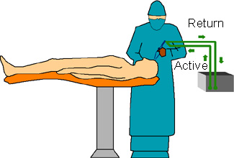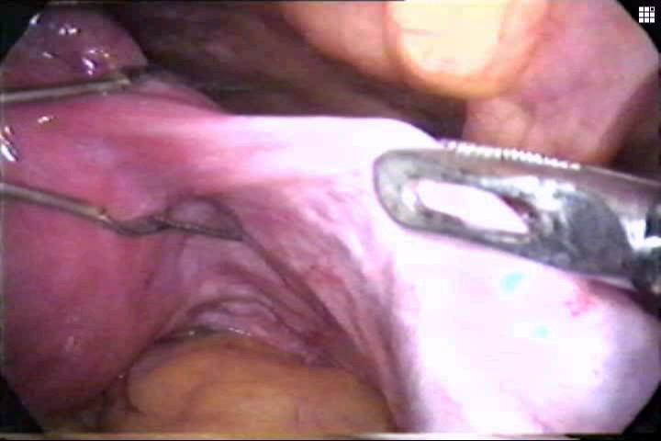
Bipolar Electrosurgery

Active output and patient return functions are both are at the site of surgery.
Current path is confined to tissue grasped between forceps.
Return electrode should not be applied for bipolar procedures.
Bipolar probes are now available for coagulation as well as for cutting. The cutting system is not strictly bipolar and is hence referred to as quasi-bipolar electrocuting.

Use of the diathermy hook
These are generally L or open C shaped, blunt ended rods mounted on an insulated handle. The active, non-insulated part is limited in size. The hook is a delicate instrument and should be protected during insertion by manual opening of the cannula valve or use of a reducing tube. As electrosurgery generates smoke (which is harmful), many handles of electrosurgical hooks have a suction attachment at the other end of the handle.

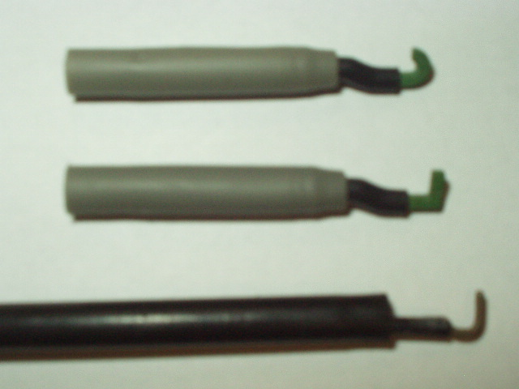
Electrosurgical hooks
Electrosurgical instruments like the hook are useful as blunt dissectors prior to activation. They are used to isolate the tissue to be divided by the current. The tip is passed into or under a layer of the tissue being dissected, which is then hooked and tented up (to increase its impedance and thus limit the spread of current when applied). Small portions of tissue are tackled so that an assessment of the tissue caught on the hook can be made before coagulation or cutting current is applied to the instrument. The hook can be used to clear unwanted tissue beside linear structures by passing the hook into the tissues parallel to the structure, and then rotating it to hook up strands of unwanted tissue. The tissue to be divided is held away from underlying tissue to prevent inadvertent damage. Short bursts of coagulating current can be followed by the use of cutting current, if the tissue has not already separated.
The use of the hook can be summarized as
“HOOK, LOOK, COOK”.
The hook or the spatula may also be used to mark out and coagulate a line for division. The heel of the hook is used with the HF current set to soft coagulation. Short bursts are applied and the hook moved along to create a “dotted” line of coagulated tissue. Where deeper penetration is desired the point of the hook maybe appropriate, a second pass being performed to hook up the intervening bridges. This type of contact is best reserved for situation where no significant damage can be caused by current penetration.
Monopolar electrosurgery has become the most widely used cutting and coagulating technique in minimal access surgery. It has proven to be versatile, cost effective and demonstrated superior efficacy for coagulation. By varying the voltage, current or waveform tissue can be cut cleanly (“pure cut”), coagulated to achieve haemostasis (“coag mode”) or a “blend cut” that combines these two functions can also be produced. Finally, a dispersed coagulation mode known as fulguration, allows coagulation of diffuse bleeding.

However, monopolar laparoscopic electrosurgery can comprise patient safety under certain circumstances. Thermal injury to non-targeted internal organs may occur firstly as a result of imprecise mechanical operation of a laparoscopic instrument and secondly through diversion of electrical current to other paths. These stray current may be released either through insulation failure, direct coupling or capacitive coupling. Other problems encountered include effect on pacemakers; return electrode burns, toxic smoke, charring of instruments and minimal control of energy delivery.

Bipolar electrodes design although virtually eliminating complication from insulation failure, capacitive coupling and direct coupling has several distinct disadvantages.

The primary electro thermal tissue effect is limited to desiccation, not cutting. It requires slightly more time than monopolar coagulation because of lower power settings and bipolar generator output characteristics.

It is not an effective method of making a “pure cut”.

Haemostasis over a large area is not possible.

Grasping dense tissue between both the active and return electrodes is difficult.

Argon Beamer Coagulator

The argon beamer is used in conjunction with monopolar electrosurgery to produce fulguration or superficial coagulation. Less smoke is produced because there is lesser depth of tissue damage.
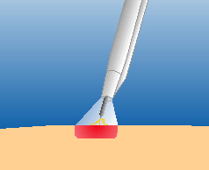
Argon beamer

Despite these advantages, the argon beamer suffers from a very significant drawback in laparoscopic surgery, namely, increased intra-abdominal pressure to potentially dangerous levels due to high-flow infusion of argon gas.

Ultrasonic dissection

Ultrasonic dissectors are of two types: low power which cleaves water containing tissues by cavitations leaving organized structures with low water content intact, e.g. blood vessels, bile ducts etc.; and high power systems which cleave loose areolar tissues by frictional heating and thus cut and coagulate the edges at the same time. Thus low power systems are used for liver surgery (Cusa, Selector) and do not coagulate vessels. High power systems (Autosonix, Ultracision) are used extensively especially in Fundoplication and laparoscopic colon surgery. It is important to remember that high power ultrasonic dissection systems may cause collateral damage by excessive heating and this is well documented in clinical practice.
Ultrasonic surgical dissection allows coagulation and cutting with less instrument traffic (reduction in operating time), less smoke and no electrical current.
- Mechanical energy at 55,500 vibrations / sec.
- Disrupts hydrogen bonds and forms a Coagulum
- Temperature by Harmonic Scalpel - 80 - 100 ° C
- Temperature through Electro coagulation - 200 - 300 ° C
- âCollateral damage, â tissue necrosis
The ultrasonic shears (harmonic scalpel) is ideal for dividing and simultaneously sealing small and medium vessels by tamponade and heat. However, larger vessels, greater than 2mm in diameter, need additional measures (clips, tie or staple) to control bleeding. Other disadvantages of the harmonic scalpel include lack of tissue selectivity and relatively expensive. Ultrasonic dissecting applicators are also designed in hook, spatula or ball coagulator shapes.
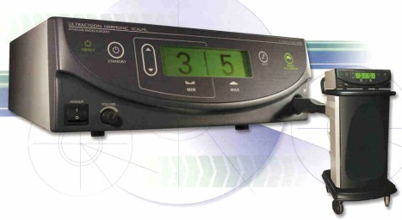
Harmonic scalpel

The Cavitational Ultrasonic Aspirator has the advantage of removing debris and is tissue selective e.g. divides liver but spares bile ducts and vessels. It affords safe, rapid dissection with reduction in tissue damage and blood loss compared to the harmonic scalpel. The problems associated with its use are evacuation of the pneumoperitoneum together with vibration and irrigation which cloud the telescope lens necessitating frequent cleaning.

High- velocity water- jet dissection

High-velocity high-pressure water- jet dissection involves the use relatively simple devices to produce clean cutting of reproducible depth. Other advantages are the cleansing of the operating field by the turbulent flow zone and the small amount of water required to complete dissection.

Specific problems were identified with the use of this modality. The “hail storm” effect result in excessive misting which obscures vision. This has been solved to some extent by incorporating a hood over the nozzle. The non-haemostatic nature of this modality, difficulty in gauging distance and poor control of the depth of the cut are additional drawbacks. The spraying of tissue fragments renders it also oncologically unsound. The present use of water- jet dissection is limited to dissection of solid organs.

Hydro dissection

Hydro dissection uses the force of pulsatile irrigation with crystalloid solutions to separate tissue planes. The operating field at the same time is kept clear. Like water jet dissection no haemostasis is achievable. The use of this dissecting modality is restricted to pelvic lymhadenectomy and pleurectomy in thoracoscopic surgery.

Laser dissection

Lasers are rarely used in general laparoscopic surgery as they offer no advantages over more user friendly and safer forms of energized dissection and coagulation systems. The previous generation of lasers (with gas vapour chambers) was large, very expensive and required special power supply (3-phase electricity) and maintenance. In addition they lacked portability. The current generation of solid state diode-array lasers has overcome all these disadvantages and may well be used for certain applications of laparoscopic general surgery in the future. Currently laser ablation is used largely in gynaecological laparoscopic surgery, e.g. ablation of endometriosis and much less commonly for the photo-ablation of secondary tumors of the liver.

The degree and extent of thermal damage produced by laser depend on the structure, water content, pigmentation, optical and thermal properties and perfusion of the tissue. The properties of a particular laser beam are also other determinants of heat damage. Therefore each of the various types of laser available has a specific clinical application.

In gynaecology the argon laser coagulator is the ideal method of treating small red endometriotic deposits. Tissue absorption of light is low and hemoglobin absorption high at its operating wavelengths of 488 and 514nm i.e. selective absorption.

The carbon dioxide laser is best suited for extremely superficial ablation. It is relatively inexpensive (compared to other lasers) and has the ability to vaporize a very thin surface of tissue. On the other hand photocoagulation of vascular lesions is ineffective using CO2 laser. This type of laser also has the potential for injuring structures in the abdomen distant from the site under laparoscopic view.

The contact Nd: YAG laser virtually eliminates the free beam effect and is therefore suitable for laparoscopic application. The thermal injury from contact laser is superficial and it provides no past point. No additional protection is needed for the endocamera since they are already fitted with infrared filters. However, Nd: YAG laser dissection was found to be significantly slower and produced more blood loss than monopolar electrosurgery in laparoscopic cholecystectomy.

All lasers including KPT and the more recently developed solid state have several major drawbacks in common. They are expensive, inefficient, produce toxic smoke, non tunable, require specialized theatre and achieve variable penetration. Safety issues such as heat cumulative effect, burns due to accidental exposure and retinal damage also contribute towards preventing widespread use of laser.

It is now obvious that from the range of available dissecting modalities in laparoscopic surgery none has proven to be ideal. Utility of a particular modality is dictated by how close it meets the requirements to achieve safe, effective and haemostatic tissue division under the specific circumstances. The surgeon must be able to use the appropriate combination of modalities in order to exploit the benefit each has to offer during dissection.

Cryotherapy and Radio-frequency Ablation
Both are used in the laparoscopic ablation of secondary tumor deposits in the liver, usually when the lesions are inoperable for whatever reason, Laparoscopic Cryotherapy with implantable probe destroys tumours by rapid freezing to -40°C or lower. The lesion re-vascularises for a short period (12—14 hours) on thawing but because the vasculature and the tumour parenchyma are damaged beyond repair, hemorrhagic infraction ensues. With RF thermal ablation, a radiofrequency current is transmitted through the probe implanted in the tumour. The RF current causes molecular and ionic agitation which heats the tissues (much like the microwave) and hence the tumour is heated to destruction. Both modalities are operated with laparoscopic contact ultrasonographic scanning.

Tissue response electrosurgical generator

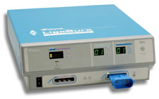
Tissue response Generator (Ligasure™)
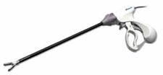
Ligasure™

The tissue response generator has unique vessel sealing ability. These Vessel sealing produces significantly reduced thermal spread compared to existing bipolar instruments. These generators precisely confine its effects to the target tissue or vessel with virtually no charring, and with minimal thermal spread to adjacent tissue. These generator uses seal mechanism by sensing body’s collagen to actually change the nature of the vessel walls by obliterating the lumen. The collagen and elastin within the tissue melt and reform to create the seal zone. These electrosurgical generator works by fusing the collagen in vessel walls to create a permanent seal. The jaw of electrosurgical forceps using this technology leaves no foreign material behind to potentially interfere with future diagnosis. The system uses the body’s own collagen to reform the tissue, creating a permanent seal which resists dislodgement.

Tissue response generator has following advantage

- It can be used with confidence on vessels up to 7 mm
- It seals all the tissue bundles without dissection and isolation
- It causes minimal thermal spread, precisely confining
- Its effect to the target tissue
- The unique energy output results in virtually no sticking
- Reduced sticking and charring
- Minimized need for multiple applications
- No dislodged clips
- No foreign material left behind

Haemostasis
Advanced procedures may require more extensive dissection and thus meticulous haemostasis becomes particularly important. Any loss of view will result in loss of control and hence decreased safety. Haemorrhage, even to a minor extent, tends to obscure their operative field and consequently is to be avoided. This means that vessels of a size that in open surgery could be divided without particular attention need to be secured prior to division when working endoscopically. Dissection must be more meticulous to proceed smoothly.
The magnification produced by the endoscope may initially confuse the surgeon as to the severity of bleeding. A moderate bleed can appear torrential. However an inexperienced endoscopic surgeon is well advised to convert should he have any doubt about his ability to control the situation expeditiously.

Safety during electro surgery:
The potential for accidental damage with electrosurgery must always be borne in mind.

Direct coupling

If the active electrode touches a non-insulated metal instrument within the abdomen, it will convey energy to the second instrument, which may in turn, if the current density is high enough, transfer it to surrounding tissues and cause a thermal burn. For example, the active electrode could come in contact or in close proximity (less than 2 mm) to a laparoscope, creating an arc of current between the two. The laparoscope could then brush against surrounding tissue, causing a severe burn to the bowel and other structures. The burns may not be in the visual field of the surgeon and therefore will not be recognized and dealt with in a timely fashion.
To prevent direct coupling, the active electrode should not in close proximity to or touching another metal instrument before you activate the generator. Bowel is particularly susceptible to this kind of collateral damage from sparks and stray currents and discovery maybe delayed until the postoperative period with serious consequences. Check that the electrode is touching the targeted tissue, and only that tissue, before you activate the generator. Note that when targeted tissue is coagulated (desiccated) the impedance increases and the current may arc to adjacent tissue, following the path of least resistance.
We should be careful that all metal instruments, such as laparoscopes passes through conductive metal trocars. This way, if the active electrode touches the instrument, the current will simply flow from the instrument to the metal trocar. As long as the trocar is in contact with a relatively large portion of the abdominal wall, the current will not be able to concentrate; instead, it will dissipate harmlessly from the trocar through the abdomen and back through adjacent tissue to the return electrode. If the trocar is completely or partially constructed of plastic, however, the energy may not be able to dissipate back through the body. The metal within the trocar will build up a charge, which could eventually arc to adjacent tissue and back to the return electrode, but at a harmful level of current. In doing so, it may travel through the bowel, skin, or even the operator’s hands, causing burns.
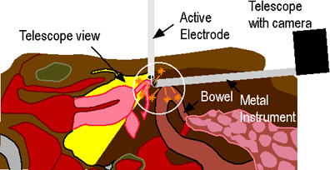
Do not activate the generator while the active electrode is touching or in close proximity to another metal object.

Capacitance coupling
This now never arise but occurred in the early days of laparoscopic surgery with the use of plastic fixation screws to fix metal ports to the abdominal wall so as to prevent them from being accidentally pulled out or pushed when instruments were withdrawn during the course of an operation.
The physics underling this injury is fairly straight forward. Whenever current is applied through an insulated instrument inserted through a metal trocar (port) some radiofrequency electric charge is transferred to the metal cannula by every activation (even if the insulation of the instrument is perfect). This effect is known as capacitance coupling.
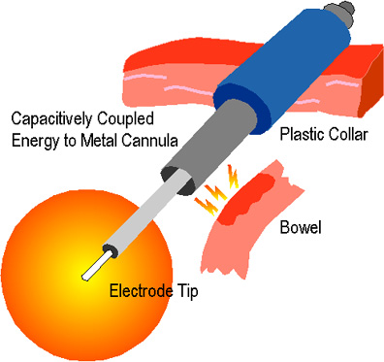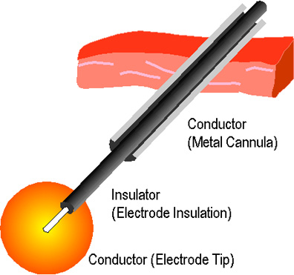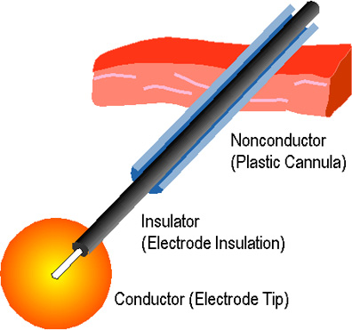
Capacitive Coupling

There is absolutely no problem if the metal cannula is in contact with the full Thickness of the abdominal wall, as the charge accumulates by the cannula is immediately discharged over a wide contact area (low power density, like the neutral return electrode plate) and hence no damage is done.
However, if the cannula is isolated from the abdominal wall, by a plastic screw (acting as an insulator), the cannula cannot discharge and thus accumulates a substantial charge with repeated activation of the electrosurgical instrument. Thus in essence it becomes an electric accumulator! Should at any stage the tip of the cannula inside the abdomen touch tissue or bowel, the accumulated charge will discharge immediately through at a single point of contact, i.e., with a high power density sufficient to causes an electrical burn. Since this occurs away from the site of action of the operation, it is usually overlooked. Capacitance coupling is not a problem if plastic fixation screws are not used and indeed they are banned nowadays.
The phenomenon of “capacitance” is the ability of two conductors to transmit electrical flow even if they are separated by an intact layer of insulation. Capacitive coupling can occur even in the best-case scenario—that is, when the insulation around the active electrode is intact and the tip of the electrode isn’t touching anything metal. If the active, insulated electrode is wrapped around a towel clamp, or placed inside a metal trocar sleeve, or comes in close contact with any conductive substance for an extended period of time, the current in the active electrode may induce a current in the second conductor.
As long as the induced current can dissipate easily through a large surface of tissue, it won’t present a problem. The danger occurs if the second conductor contains some insulating material, as in the case of a metal cannula held in place by a plastic anchor. The plastic anchor will prevent the energy from dissipating and increase the likelihood of a thermal burn. Burns from capacitance current may occur when the surface area is less than 3 cm2 or the current density is approximately 7 w/cm2.
As with direct coupling, the best way to prevent this phenomenon is to use the active electrode monitoring system that prevents current from capacitive coupling from building to dangerous levels. Also, you should avoid all plastic-metal hybrid instruments, including cannulas, trocars, and clamps, when doing electrosurgery.

Insulation failure:
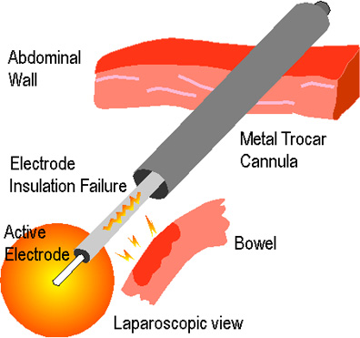

Insulation failure may cause severe electrical burn Injury and patient comes two days after surgery with perforation.
Continued regular use or cleaning and sterilization can cause the layer of insulation covering the shaft of the active electrode to break down. Tiny, visually undetectable tears are actually more dangerous than large cracks, since the current escaping from these miniscule breaks is more concentrated, and therefore capable of causing sparks (averaging 700° C). These sparks can cause severe burns and even ignite fires, especially in oxygen-rich environments.
Unfortunately, many surgeons unknowingly contribute to the problem. Routine use of the high voltage “coagulation” current may actually compromise insulation integrity. The higher the voltage, the greater the risk that the current will break through weak insulation.
Surgeon should always use the lowest voltage they can. All electrosurgery systems will allow you to use a “coagulation” or “cutting” waveform of current.
In most cases, we should try to use the cutting current for both cutting and coagulation. The coagulation mode is really only necessary when you need to fulgurate, or stop diffuse bleeding on highly vascularized tissue. Using the lowest voltage may reduce the wear on the insulation and minimize the chance that the current can escape through hairline cracks.
We should always keep in mind that using the cutting current minimizes, but does not eliminate, the risk of insulation failure. To really be sure that the insulation is not compromised, It is recommended to use an electrosurgical unit that employs active electrode monitoring technology (AEM). This technology is called “Electro-Shield” (ElectroScope Inc., Boulder, Colo.) and it virtually eliminates these types of electrical burns.
Active electrode monitoring protects against thermal burns in two ways. First, it encases the insulated electrode in a protective metal shield that is connected to the generator; the entire probe is also covered with an extra layer of insulation. The extra conductive and insulating layers ensure that stray current is contained and flows right back to the generator. Second, the system monitors the electrical circuit so if stray energy reaches dangerous levels, the unit shuts off automatically and sounds an alarm before a burn can occur. Electroscope’s AEM system operates on a principle similar to Ground Fault Interrupt (GFI) outlets in our home. It protects against insulation breaks by grounding electricity’s unpredictable elements, eliminating stray burns to the patient. This is presently considered the standard of care in endoscopic electrosurgery.

Surgical Smoke

When an electrosurgical probe heats tissue and vaporizes cellular fluid, one byproduct is surgical smoke. We know that these fumes, which can contain carbon monoxide, DNA, bacteria, carcinogens, and irritants, are malodorous and can cause upper respiratory irritation. We do not yet know whether they are capable of causing cancer or spreading infectious disease. Surgical smoke can also obscure the operative site and cause the surgeon to inadvertently touch the electrode to non-targeted tissue.
Surgical masks do not adequately filter surgical smoke; the particles are too small. A much better solution is a smoke evacuation system, a high-flow suction and filtering device that removes the particles from the air. Two kinds are available. One uses a hand-held nozzle, which is intended to be positioned at the surgical site.

Burn at Pad site in monopolar electrosurgery:
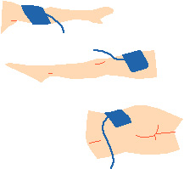

- Assess Pad Site Location
- Choose:
Well vascularized muscle mass
- Avoid:
Vascular insufficiency
Irregular body contours
Bony prominences
- Consider:
Incisionsite / prep area
Patient position
Other equipment on patient
To avoid complication of laparoscopic electrosurgery surgeon should always keep in their mind following points
- Inspect insulation carefully
- Use lowest possible power setting
- Use a low voltage waveform (cut)
- Use brief intermittent activation vs. prolonged activation
- Do not activate in open circuit
- Do not activate in close proximity or direct contact with another instrument
- Use bipolar electrosurgery when appropriate
- Select an all metal cannula system as the safest choice. Do not use hybrid cannula systems that mix metal with plastic
- Utilize available technology, such as a tissue response generator to reduce capacitive coupling or an active electrode monitoring system, to eliminate concerns about insulation failure and capacitive coupling.
For More Information Contact:
Laparoscopy Hospital
Unit of Shanti Hospital, 8/10 Tilak Nagar, New Delhi, 110018. India.
Phone:
+91(0)11- 25155202
+91(0)9811416838, 9811912768
Email: contact@laparoscopyhospital.com

Copyright © 2001 [Laparoscopyhospital.com]. All rights reserved.
Revised: .

