WORLD LAPAROSCOPY HOSPITAL
Cyberciti, DLF Phase II, NCR Delhi, Gurgaon, 122 002, India
Phone: +91(0)12- 42351555 Mobile: +91(0)9811416838, 9811912768,
Email: contact@laparoscopyhospital.com
Click here for training detail

Laparoscopic Sterilization

Worldwide, laparoscopic sterilization is now the most commonly used method of family planning. The percentage of couples who used sterilization doubled from 1973 (16%) to 1998 (36%).

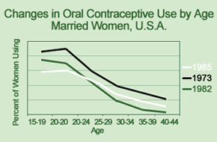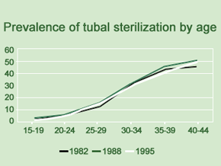

Laparoscopic sterilization has evolved by Palmer and Steptoe in USA by monopolar technique. Rioux and Kleppinger developed bipolar technique for sterilization because of more cases of bowel injury were reported with the use of monopolar. Later silastic band & spring clips were invented for occlusive method of sterilization.

Methods of Tubal Sterilization
- Destructive-

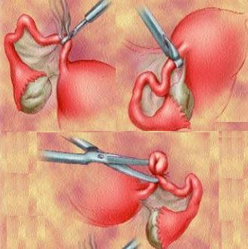

- Unipolar,
- Bipolar
- Coagulation using thermal cautery
- Ligation and cutting by scissors (Pomeroy technique)

- Occlusive

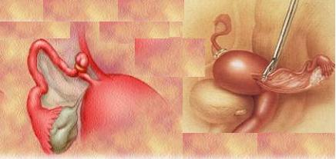

- Filshie clip
- Fallope ring,
- Hulka clip,
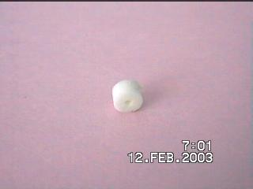
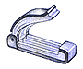
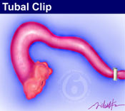
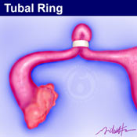

Laparoscopic sterilization by occlusive method is most popular method of interval sterilization and in USA more than 200,000 procedures are performed annually. Use of laparoscopic sterilization in immediate post partum period is not wise and usually planned 4 to 6 weeks after delivery. Laparoscopic sterilization can be planned together with first trimester MTP but in second trimester again interval of 6 week is essential. The main risk of laparoscopic sterilization just after delivery or after second trimester MTP is because uterus is large and may be injured by trocar.
The occlusion of tube in the leuteal phase may lead to pregnancy just after sterilization. This creates a medicolegal problem for gynaecologist. To avoid this problem a urine pregnancy test should be obtained on the morning of surgery and patient should be advised to return for MTP if sign of intrauterine or ectopic pregnancy develops.

Bipolar Coagulation

Two port techniques are used for sterilization by electrosurgery. One in umbilicus & one in left iliac fossa. Gynaecologist stand left to the patient & camera assistant right to the gynaecologist. Uterine manipulator is helpful to bring both the tube under vision.

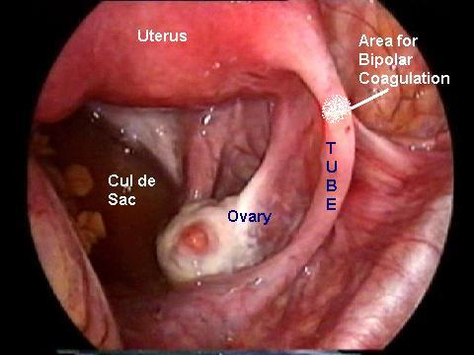

Fallopian tube is grasped 2cm lateral to the uterine end and bipolar is activated. If tube is coagulated very close to uterus there is chance of development of uteroperitoneal fistula containing endometrial tissue due to continuous contractility of uterus. Activation of bipolar should be intermittent and after each activation jaw of bipolar should be slightly opened to avoid sticking of jaw of bipolar with tube. The procedure should be repeated at three adjacent areas.
If the jaw of bipolar adhered with tube forceps should be gently twisted clockwise and counterclockwise and at the same time the pressure from the handle of grasper is decreased.
Some gynaecologist prefer coagulation and division of tube between coagulated area but study has shown that coagulation of 2 to 3 cm of tube without division is better because division lead to significant incidence of bleeding from underlying vessels. Bipolar should be applied always at three places. If only one place bipolar coagulation per tube is performed, there is always a risk of spontaneous re-canalization in about three months.

Fallop ring application
Yoon in (1974) described silastic band technique for occlusive tubal sterilization. The fallop ring is applied with the help of fallop ring applicator.

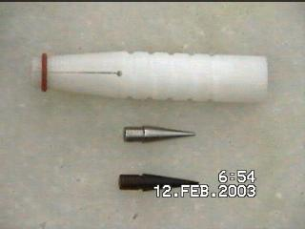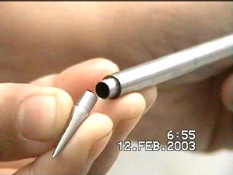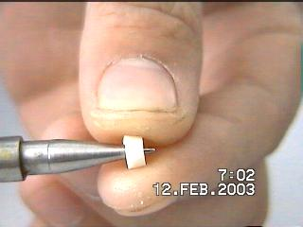
Ring loading
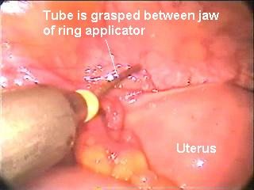

Operative technique
Pneumoperitoneum is created in usual manner. First of all diagnostic laparoscopy should be performed to exclude any other abnormality. The Filshie clip or Fallop ring is loaded into the receiving edge of the applicator. The clip or ring should be applied across the narrow isthemic area about 2 cm from the cornua. This area is very mobile and easy to see in case of desired re-anastomosis this area is easy to do anastomosis. The tube is withdrawn into the inner cylinder of the ring applicator instrument. Get whole thickness of the tube in the jaws and then the clip is applied by squeezing the spring handle back towards the back stop. Once it is fired silicon band are applied to the grasped segment of the fallopian tube. See for the blanching of the tube after clip application. Blench is due to ischemia and this means that the sterilization is perfect.

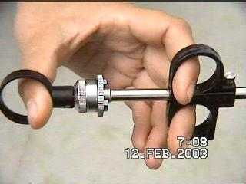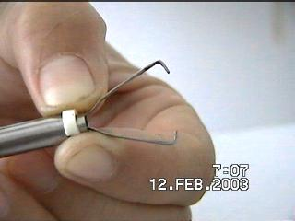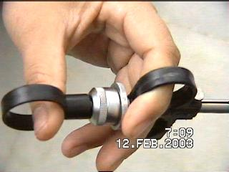 Once fallop ring is discharged and a proper loop is formed applicator should be with drawn and the tube of other side is occluded. When both the tubes have been occluded, indigo carmine dye is injected through the uterus to confirm occlusion of lumen of fallopian tube. If everything goes well patient can be discharged on the same day. The snapshot pictures and video recording of all the procedure is good practice for future references.
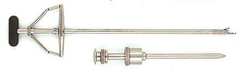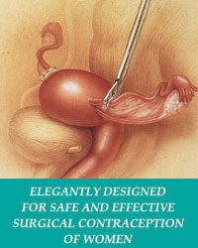
Filshie Clip
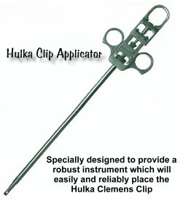
Hulka clip
Filshie Clip and Fallop ring for female sterilisation
Filshie and Hulka clip is also applied with same manner, only difference is that clips does not form loop hence the chances of reversal of sterilization are better compared to fallop rings.

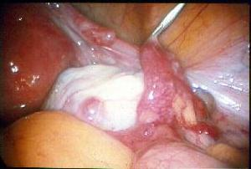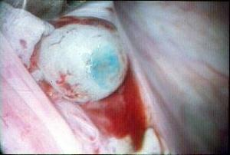
Reversal of sterilization
Identification of site of tubectomy
Blind stump has been cut to show healthy end (25X magnification)
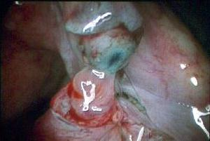
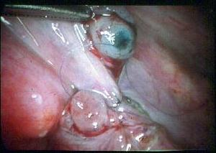
Reversal of sterilization
Anastomosis by surgeons knot

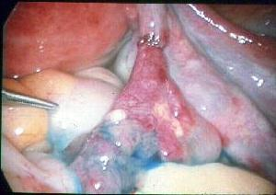
Reversal of sterilization
The anastomosis has been completed after four 6/0 sutures have been tied. Methylene blue dye injected into the uterine cavity emerges from the end of the tube with no leakage at the joint.
Factors affecting success of tubal reversal

Method of Sterilization-most successful for Hulka clips, followed by rings, and then cautery and Pomeroy-type technique
Length of Tube-more successful when residual tube is longer than 2 centimeters
Age at Reversal-more successful in women less than age 35
For More Information Contact:
Laparoscopy Hospital
Unit of Shanti Hospital, 8/10 Tilak Nagar, New Delhi, 110018. India.
Phone:
+91(0)11- 25155202
+91(0)9811416838, 9811912768
Email: contact@laparoscopyhospital.com

Copyright © 2001 [Laparoscopyhospital.com]. All rights reserved.
Revised: .

