WORLD LAPAROSCOPY HOSPITAL
Cyberciti, DLF Phase II, NCR Delhi, Gurgaon, 122 002, India
Phone: +91(0)12- 42351555 Mobile: +91(0)9811416838, 9811912768,
Email: contact@laparoscopyhospital.com
Click here for training detail

Laparoscopic Management of Tubal Diseases

Laparoscopy is one of the major advancement for tubal and uterine disease. Surgical procedures for managing benign adnexal masses include aspiration, fenestration, ovarian cystectomy, unilateral or bilateral salpingo-oophorectomy, and laparoscopically-assisted vaginal hysterectomy (LAVH) with or without unilateral or bilateral salpingo-oophorectomy

Ectopic pregnancy
In Europe 90 per cent of Ectopic pregnancies are now dealt with by Laparoscopy.
The procedure includes:
- Laparoscopic aspiration - tubal abortion or fimbrial ectopic,
- Laparoscopic linear salpingostomy - products of conception removed, tube flushed, follow-up HCG levels? Methotrexate is being used in some centre,
- Laparoscopic segmental tubal resection,
- Laparoscopic salpingectomy,
- Laparoscopic salpingo-oophorectomy,
- Laparoscopic Oophorectomy (ovarian ectopic).
Most patients are discharged within 48 hours. There is a higher fertility rate/intra-uterine pregnancy rate in subsequent pregnancies with laparoscopic techniques.
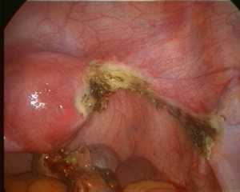
Salpingotomy

Adnexal surgery
These include - adhesiolysis, ovarian cystectomy, Oophorectomy, ovariectomy, correction of torsion and non-ectopic tubal surgery, e.g. hydro-salpinx, drainage or resection. A high degree of clinical prediction of benign conditions is a pre-requisite. Cystic lesions are usually aspirated and removed. Solid benign tumours can be removed piecemeal or through culdotomy (the Pouch of Douglas).

Salpingotomy:

Preventive haemostasis
Dissolve 5 I.U. of vasopressin in 20 ml of Saline
Injection of vasopressin in Mesosalpinx result into transient ischemia and will provide a bloodless field

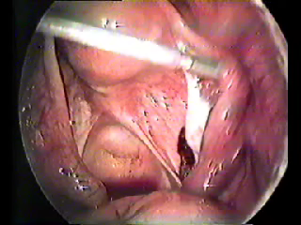
Preventive Haemostasis by injecting Vasopressin

10 -15 mm incision at anti mesenteric border of fallopian tube
Aspirate trophoblast with mild suction using suction irrigation instrument

Contraindication of conservative treatment

Absolute:
  - 6 cm in diameter
  - HCG level 15000 I.U/ ml
Relative
- Cases with poor pregnancy prognosis
- Severe adhesion

Weekly HCG essay should made until undetected

Salpingectomy:
Dissection starts at uterine end of fallopian tube
Mesosalpinx is progressively coagulated and sectioned.
Suturing or Bipolar electro surgery is the safest choice
Haematoma due to Large ruptured Ectopic should be aspirated before starting dissection

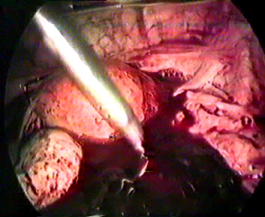
Haemoperitoneum

If there is more than 1500cc haemoperitoneum laparoscopic approach is contraindicated
Heparinized saline should be used in cases of large haematoma
Large ruptured Ectopic require extracorporeal knotting.

Colposuspension

This involves replicating an open Burch procedure with laparoscopic techniques. Laparoscopy provides excellent anatomical definition. The advantages over the open Burch procedure are no need for supra-pubic catheterization and subsequent voiding retraining which usually takes four plus days. With the laparoscopic technique an indwelling catheter (Foleys) remains in situ for only 24 hours post-operatively. Patients are discharged 48 hours post surgery.
There is no need for a Redivac drainage to the cave of Retzius. Recent studies have shown that the laparoscopic procedures maintains the high expected long term cure rate of genuine stress incontinence as does the open procedure (90 per cent).

Endometrial Ablation - Resection

This procedure has now found its niche and continues to be a popular alternative for women with unacceptable menstrual blood loss (quantity, length) or unacceptable withdrawal bleeds on hormonal replacement. Term "ablation" is used to refer to pure roller-ball coagulation and TCRE (trans-cervical resection of endometrium) to refer to resectoscope excision alone or in combination with roller-ball (usually).

Patient selection is critical and permanent amenorrhea is no longer emphasized (although this occurs in 50 per cent + of patients). If the woman would not accept a continuation of menstruation she is not a good candidate for ablation or resection. A much higher degree of permanent amenorrhea is expected the closer to the menopause. The advantages clearly lie with its shortness and simplicity of surgical procedure only one day stays and virtually pain free, and early return to usual activities.

Salpingo-oophorectomy:
At times unilateral or BSO is the best way to manage ovarian cysts. This procedure is indicated, for example, when the ovary appears unsalvageable or the nature of the ovarian cyst is questionable, in women with a family history of ovarian cancer, patients with oestrogen receptor-positive breast cancer, and postmenopausal women.
Inspect the ureters before beginning salpingo-oophorectomy. Elevate the fimbrial end of the fallopian tube and the ovary to stretch the infundibulo-pelvic ligament. Create a window in the peritoneum of the broad ligament to grasp the infundibulo-pelvic ligament without risking injury to the ipsilateral ureter. Secure the ligament with ligature and cut it with a scissors or transect it using a laparoscopic stapler. Occasionally, you can use clamp, bipolar coagulation, and then sever the infundibulo-pelvic ligament using an extracorporeal knot technique (Figure 4). It's my practice to use bipolar cautery, as it is inexpensive, safe, and readily available. After severing the coagulated infundibulo-pelvic ligament with scissors, the posterior leaf of the broad ligament is cut, up to its attachment to the uterus. Coagulate the uterine end of the fallopian tube and the ovarian ligament using bipolar diathermy and cut them using scissors. Alternatively, you can ligate these structures with an endoloop and then cut them with scissors. Place the separated tube and ovary in an Endobag and remove them through the secondary or tertiary incisions (which may first need to be enlarged).
For More Information Contact:
Laparoscopy Hospital
Unit of Shanti Hospital, 8/10 Tilak Nagar, New Delhi, 110018. India.
Phone:
+91(0)11- 25155202
+91(0)9811416838, 9811912768
Email: contact@laparoscopyhospital.com

Copyright © 2001 [Laparoscopyhospital.com]. All rights reserved.
Revised: .

