WORLD LAPAROSCOPY HOSPITAL
Cyberciti, DLF Phase II, NCR Delhi, Gurgaon, 122 002, India
Phone: +91(0)12- 42351555 Mobile: +91(0)9811416838, 9811912768,
Email: contact@laparoscopyhospital.com
Click here for training detail

Laparoscopic Instrument Detail: 2

Laproflator
The Electronic CO2 Laproflator is a general purpose insufflation unit for use in laparoscopic examinations and operations. The required values for pressure and flow can be set exactly using jog keys and digital displays. Insufflation pressure can be continuously varied from 0 to 30 mm Hg; total gas flow volumes can be set to any value in the range 0-9.9 liters/mm.
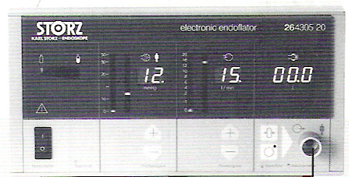
Patient safety is ensured by optical and acoustic alarms as well as several mutually independent safety circuits. The detail function and Quadro-manometric indicators of insufflator is important to understand for safety point of view. These four setting of insufflators are preset pressure, actual pressure, flow rate & total gas used.

Suction irrigation machine or Pelvis-Cleaner
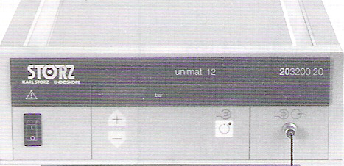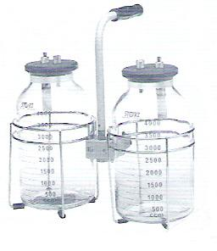
It is used for flushing the abdominal cavity and cleaning during endoscopic operative intrusions. It has been designed for use with the 26173 AR suction /instillation tube. Its electrically driven pressure/suction pump is protected against entry of bodily secretions. The suction irrigation machine is used frequently at the time of laparoscopy to make the field of vision clear. Most of the surgeon use normal saline or ringer lactate for irrigation purposes. Sometime heparinized saline is used to dissolve blood clot to facilitate proper suction in case excessive intra-abdominal bleeding.

Veress needle

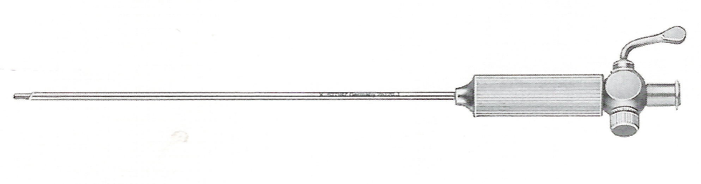
Veress needle was invented by a chest physician for aspiration of pleural effusion keeping in mind that its spring mechanism and blunt tip will prevent the injury of lung tissue. The Veress needle consists of a sharp needle with an internal, spring loaded trocar. The trocar is blunt ended with a lumen and side hole. Disposable and non disposable metal Veress needles are available commercial in different lengths i.e. long for obese patients, short for thin or pediatric patients. Veress needle is used for creating initial pneumoperitoneum so that the trocar can inter safely and the distance of abdominal wall from the abdominal viscera should increase. Veress needle technique is the most widely practiced way of access. Before using veress needle every time it should be checked for its patancy and spring action. Veress needle is available in three length 80mm, 100mm, 120mm. In obese patient 120mm and in very thin patient with scaphoid abdomen 80mm veress needle should be used. Veress needle should be held like a dart at the time of insertion. The proper technique of veress needle insertion, different safety measures and indicators are discussed in chapter of access technique of this book.

Trocar and Canulla
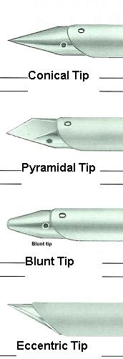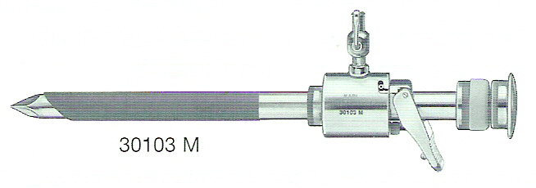

Trocar and canulla are of different sizes and diameter depending upon the instrument for which it is used. The metal trocar has different type of tips ie; Pyramidal tip, Eccentric tip, Conical tip or blunt tip depending on the surgeons experience. Surgeon should always remember that sharp trocars although looking dangerous are actually better than blunt one because they need less force to introduce inside the abdominal cavity and chances of inadvertent forceful entry of full length of trocar is less.

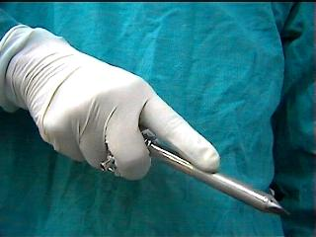

Trocar should be held in proper way in hand so that head of the trocar should rest on the thenar eminence, the middle finger should rest over the gas inlet and index finger is pointed towards the sharp end of the trocar.

Hand Instruments
Most of the laparoscopic procedures require a mixture of sharp and blunt dissection techniques, often using the same instrument in a number of different ways. The hand instrument used in laparoscopic surgery are of different length (varies company to company) but they are ergonomically convenient to work if they have same length of approximately 36 cm in adult and 28 cm in pediatric practice.
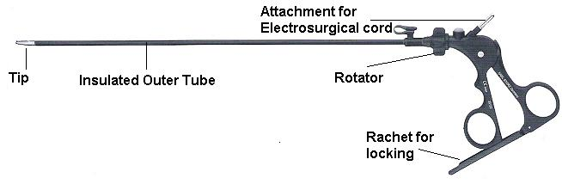
Most of the hand instrument has three detachable parts.
- Handle,
- Insulated outer tube and
- Insert which makes the tip of the instrument.

Different Handles of Hand instrument

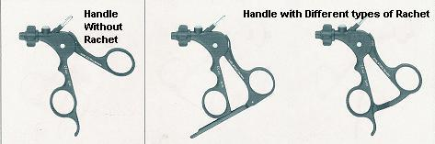

Most of the Laparoscopic instruments handle has attachments for unipolar electrosurgical lead and many has rotator mechanism to rotate the tip of the instrument.

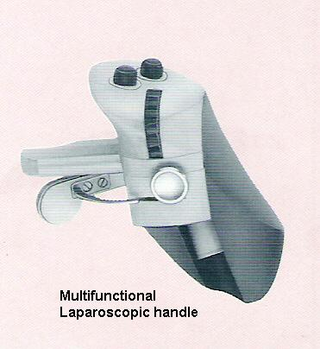

Some multifunctional Laparoscopic handle has attachment for suction and irrigation and some time hand switch for cutting and coagulation switch of electrosurgery.

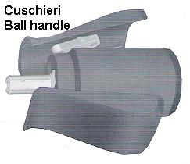
Cuschieri Ball Handle is invented by Prof. Sir Alfred Cuschieri. This handle lies cofirtably in surgeons palm. This design reduces the fatigue of surgeon and eases rotation of the instrument by allowing rotation within the palm rather than using wrist rotation. Squeezing the front of the handle between the thumb and the first fingers increases the jaw closing force; squeezing the rear of the handle between the thenar eminence of the thumb and last fingers opens the jaws.
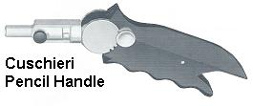
Cuschieri pencil handle also has very great ergonomic value specially when used with needle holder. This handle allows the angle between the handle and the instrument to be altered to suit the surgeon’s wrist angle. The conveniently placed lever of this pencil handle when pressed can change the angle. Just like ball handle, pressure at the front increases the jaw closing force while pressure at the rear opens the jaw.

Outer sheath of Hand instrument

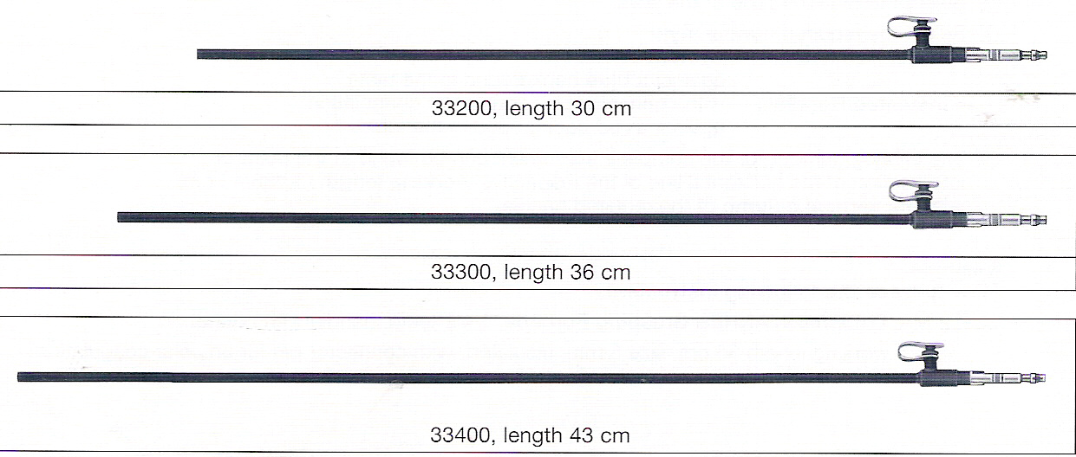
The insulation covering of outer sheath of hand instrument should be of good quality in hand instrument to prevent accidental electric burn to bowel or other viscera.
Insulation covering may be of silicon or plastic. At the time of cleaning the hand instrument utmost care should be taken so that insulation should not be scratched with any sharp contact. A pin whole breach in insulation is not easily seen by naked eye but may be dangerous at the time of electro surgery.

Insert of Hand instrument

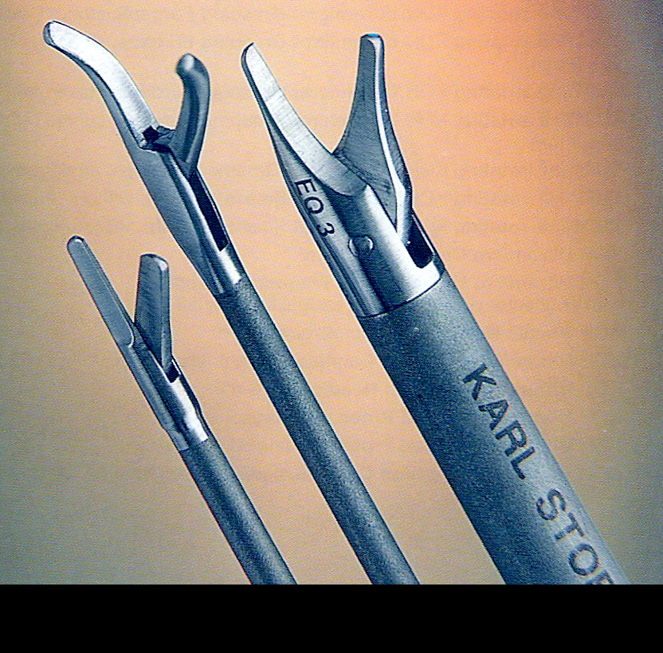

Insert of hand instrument varies only at tip. It may be grasper, Scissors, or Forceps. These grasper may have single action jaw or double action jaw.

Single action jaw graspers

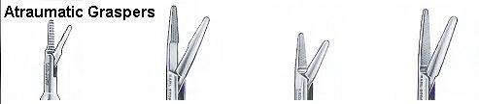

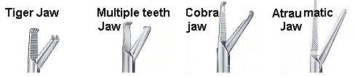

These graspers are good when you don’t have control over depth and surgeon wants to work in single plane in controlled manner particularly during adhesiolysis.

Double action jaw graspers
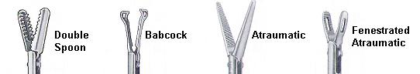

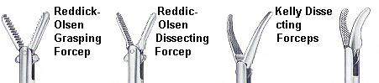
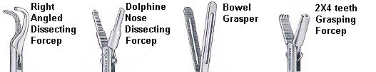
For More Information Contact:
Laparoscopy Hospital
Unit of Shanti Hospital, 8/10 Tilak Nagar, New Delhi, 110018. India.
Phone:
+91(0)11- 25155202
+91(0)9811416838, 9811912768
Email: contact@laparoscopyhospital.com

Copyright © 2001 [Laparoscopyhospital.com]. All rights reserved.
Revised: .

