WORLD LAPAROSCOPY HOSPITAL
Cyberciti, DLF Phase II, NCR Delhi, Gurgaon, 122 002, India
Phone: +91(0)12- 42351555 Mobile: +91(0)9811416838, 9811912768,
Email: contact@laparoscopyhospital.com
Click here for training detail

Laparoscopic Fundoplication

Gastro Esophageal Reflux Disease (GERD) is defined as the failure of the anti reflux barrier, allowing abnormal reflux of gastric contents into the esophagus. It is a mechanical disorder which is caused by a defective lower esophageal sphincter, a gastric emptying disorder or failed esophageal peristalsis. Gastro-esophageal reflux is one of the most common digestive symptoms. Exposure of the oesophageal mucosa to acid, enzymes and other digestive secretions, leads to acute and chronic inflammation, with pain, and ulceration or stricture formation if untreated. Medical therapy is the first line of management. Esophagitis will heal in approximately 90% of cases with intensive medical therapy. However, symptoms recur in more than 80% of cases within one year of drug withdrawal. Since it is a chronic condition, medical therapy involving acid suppression and/or pro-motility agents may be required for the rest of a patient's life. Despite the fact that current medical management is very effective for the majority a small number of patients do not get complete relief of symptoms. Currently, there is increasing interest in the surgical management of gastro-oesophageal reflux disease (GORD).
In U.S. and Europe 44% of population describe their problem as GERD.
Symptoms characteristic to GERD is only present in 10 to 15%.
Men appear to have more complication secondary to GERD like esophagitis and stricture
10 to 50 % patients require long-term treatment

Symptoms:

- Heart burn (Retrosternal burning)
- Regurgitation
- Pain
- Respiratory symptoms

Diagnostic test:
- Endoscopy
- Barium swallow
- Oesophageal transit +/- Manometry
- pH monitoring

Indications for Surgical management of GRED:
- Refractory to medical management
- Associated with hiatus hernia
- Intolerance to PPH or H2 receptors
Study has shown those patients resistant to anti secretory treatment are not a good candidate for antireflux surgery

Currently there are two methods of Fundoplication
  - The classical open methods, or
  - The modern laparoscopic techniques.
Laparoscopic Fundoplication is a safe procedure, and can provide less postoperative morbidity in experienced hands. This is a surgical procedure done for Gastro oesophageal Reflux Disease (GERD). Fundus of the stomach which is on the left of the oesophagus and main portion of the stomach is wrapped around the back of the oesophagus until it is once again in front of this structure. The portion of the fundus that is now on the right side of the oesophagus is sutured to the portion on the left side to keep the wrap in place. The Fundoplication resembles a buttoned shirt collar. The collar is the fundus wrap and the neck represents the oesophagus imbricated into the wrap. This has the effect of creating a one way valve in the esophagus to allow food to pass into the stomach, but prevent stomach acid from flowing into the esophagus and thus prevent GERD.
Laparoscopic fundoplication is a useful method for reducing hospital stay, complications and return to normal activity. With better training in minimal access surgery now available, the time has arrived for it to take its place in the surgeon’s repertoire.
Types of Fundoplication surgery:
The 360 degrees Nissen fundoplication (NF) has been the standard operation for Gastro Esophageal Reflux, but is associated with substantial rates of, "gas bloat," gagging and dysphasia
Toupet fundoplication (TF), a 270 degrees posterior wrap, has fewer complications, and its outcome in compared with Nissen Fundoplication is favourable both in children as well as adults

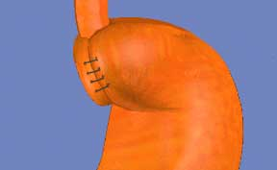
Nissen Fundoplication (NF)
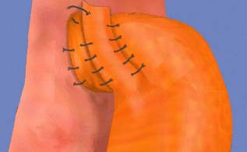
Toupet fundoplication (TF), a 270 degree wrap
Although Nissen total fundoplication is the most commonly performed procedure, partial fundoplication, either anterior or posterior, is becoming more acceptable because of lower risk of long term complication. Dor in 1962 described anterior fundoplication as an anti-reflux operation for patients who had a Heller’s myotomy for achalasia. In the 1970s, Watson developed an operation for patient suffering from GERD. .
The 360 degrees Nissen fundoplication (NF) has been the standard operation for Gastro Esophageal Reflux (GER), but is associated with substantial rates of recurrence, "gas bloat," gagging, and dysphagia. most surgeon believe that the Toupet fundoplication (TF), a 270 degrees posterior wrap originally described in conjunction with myotomy for achalasia, has fewer complications, and its long-term outcome in compared with Nissen Fundoplication is favorable both in children as well as adults. This article describes a technique of laparoscopic posterior Toupet fundoplication.
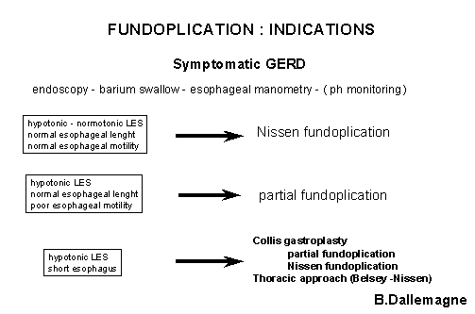
The main tasks of this operation consist of:
- Preparation of the patient.
- Creation of pneumoperitoneum. Insertion of port.
- Diagnostic laparoscopy and Dissection of visceral peritoneum.
- Mobilisation of 5 cm. intra-abdominal oesophagus.
- Fundus pulls from below the oesophagus.
- Insertion of posterior sutures to tighten the crural opening.
- Fixation of Fundus to the left crura.
- Fixation of the fundus with the right crura.
- Fixation of the fundus with oesophagus. Inspection of tightness of fundoplication.
- Irrigation and suction of operating field.
- Final Diagnostic laparoscopy for any bowel Injury or haemorrhage.
- Removal of the instrument with complete exit of CO2. Closure of wound.
Patient selection:
Many patients have symptoms palliated by lifestyle measure like diet and exercise, others by simple medication, and some by strong medication like, proton pump inhibitors. A certain proportion of patient has refractory or long-term symptoms, and operation can be considered in this group of patients. As reflux symptoms are frequent and variable, it is wise to obtain both ambulatory 24 pH-metry and oesophageal motility studies prior to surgery. Upper G.I. Endoscopies should be performed in all patients.
OPERATIVE TECHNIQUE
Patient Position
- The patient is placed on the operating table with the legs in stirrups, the knees slightly bent and the hips flexed approximately 10°.
- The operating table is tilted head up by approximately 15 degree.
- Compression bandage are used on leg during the operation to prevent thromboembolism.
- The surgeon stands between the patient’s legs.
- The first assistant, whose main task is to position the video camera, sits on the patient’s left side.
- The instrument trolley is placed on the patient’s left allowing the scrub nurse to assist with placing the appropriate instruments in the operating ports.
- Television monitors are positioned on either side of the top end of the operating table at a suitable height so surgeon, anaesthetist, as well as assistant can see the procedure.

Port Position:
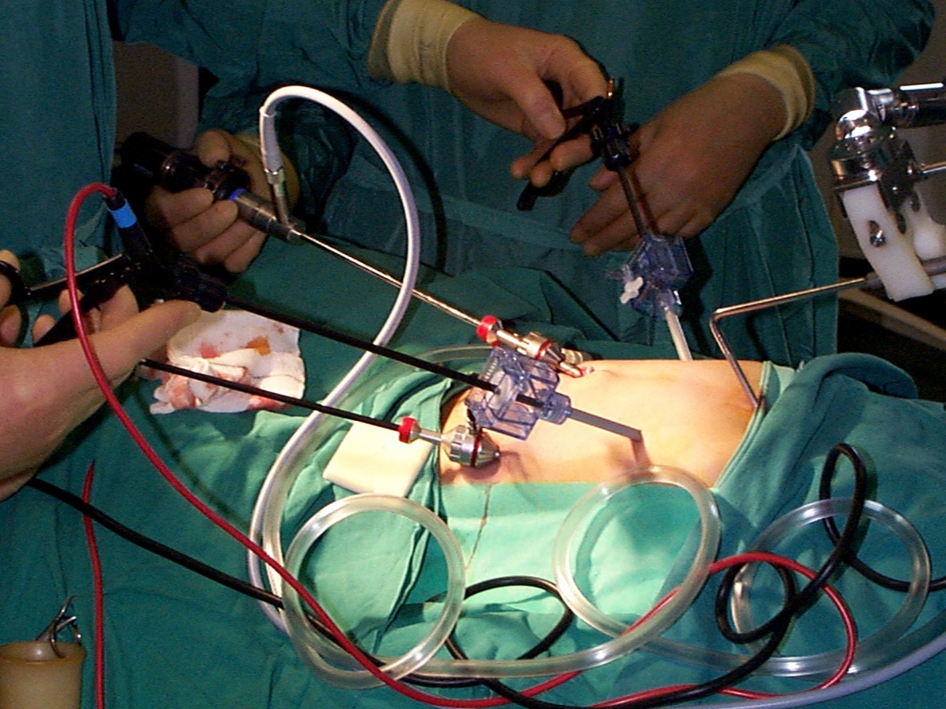
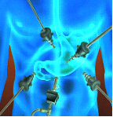
- A 10mm camera port 5cm above the umbilicus.
- A 5mm port in the right upper quadrant.
- A port, with a variable 5-10 mm is in the left upper quadrant - a mirror image of the one on the patient’s right.
- Nathanson liver retractor is inserted through a 5 mm incision in the midline, extending from skin to the peritoneal cavity,
- A 5 mm port is positioned in the left mid clavicular line immediately below the costal margin. This port is mainly used for a forceps which will hold the tape encircling the oesophagus.
Tissue Dissection and Mobilisation
- Start dissection at the avascular portion of the lesser omentum above the hepatic branch of the vagus.
- The dissection is continued carefully up to the hiatus, which can be seen through the defect created. An opening is created in the lesser omentum below the hepatic branch of vagus to allow better access to the hiatus.
- The right crus are dissected using diathermy and scissors to identify the plane between the crus and surrounding loose areolar tissues.
- Expose the loose areolar tissue around the oesophagus and secure the bleeding from any blood vessels visible during mobilisation of oesophagus. Always remember not to injure the oesophageal wall and vagal fibres when dissecting this area around oesophagus.
- The space between the hiatus and the anterior aspect of oesophagus is developed using fine dissection by scissors to divide blood vessels crossing this space.
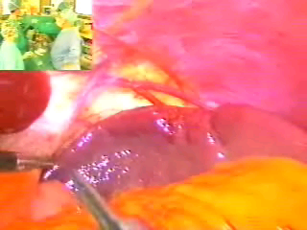
Lesser sac opened
- The posterior aspect of the left crus is identified as it meets the right crus and dissection of its surface commences specially the peritoneal covering over the margin of right crus is dissected down to fee the fundus from the diaphragm known as Rosetti dissection or technique.
- Dissection of the posterior aspect of the left crus is done by lifting the intra-abdominal oesophagus forwards with a blunt instrument.
- A sling is fed into the jaws of the grasping forceps and then pulled round behind the oesophagus.

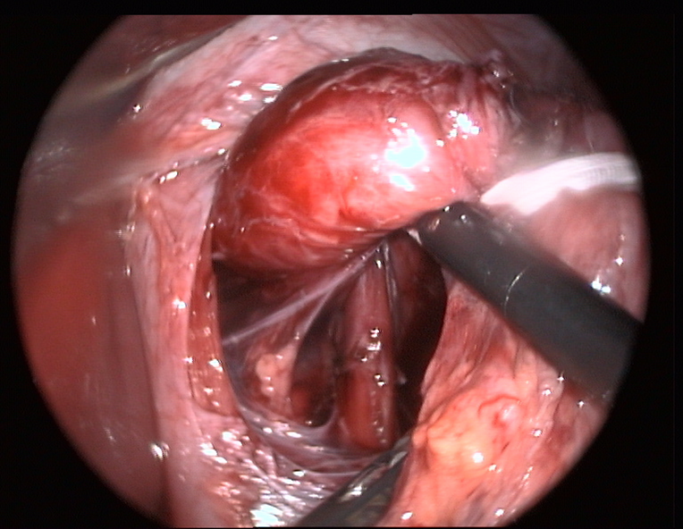
Sling insertion
- Sling is passed through a separate punctured wound from abdominal wall without port.
- A grasping forceps is inserted through one of the port to hold the sling so that the oesophagus can be manipulated.
- Dissect the surroundings of oesophagus in the posterior mediastinum for 5 to 6 cm.
- Mobilise the oesophagus and stomach sufficient enough to have a good floppy fundus for wrap
- Next step is to pull the fundus from behind the oesophagus to form a wrap.
Fundus pull:
- After mobilising the fundus nicely the tip of the fundus is pulled by one of the grasper introduced through below and right side of the oesophagus
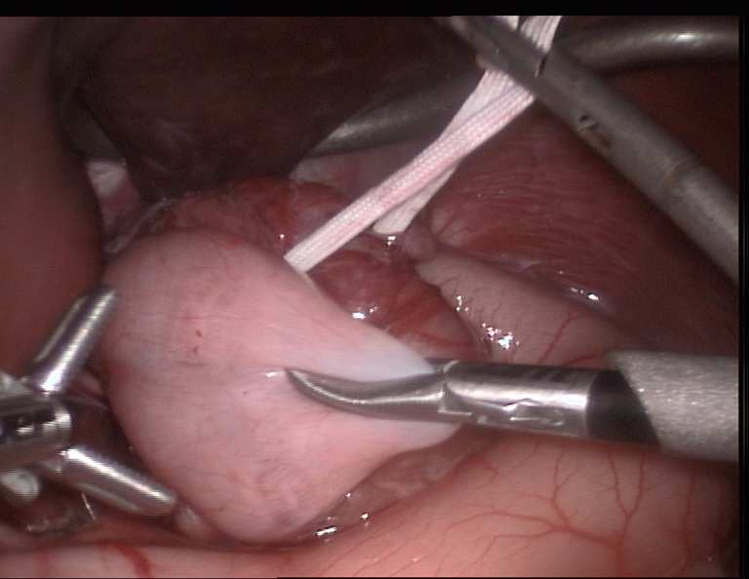
Wrap of Fundus
- The mobilization of stomach should be adequate to give a floppy fundus for plication otherwise patient may develop dysphagia
- One stay suture may be applied to the fundus to hold it in place or one of the grasper may be used
- The next step is crural repair.
Crural Approximation
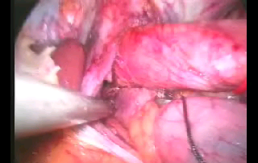
Approximation of Crura
  - Approximate the crura behind the oesophagus using two or three sutures of 2/0 braided polyamide on a 30 mm needle using Tumble Square Knot.
  - A further one or two sutures are inserted in the same way, at about 1cm intervals and tied using Tumble square knot.
  - It is important not to make the crural opening too tight since this will produce dysphagia.
Fundoplication:
- Suture is applied which involves a 1cm bite of the seromuscular layer of gastric fundus, which is sutured to the anterior aspect of the left crus. Since the fundus lays some way from the left crus the slip reef knot or Tumble square knot is particularly valuable for this suture.
- After this a further suture is placed between the fundus and the left anterior aspect of the hiatus.
- The next suture is placed between the fundus and the right anterior aspect of the hiatus.
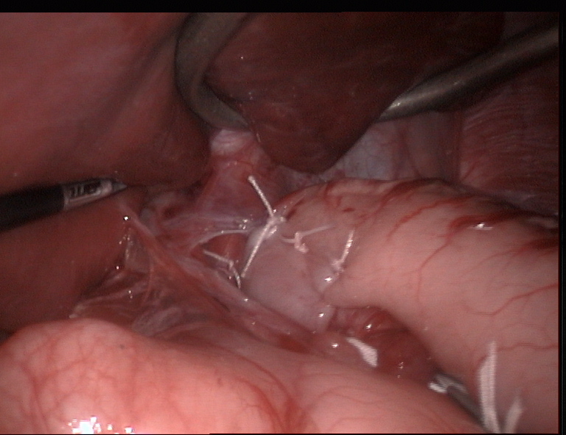
Fixation of wrap by Intracorporeal sutures:
- Further three sutures are then positioned at approximately 1 cm intervals to the posterior fundus and the right crus.
- The sling used for oesophageal retraction is removed.
- One or two suture may be placed to fix the side of the oesophagus with the wrapped portion of the stomach. But always remember the wrap is not in place due to these sutures. The suture of Fundus with crura actually holds the wrap in position. Never take a full thickness bite on the oesophagus with Endoski needle otherwise there is always a chance of perforation of oesophagus.
Ending of the operation.
- Examine the abdomen for any possible bowel injury or haemorrhage.
- Remove the Instrument and then port.
- Remove telescope leaving gas valve of umbilical port open to let out all the gas.
- Close the wound with Suture.
- Use Vicryl for rectus and Un-absorbable intra-dermal or Stapler for skin.
- Apply adhesive sterile dressing over the wound.

Patient may be discharged 2 days after operation if every thing goes well. The patient may have slight dysphagia initially but usually resolves after 6 weeks. The patient having any complain of dysphagia should be examined endoscopically after 3 to 4 week of operation.
Laparoscopic fundoplication is a useful method for reducing hospital stay, complications and return to normal activity if carried on in proper manner. With better training in minimal access surgery and better ergonomics now available the time has arrived for it to take its place in the surgeon’s repertoire.

For More Information Contact:
Laparoscopy Hospital
Unit of Shanti Hospital, 8/10 Tilak Nagar, New Delhi, 110018. India.
Phone:
+91(0)11- 25155202
+91(0)9811416838, 9811912768
Email: contact@laparoscopyhospital.com

Copyright © 2001 [Laparoscopyhospital.com]. All rights reserved.
Revised: .

