WORLD LAPAROSCOPY HOSPITAL
Cyberciti, DLF Phase II, NCR Delhi, Gurgaon, 122 002, India
Phone: +91(0)12- 42351555 Mobile: +91(0)9811416838, 9811912768,
Email: contact@laparoscopyhospital.com
Click here for training detail

Laparoscopic Clipping
Titanium Clip is most widely used tissue approximation technique used by general laparoscopic surgeon
Choose the correct size of clip for the structure
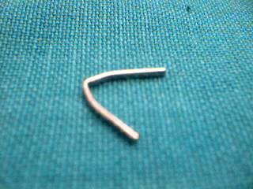
Double clip should be applied over important structures
Always confirm the dumbbell effect after clipping
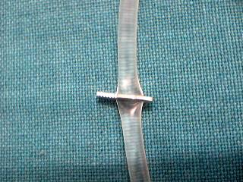
Dumbbell effect after clipping confirm the tension on tissue
Do not clip fatty pedicles
Check positioning of jaws, the tips and content before clipping

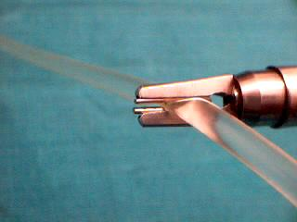
Beware of cross clipping
Are Titanium clips completely safe?
?
Cases of cat eye stone has been reported

Sometime clip applied on cystic duct may internalize and it may act as foreign body. After many years it stimulates stone formation by deposition of bile. It is called cat eye stone because after taking a cross section of these stone the titanium clips look like pupil of a cat seen in dark.
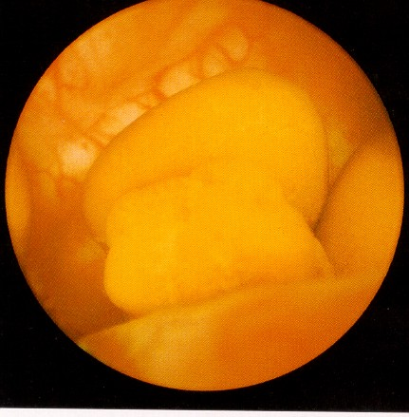
Titanium clips are not completely safe
Cat Eye Stone
For More Information Contact:
Laparoscopy Hospital
Unit of Shanti Hospital, 8/10 Tilak Nagar, New Delhi, 110018. India.
Phone:
+91(0)11- 25155202
+91(0)9811416838, 9811912768
Email: contact@laparoscopyhospital.com

Copyright © 2001 [Laparoscopyhospital.com]. All rights reserved.
Revised: .

