WORLD LAPAROSCOPY HOSPITAL
Cyberciti, DLF Phase II, NCR Delhi, Gurgaon, 122 002, India
Phone: +91(0)12- 42351555 Mobile: +91(0)9811416838, 9811912768,
Email: contact@laparoscopyhospital.com
Click here for training detail

Laparoscopic Appendicectomy

Introduction:
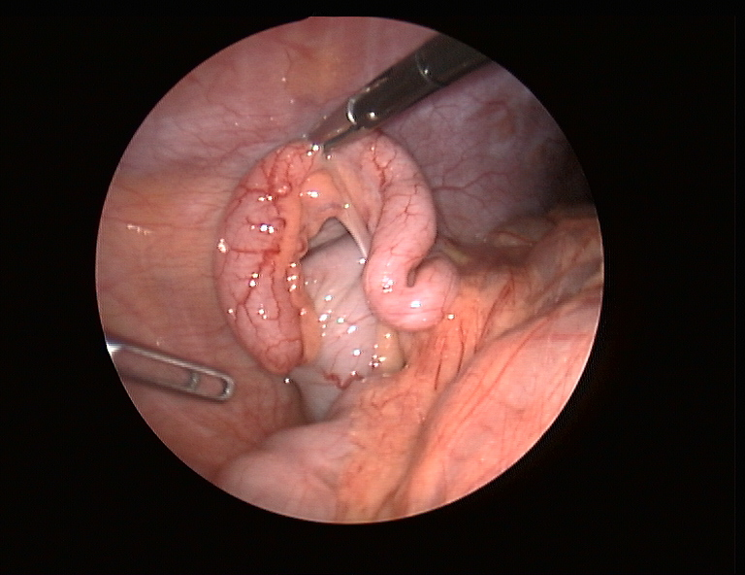
Appendicitis was first recognized as a disease entity in the sixteenth century and was called perityphlitis. Mc Burney described the clinical findings in 1889.

Laparoscopic approach has following advantages.

- Diagnostic advantage in female of reproductive age group
- Cosmetically better outcome.
- Less tissue dissection and disruption of tissue planes
- Less pain postoperatively.
- Low intra-operatively and postoperative complications.
- Early return to work.

Laparoscopic appendectomy in expert hands is now quite safe and effective, and is an excellent alternative for patients with acute appendicitis. It is more complex and is not widely available. The public needs to be educated as to its advantages. All surgeons agree that for women of child bearing age, laparoscopic appendectomy is unquestionably the method of choice.

Patient selection:
Laparoscopic appendectomy is a safe procedure, and can provide less postoperative morbidity in experienced hands, as open appendectomy. Most cases of acute appendicitis can be treated laparoscopically. Laparoscopic appendectomy is a useful method for reducing hospital stay, complications and return to normal activity. With better training in minimal access surgery now available, the time has arrived for it to take its place in the surgeon’s repertoire.

Relative contra-indications.
- Complicated appendicitis
- Stump appendicitis
- Poor risk for general anaesthesia
- some cases of previous extensive pelvic surgery
The general anaesthesia and the pneumoperitoneum required as part of the laparoscopic procedure do increase the risk in certain groups of patients. Most surgeons would not recommend laparoscopic appendectomy in those with pre-existing disease conditions. Patients with Cardiac diseases and COPD should not be considered a good candidate for laparoscopy. The laparoscopic appendectomy may also be more difficult in patients who have had previous lower abdominal surgery. The elderly may also be at increased risk for complications with general anaesthesia combined with pneumoperitoneum...

Patient Position:
The patient is in supine position, arms tucked at the side. The surgeon stands on the left side of the patient with the camera holder-assistant. For maintaining co-axial alignment surgeon should stand near left shoulder and monitor should be placed near right hip facing towards surgeon.

Port Position.
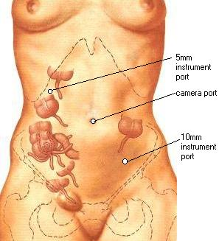
- Total 3 trocar should be used
- Two 10mm, umbilical and left lower quadrant trocar and
- One 5 mm Right upper quadrant trocar
- The right upper quadrant trocar can be moved below the bikini line in females

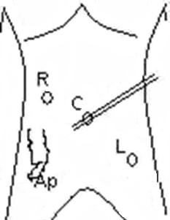
C. Port for telescope
R. Surgeon right hand
L. Surgeon left hand

Position of the surgical team:

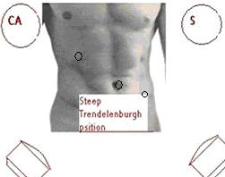

S= Surgeon
CA= Camera assistant

Alternative Port and theatre Set-up

In beauty conscious female for cosmetic reason the base ball diamond concept of port position can be altered and three ports should be placed in such a way so that the two 5mm port will be below bikini line. Access should be performed by 10 mm umbilical port. Once the telescope is inside one 5 mm port should be placed in left iliac fossa below the bikini line under vision. Second 5 mm port should be placed in right iliac fossa, just mirror image of left port. After fixing all the ports in position, one another 5 mm telescope is introduced through left iliac fossa and surgery should be performed through umbilical port (for right hand) and left iliac fossa port (for left hand). In this alternative port position 60 degree manipulation angle can not be achieved but patient will get cosmetic benefit.
This alternative port position for laparoscopic appendicectomy should not be performed in case of retrocoecal appendix.

Alternative port position in beauty conscious female:
Monitor
10mm
5mm
5mm
Mc Burney’s point
Laparoscope
Surgeon
Assistant
Nurse

Operative Technique:

Pneumo-peritoneum is created in the usual fashion. Three ports are used n atraumatic grasper [Endo Babcock or Dolphin Nose Grasper] is inserted via the right upper quadrant trocar. The cecum is retracted upward toward the liver. In most cases, this manoeuvre will elevate the appendix in the optical field of the telescope.

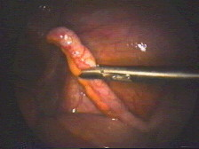
Retraction of Appendix
The appendix is grasped at its tip with a 5 mm claw grasper via the RUQ trocar. It is held in upward position.
Left lower quadrant (LLQ) grasper is used to create a mesenteric window behind the base of the appendix. A dolphin nose grasper is used to create a mesenteric window under the base of the appendix. The window should be made as close as possible to the base of the appendix and should be approximately 1cm in size.
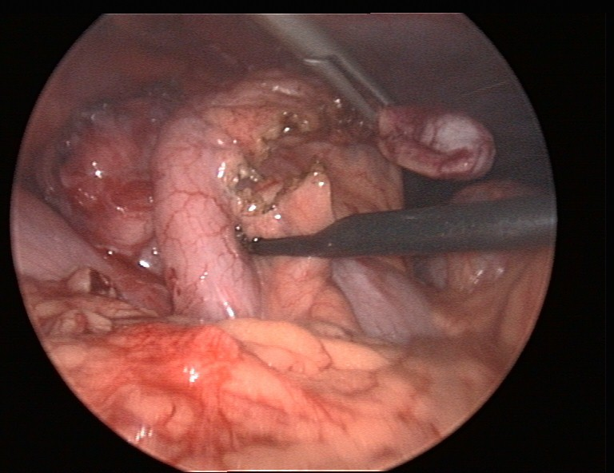
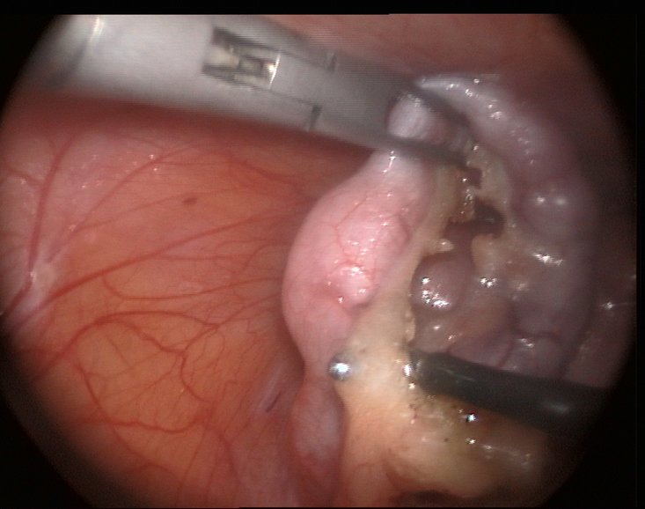
Dissection of Mesoappendix
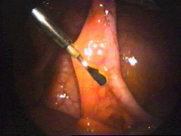
Window in Mesoappendix
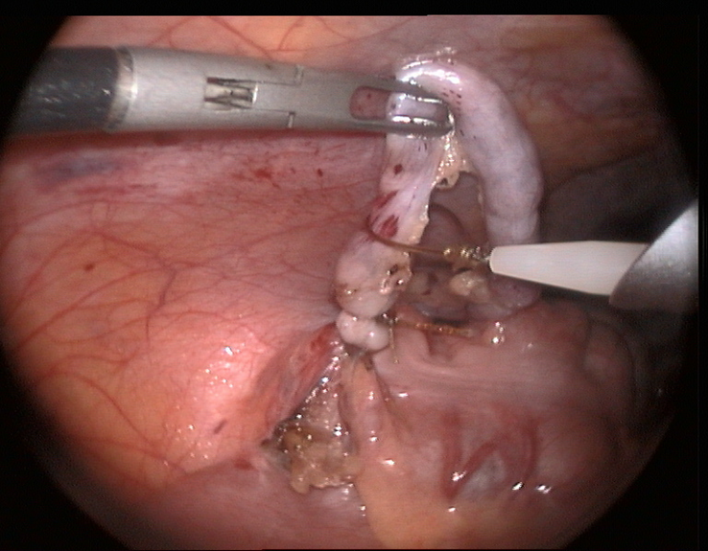
Meltzer Knot over appendix
Extra-corporeal knotting performed (Meltzer or Tayside knot) for mesoappendix as well as appendix
The appendix is now amputated from the gastrointestinal tract.
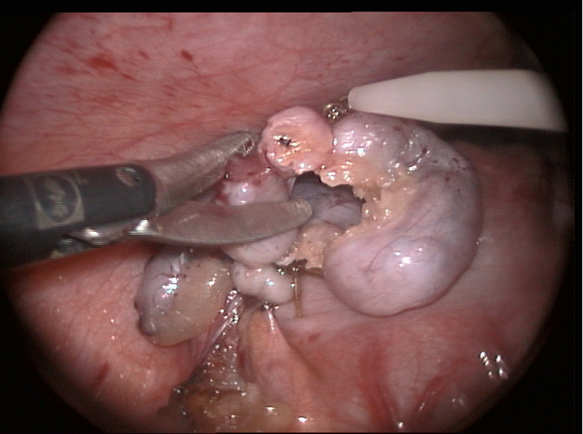
The appendix held by the grasper and is placed into the specimen bag or if not inflamed take it out after hiding it inside reducer or cannula itself.
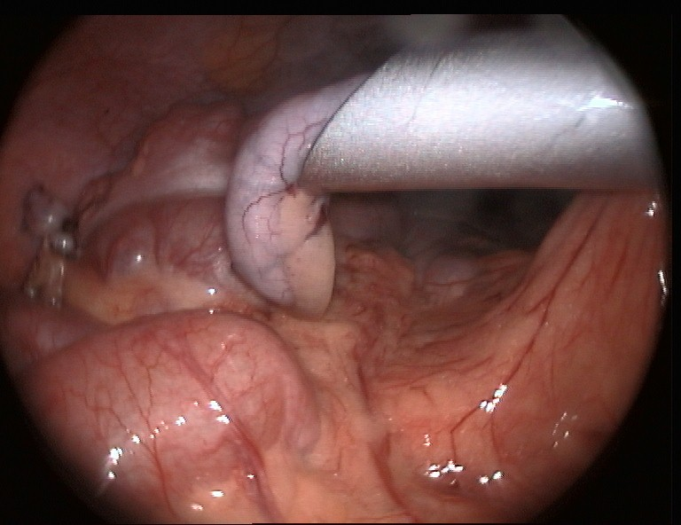
Amputated Appendix inside cannula

Examine the abdomen for any possible bowel injury or hemorrhage.
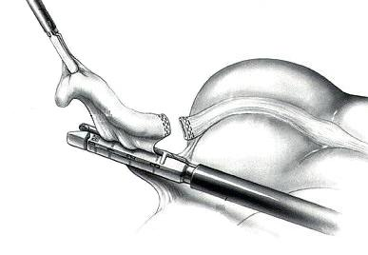
The appendix may be transacted by inserting an ENDO GIA instrument via the RUQ trocar (blue cartridge, 3.5), closing it around the base of the appendix and firing it.

An ENDO CATCH*instrument is inserted via the RUQ trocar and deployed in the intra-abdominal cavity. The appendix, held by the grasper and, is placed into the specimen bag.
The intra-abdominal cavity is irrigated thoroughly with normal saline.
For perforated appendicitis with or without an intra-abdominal abscess, a drain is left in the RLQ and pelvis.
In experienced hand extra-corporeal knotting can be well performed (Meltzer or Tayside knot) instead of stapler.

Ending of the operation.

Abdomen should be examined for any possible bowel injury or haemorrhage. All the Instrument and then port should be removed carefully. The wound should be closed with Suture. Use vicryl for rectus and Un-absorbable intra-dermal or Stapler for skin. Adhesive sterile dressing should be applied over the wound.
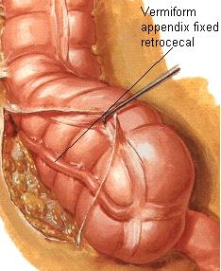

Laparoscopic appendectomy has gained lot of attention around the world. However, the role of laparoscopy for appendectomy, one of the commonest indications, remains controversial. Several controlled trials have been conducted, some are in favor of laparoscopy, others not. The goal of this review was to ascertain that if the laparoscopic appendectomy is superior to conventional, and if so what are the benefits and how it could it be instituted more widely. There is also diversity in the quality of the randomized controlled trials. The main variable in these trials are following parameters:
- Number of patients in trial
- Withdrawal of cases
- Exclusion of cases
- Blinding
- Intention to treat analysis
- Publication biases
- Local practice variation
- Prophylaxis antibiotic used
- Follow-up failure.
Without proper attention to the detail of all the parameters it is very difficult to draw a conclusion. It has been found among the surgeons that; there is a hidden competition between laparoscopic surgeons and the surgeons who are still doing conventional surgery, and this competition influences the result of study. One should always think of laparoscopic surgery and open as being complimentary to each other.
A successful outcome requires greater skills from the operator. The result of many comparative studies have shown that outcome of laparoscopic appendectomy was influenced by the experience and technique of the operator. Minimal access surgery requires different skills and technological knowledge. With a clear diagnosis of complicated appendicitis, the skill and experience of the surgeon should be considered for the selection of operating method. Surgeons should perform the procedure with which they are more comfortable.

Relative risk factors of laparoscopic appendectomy:

Missed Diagnosis
There is report also of Mucinous cystadenoma of the cecum missed at laparoscopic appendectomy. Less than 1% of all patients with suspected acute appendicitis are found to have an associated malignant process. During conventional appendectomy through a laparotomy incision, the caecum and the appendix are easily palpated, and an obvious mass can be detected and properly managed at the time of appendectomy. The inability to palpate any mass is an inherent problem of laparoscopic surgery.

Bleeding:
From the mesoappendix, omental vessels or retroperitoneum. Bleeding is usually recognized intra-operatively via adequate exposure, lighting, and suction. It is recognized post-operatively by tachycardia, hypotension, decreased urine output, anemia, or other evidence of hemorrhagic shock.
Visceral Injury:
Risk of accidental burns is higher with monopolar system because electricity seeks the path of least resistance, which may be adjacent bowel. In a bipolar system since the current does not have to travel through the patient, there is little chance of injury to remote viscera. In laparoscopic appendectomy only bipolar current should be used. Laparoscopists should also routinely explore the rest of the abdomen.
Wound infection:
Proper tissue retrieval technique is required to prevent wound infection after appendectomy
It is recognized by erythema, fluctuation and purulent drainage from port sites. The absence of wound infections after laparoscopic appendectomy can be attributed to the practice of placing the appendix in a sterile bag or into the trocar sleeve prior to removal from the abdomen. The regular use of retrieval bag is a very good practice for preventing infection of the wound.
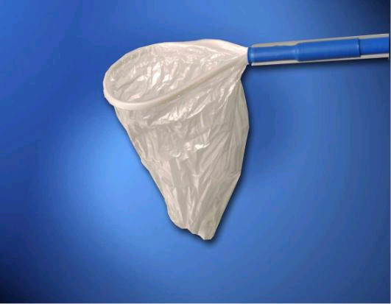
Endobag should be used for infected Appendix

Incomplete appendectomy:
If surgeon is not experienced, the stump of the appendix may be to long. There is a report of intra-abdominal abscess formation due to retained faecolith after laparoscopic appendectomy. It is strongly advised that the surgeons performing laparoscopic appendectomy should remove faecolith if found, and the stump of appendix should not big enough to contain any thing. Incomplete appendectomy is a result of ligation of the appendix too far from the base. It may lead to recurrent appendicitis, which presents with symptoms and signs of appendicitis even after laparoscopic appendectomy.
Some surgeons prefer stapling of the appendiceal stump for laparoscopic appendectomy for the treatment of all forms of appendicitis. But most of the surgeons now agree that ligation of the appendectomy stump is the best approach. There is report of slippage of clip, residual appendicitis followed by abscess formation after using clip for appendiceal stump. The ligation should be preformed by using endoloop, an intra-corporeal surgeon’s knot, or done extra corporeally using a Meltzer’s knot or Tayside knot. The security of the knot is essential. It is influenced by the proper port location and experience of the surgeon.
Leakage of purulent exudates from appendix at the time of operation:
It is usually seen intra-operatively while dissecting appendix. Copious irrigation and suction followed by continued antibiotics can prevent this complication until patient is afebrile with a normal white blood cell count. Retrieval bag should be used to prevent the spillage of infected material from the appendiceal lumen.
Intra-abdominal abscess:
This post-operative morbidity is recognized by prolonged ileus, sluggish recovery, rising leukocytosis, spiking fevers, tachycardia, and rarely a palpable mass. After confirmation of the intra-abdominal abscess drainage of pus followed by antibiotic therapy is essential. Sometime laparotomy may be required.
Hernia:
Trocar site hernia as visible or palpable bulge is sometime encountered. Possible occult hernia manifested by pain or symptoms of bowel obstruction.
Laparoscopic appendectomy is now safe in experienced hands. In experienced hands, satisfactory peritoneal toilet can be performed even in the presence of Peri-appendiceal pus and regional peritonitis. Laparoscopic appendectomy is not advocated when the patient has generalized peritonitis.
Indications for the surgical treatment of appendicitis:
Laparoscopic appendectomy | Open appendectomy
Female of reproductive age group | Complicated appendicitis
Female of pre-menopausal group | COPD or Cardiac disease
Suspected appendicitis | Generalized peritonitis
High working class | Previous lower abdominal surgery
Obese patients | Hypercoagulable sates
Disease conditions like Cirrhosis of liver and sickle cell disease | Stump appendicitis after previous Incomplete appendectomy
Immune-compromised patients
Future prospects of laparoscopic appendectomy.
In the future, remote handling technology will overcome some of the manipulative restriction of current instruments. There is no doubt that 20 years from now some surgeons will be operating exclusively via a computer interface controlling a master–slave manipulator. But the future of any new technology depends upon applications and training.
Laparoscopic appendectomy is equally safe, and can provide less postoperative morbidity in experienced hands, as open appendectomy. Most cases of acute appendicitis can be treated laparoscopically. Laparoscopic appendectomy is a useful method for reducing hospital stay, complications and return to normal activity. With better training in minimal access surgery now available, the time has arrived for it to take its place in the surgeon’s repertoire.
For More Information Contact:
Laparoscopy Hospital
Unit of Shanti Hospital, 8/10 Tilak Nagar, New Delhi, 110018. India.
Phone:
+91(0)11- 25155202
+91(0)9811416838, 9811912768
Email: contact@laparoscopyhospital.com

Copyright © 2001 [Laparoscopyhospital.com]. All rights reserved.
Revised: .

