WORLD LAPAROSCOPY HOSPITAL
Cyberciti, DLF Phase II, NCR Delhi, Gurgaon, 122 002, India
Phone: +91(0)12- 42351555 Mobile: +91(0)9811416838, 9811912768,
Email: contact@laparoscopyhospital.com
Click here for training detail

Hysteroscopy A Guide line

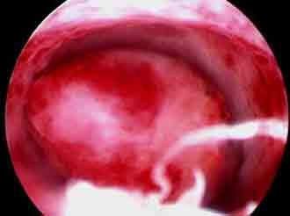
Definition
Hysteroscopy is a procedure used to view the inside of the uterus through a telescope-like device called a hysteroscope
The hysteroscope is placed in the vagina and introduced into the uterus through the cervix
INDICATIONS
Abnormal uterine bleeding
Infertility
Recurrent pregnancy loss
Abnormal hysterosalpingogram revealing intrauterine adhesions, polyps, fibroids, septum
Possible intrauterine foreign bodies
CONTRAINDICATIONS
Pregnancy
Heavy uterine bleeding
Pelvic inflammatory disease
Cervical malignancy
Recent uterine perforation
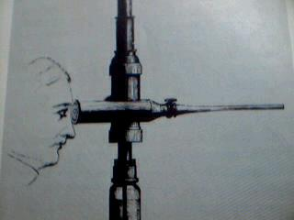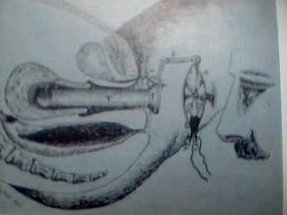
History
First hysteroscope with Cystoscope of Desormeaux by Pantaleoni 1869
First hysteroscope with built in lens to magnify the image
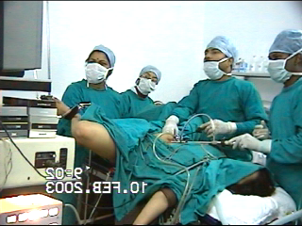
DELIVERY DEVICES
Maximum recommended intrauterine operating pressure is 150 mm Hg
Intrauterine pressure is a function of inflow pressure and outflow pressure
Inflow pressure may be produced by gravity, pressured cuffs with (pressure) gauges, or approved pumps
DISTENDING MEDIA
Group A: Isotonic Ionic Solutions (Normal Saline, Ringer's Lactate)
Group B: 5% Dextrose in Water
Group C: 1.5% Glycine, Sorbitol, Cytal
Group D: Hyskon (32% Dextran 70)
FLUID MONITORING
It is the role of the circulating nurse to maintain a flow sheet recording inflow and outflow of hysteroscopic media during the case
For Groups A, B and C the inflow and outflow must be estimated for every 500 cc of fluid used and measured at the conclusion of each bag of distending media
For Group D the inflow and outflow must be measured for every 100 cc of fluid used
The operating surgeon will be informed of fluid balance status as it is recorded on the flow sheet
Spillage should be avoided and quantities whenever a significant spill occurs
Use of a table drape to collect excess fluid for accurate recording of fluid output is required
EXCESSIVE FLUID ABSORPTION
The recommended volume of input to output discrepancy at which point the surgeon must assess serum electrolytes (especially sodium concentration) is
Group A: 1 liter
Group B: 1 liter
Group C: 1 liter
Group D: 250 ml
Once these volumes of discrepancy have been reached, serum electrolytes must be obtained and the operating surgeon has the option of:
Terminating the case
Awaiting the results of the electrolyte levels and proceeding accordingly
Administering Lasix IV and judiciously proceeding with the case until the results are available
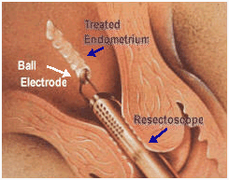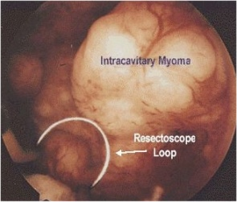
Resectoscope
The resectoscope has been used for male prostate surgery for over 50 years.
The resectoscope with a built in wire loop or other shape device, uses high-frequency electrical current to cut or coagulate tissue.
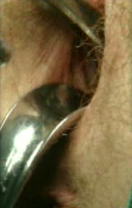
Procedure
Inside of the uterus is a potential cavity, like a collapsed airdome, it is necessary to fill (distend) it with either a liquid or a gas (carbon dioxide) in order to see.
Diagnostic hysteroscopy and simple operative hysteroscopy can usually be done in an office setting.
More complex operative hysteroscopy procedures are done in an operating room setting.

IMPORTANT NOTES:
The volumes that are recommended in this section are not based on established "standards of care" since such standards have not yet been clearly formalized. For example, I use 1 Liter as a cut off for D5W while some of the world's leading hysteroscopic surgeons use 3 Litters. There is no established limit for the volume of D5W that can safely be given as an IV solution being directly infused into the circulation of a healthy person. I have found no reports of major morbidity associated with the use of D5W in the literature.
Additional patient assessment following a large volume discrepancy between input and output may immediately involve determination of serum electrolytes. If a significant time has passed since the (presumed) absorption of fluid, other clinical parameters (if available) may become more informative (evidence of tissue oedema, an increase in cardiac output associated with volume overload, change in pulse oximetry or ventilation parameters, change in patient temperature if room temperature fluid is used)
Use a resectoscope with continuous flow and a loop electrode to perform most of hysteroscopic surgery. I have not found a pumping system for distending media that is sufficiently accurate, rapid in response (so as to maintain a constant pressure), affordable, and easy to use. Many pumps are available and as this technology develops I anticipate that a great pumping system will become available. At present, I use a simple system of placing a blood pressure cuff around each one liter bag of D5W solution to be used and apply 150 mm Hg pressure (as measured on a gauge attached to the cuff) to the pressure cuff. This is connected to the inflow port on the resectoscope and flow is then adjustable using a stop cock on this port. Outflow from the resectoscope is via tubing that connects directly to a suction canister under full wall suction. The outflow port also has a stopcock that can be used to adjust the outflow.
The circulating nurse's primary responsibility during the operative hysteroscopy is to maintain pressure on the pressure cuff and watch the inflow and outflow balance. The nurse might appropriately report this balance to the surgeon and anaesthesiologist every 15 minutes or whenever there is a significant volume of use (say 500cc).
The resectoscope's monopolar electrocautery loop is attached to an electrical generator with variable power (wattage) settings. For any given power setting selected, there are also various blends of cutting or coagulation that can be chosen. Use blend 1 which applies current 80% of the time and gives just a little coagulation as compared to pure cutting. For most resectoscopic use 50-80 Watts on blend 1 and coagulate bleeders (if not initially controlled with the blend 1 settings) using 50 Watts at pure coagulation.
Once the hysteroscopic portion of the case is completed, do a final tabulation of inflow and outflow volumes for the distending media and direct your attention to the laparoscopy once the hysteroscopy is complete. A uterine manipulator is placed through the cervix;
Laparoscope should be inserted now. For this Veress needle is introduced. Insufflation of the abdomen with CO2 gas so as to create a pneumoperitoneum is accomplished after "confirming the proper placement" of the Veress needle.
Once the pneumoperitoneum is created, the Veress needle is replaced by a trocar and sleeve. The diameter of the umbilical (main) trocar is 10-12 mm so that this instrument can cause considerable injury if not placed properly and atraumatically into the abdominal cavity. The presence of adhesions (scar) that elevates the bowel to the anterior abdominal wall is a consistent source of concern for laparoscopic surgeons.
If abundant adhesions are anticipated such that the surgeon believes that the complication rate with the blind Veress needle and trocar insertion is unacceptably high, then "open laparoscopy" may be chosen. Hasson introduced this technique in which the direct insertion of the trocar without the creation of a prior pneumoperitoneum is accomplished by performing a cut down under direct observation of the layers of the abdominal wall. Suture holds the layers of the inner abdominal wall (fascia and peritoneum) to the trocar sleeve to prevent the release of gas through the incision site during the case. Extreme care must be exercised in making the peritoneal incision since bowel injury to adherent bowel may occur under direct observation as well.
Accessory trocar sites are usually required during the laparoscopic case. Typically use two additional sites for placement of 5 mm (or uncommonly 10 mm) trocars in the suprapubic midline and left lower quadrant. All accessory trocars have the advantage of being able to be inserted under direct observation so injury is less common. One injury associated with placement of the accessory trocars is laceration of the deep inferior epigastric vessels (which may be difficult to see either directly or via transillumination). Injury to the inferior epigastric vessels can be consistently avoided by placement of the additional trocars either lateral to the internal inguinal ring or medial to the umbilical ligaments (two structures that are usually easy to identify under direct laparoscopic observation).
Tools that are selected for the performance of the laparoscopic surgery should allow the surgeon to minimize postoperative adhesion formation. The surgical principles as discussed above are very important in terms of achieving the desired outcome. Gentle tissue handling during laparoscopy takes a great deal of time to develop. Avoidance of bleeding with gentle tissue handling is important and so is careful haemostasis using (selective) bipolar cautery. Continuous irrigation and aspiration of the tissues to remove char and minimize drying should be second nature to the laparoscopic infertility surgeon. Use of cutting instruments that minimize lateral tissue damage is also a primary concern.
Once the case has been completed, the instruments are removed from the abdomen allowing for the efflux of CO2 gas. Usually take additional 5 or so minutes to move the abdominal wall and contents about with only one remaining trocar sleeve in place to try to allow any trapped gas to escape. Incisions are closed with subcuticular stitches so as to avoid cosmetically unpleasant "railroad" type skin scars. The fascia is closed on any incision in the fascia greater than 5 mm.
In the immediate postoperative recovery time period, common problems include
Nausea and vomiting, most likely related to the CO2 gas or the narcotic pain medications used perioperatively. Zofran is often the most effective anti emetic agent for post laparoscopic vomiting. The nausea and vomiting does not typically persist for more than 12 hours postop.
Shoulder pain due to retained CO2 gas, which if trapped under the diaphragm (at base of the lungs) causes irritation of the phrenic nerve to cause the sensation of shoulder pain. Lying on one's abdomen with a pillow under the hips and lower abdomen (or the knee chest position) may allow the CO2 gas to recollect in the pelvis rather than under the lungs and reduce this discomfort.
Subcutaneous crepitance (crackling) under the skin over the abdomen and extending superiorly to the chest and neck or inferiorly to the buttocks and thighs is typically a minor complication due to escape of the gas into the abdominal wall. A rare patient develop a very low blood pressure (not related to blood loss) and usually responds immediately to a bolus of IV solution.
Incisional pain is usually mild but the internal (visceral) pain after surgery can be intense and may require narcotics or anti inflammatory agents. Reportedly a heating pad applied to the abdomen may also be helpful.
If a large volume of fluid is left in the abdomen at the conclusion of the case then leakage through the incision sites is common for up to 2 days.
the surgeon should be called if there is a fever (greater than 100 degrees) or chills, heavy or prolonged vaginal bleeding, heat or swelling of the incision sites, frequency or burning on urination, severe pelvic pain, persistent nausea or vomiting, faintness or dizziness, inability to spontaneously urinate.
Postoperative urinary retention occurs more often in cases that last longer than 2 hours. If the patient is not able to void within 4-5 hours post-op (and after removal of the Foley catheter) then she should be straight catheterized for the residual volume of urine and she should try to void spontaneously once again. Do not allow my patients to go home until either they can void spontaneously or they have an indwelling Foley catheter placed (for about 1 day).

Complications of Operative Hysteroscopy
Trauma
Cervical laceration
Uterine perforation
Injury to Intra-abdominal Viscera-Rectum, Bladder, Intestine
Intravasation – Predisposing factors for venous intravasation of distending media:
Uterine Tuberculosis, Submucous tumour, Hypoplastic uterus, Recently
Traumatised uterine cavity, Proximal tubal obstruction, Excessive Pressure of Instillation
Infection
Exacerbate latent salpingitis
PID
Febrile reaction
Bleeding
Peritonitis

Safety measures:
1) Dilatation of the cervix:
The cervix must be dilated in order to enter the hysteroscope into the uterine cavity. Most resectoscope has an outer sheath diameter of about 9 mm so that cervical dilatation using mechanical dilators must be at least this amount. It is optimal to avoid over dilatation of the cervix since leakage of the distending media through the cervix and around the hysteroscope (especially under pressures of about 150 mm Hg) then becomes possible.
Some cervical canals are difficult to negotiate with dilators. Different dilators have a variable amount of curvature to choose from. It is possible to perforate the lower uterine segments during dilatation. Clinical situations in which perforation is more common include dilatation of the pregnant uterus, fibroid uterus, uterus of a women exposed to DES in utero, uterus after exposure to prostaglandins for cervical ripening, and infected uterus. Many cases of perforation occur at the onset of dilatation and the subsequent dilators then continue to open the perforation site.
Occasionally, a rent in the lower uterine segment occurs during dilatation. It is thought that rapid dilatation or a difficult dilatation involving a stenotic inflexible cervix may enhance the frequency of these tears. It is possible for a tremendous amount of distending media to become intravasated through these rents and into the large vessels of the lower uterine region if they are transacted.
Cervical incompetence following hysteroscopic surgery is rarely reported but theoretically possible. The cervix is composed of a tough fibroconnective tissue and smooth muscle. Closure of the internal os of the cervix is the general rule even following manual dilatation of up to 15 mm.
2) Bleeding:
The pressure maintained in the uterine cavity may (but generally should not) exceed both the venous and the arterial pressures so that active blood flow from transacted vessels may not become apparent until the uterus is deflated. At lesser pressures, bleeding can be identified and usually controlled. If there is excessive bleeding following destructive procedures such as endometrial ablation then this is frequently controlled by tamponade using an inflated Foley catheter balloon (10-30 ml for up to 16 hours) in the uterus. Sometimes the excessive flow can be controlled with estrogens hormonal therapy (if due to denuding the lining).
3) Excessive intravasation of distending media or CO2 gas:
Whenever vessels are transacted during hysteroscopic surgery and either fluid or gas is entered into the uterine cavity under pressure there is a possibility of intravasation (entry of these substances into the circulation). For a more complete discussion of characteristics of the different available distending media and a sample operating room protocol see "The Surgeon's Routine" subsection.
D5W (5% Dextrose in Water) is a good distending media for diagnostic hysteroscopy. Major complications with this solution are very rare. In fact, there are no reports in the world literature of major morbidity or mortality with the use of D5W at hysteroscopy. Possible complications include water intoxication (a reduction in serum osmolality) with a dilutional reduction in sodium concentration, volume overload (when the circulating volume in the vascular system exceeds the ability of the heart to adequately pump this volume and the excess fluid typically begins to collect in the tissues of the lungs), hypothermia (significant reduction in body temperature) if room temperature solutions are used without warming the patient with devices like a "Bair Hugger," and hyperglycaemia (significant excess in circulating glucose concentration that may not be rapidly metabolized if the patient has insulin resistance or diabetes mellitus).
The major complication that most hysteroscopic surgeon's focus on avoiding is water intoxication. The risk of water intoxication from D5W in a healthy woman with normal renal function is very low, since the kidneys can typically produce in excess of 1000cc of dilute urine in response to a decrease in serum osmolarity.
4) Adhesions:
Following hysteroscopic surgery, there is a chance of adhesion (scar) formation. If significant electro coagulation is used within the uterine cavity in the infertility patient with intra-operative estrogen IV (25 or 50 mg of Premarin) and at least a 30 day course of higher dose Premarin postoperatively (1.25 mg or preferably 2.5 mg if tolerated) should be used.
5) Burn injury to the bowel:
When resectoscopic electrosurgery is performed in the area of the uterine ostia (near the entry site of the fallopian tubes) there is a chance of thermal injury to adjacent tissue outside the uterine cavity. This is because the uterine wall in these regions is very thin and heat from the cautery can travel through the uterine wall and burn adjacent bowel.
6) Infection:
Endometritis is uncommon after operative hysteroscopy and antibiotics are usually not "routinely" given. I however have a very low threshold for the decision to use antibiotics since their potential benefits outweigh their risks when exposure to infection occurs.
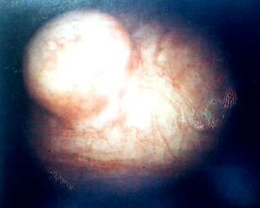
Hysteroscopy in abnormal uterine bleeding
Sub mucous Myoma
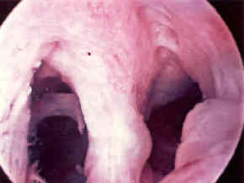
Hysteroscopy in cases of Infertility
Septate uterus
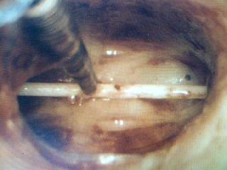
Hysteroscopy in cases of Infertility
Forgotten IUD
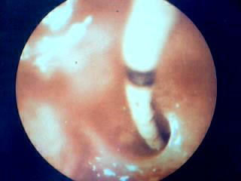
Tubal cause of Infertility
Salpingo
catheterization
To clarify tubal cause of Infertility :
Ureteric catheter used to cannulate tube
Intracavitory pressure rises
Flow rate falls
Salpingocathetarization not possible
Inability to induce contraction of tubal angle ( Post Inflammatory Fibrosis)
Combined Laparoscopy and Hysteroscopy used for TUBAL PATENCY TEST and Therapeutic options
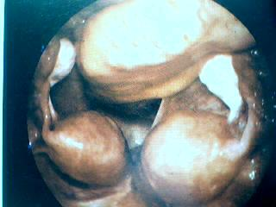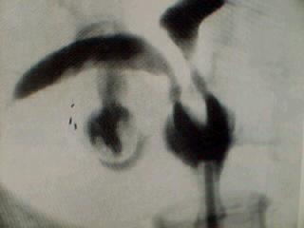
Hysteroscopy correlation in Diagnosis
Bicornuate Uterus

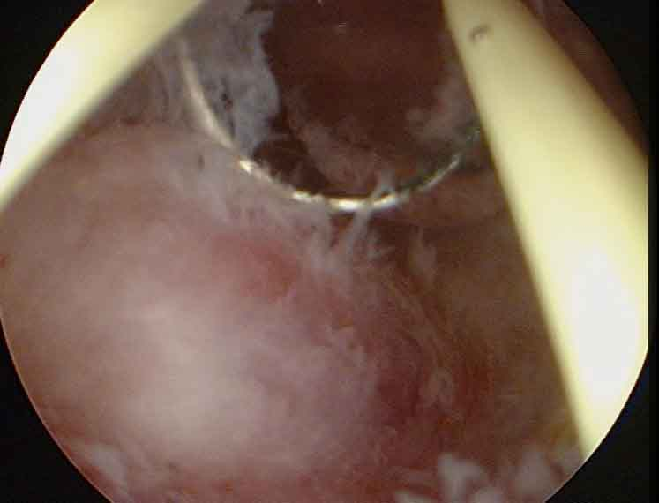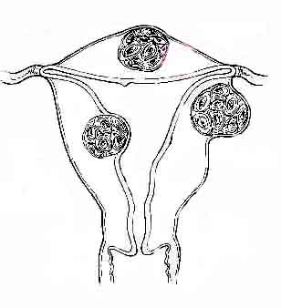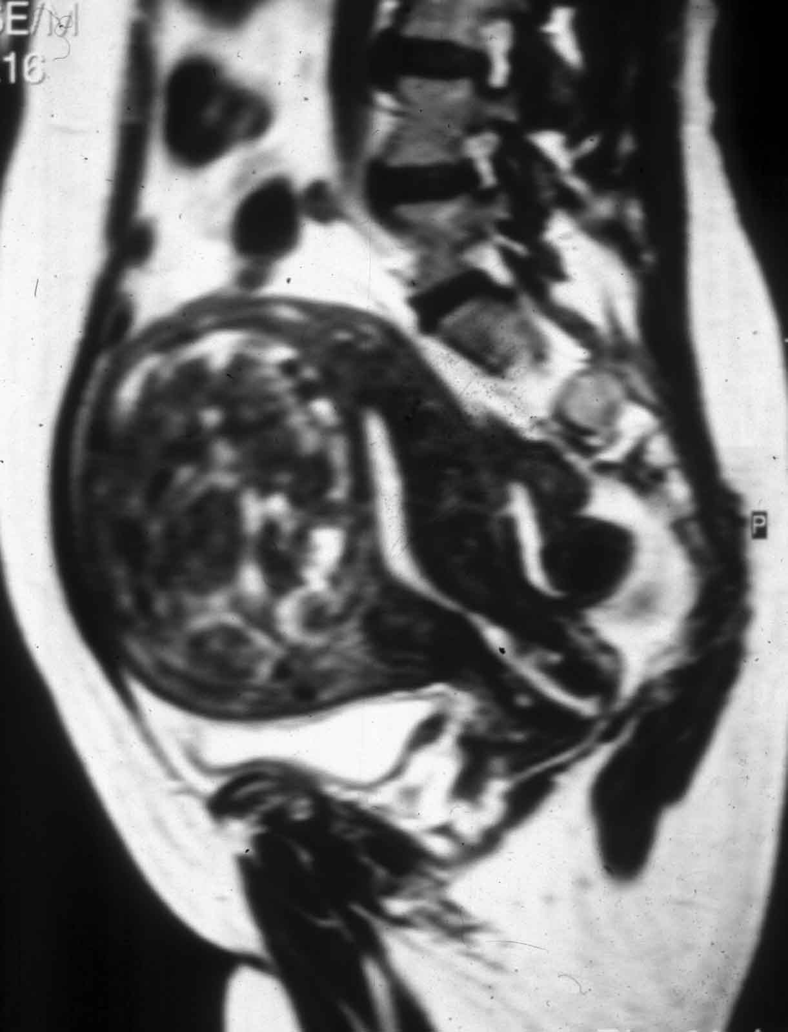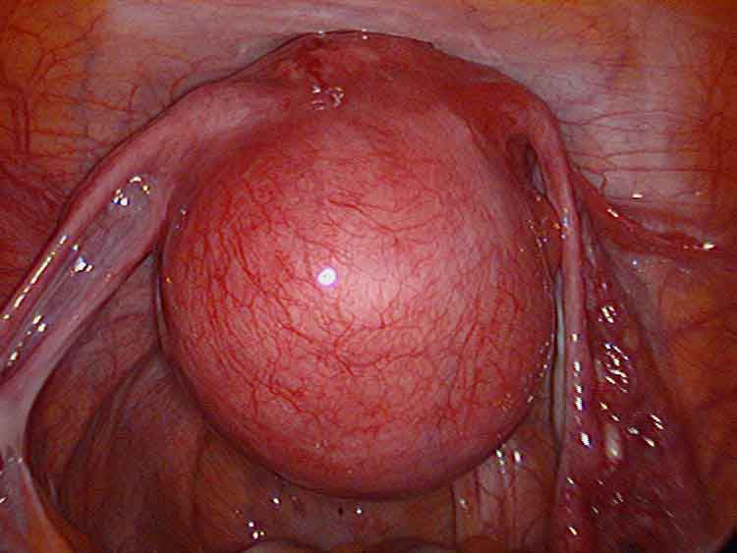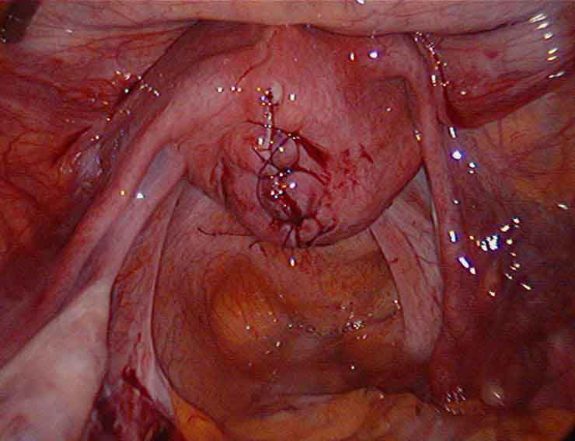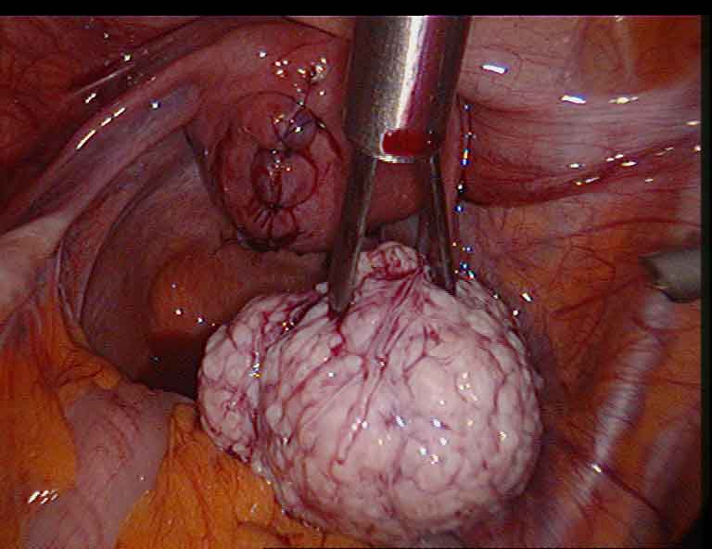
Hysteroscopic correlation and Diagnosis
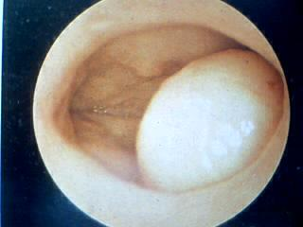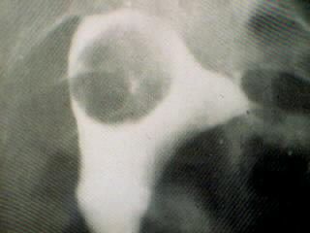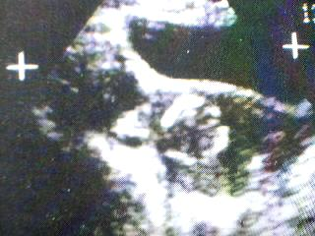
Hysteroscopy correlation in Diagnosis
Submucous Myoma
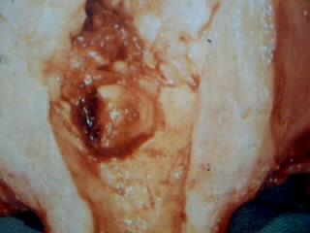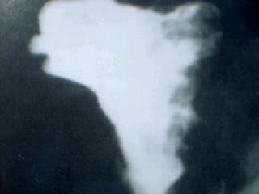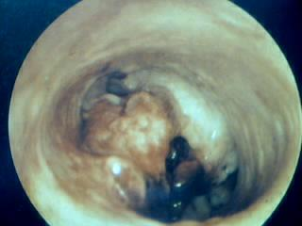
Hysteroscopy correlation in Diagnosis
Endometrial Carcinoma
Contraindications
Absolute
Adnexal and endometrial infection
Relative
Menstruation
Pregnancy
Cone Biopsy of Cervix
Pelvic irradiation
Cardiac and Pulmonary diseases
Scarred Uterus and adhesions
For More Information Contact:
Laparoscopy Hospital
Unit of Shanti Hospital, 8/10 Tilak Nagar, New Delhi, 110018. India.
Phone:
+91(0)11- 25155202
+91(0)9811416838, 9811912768
Email: contact@laparoscopyhospital.com

Copyright © 2001 [Laparoscopyhospital.com]. All rights reserved.
Revised: .

