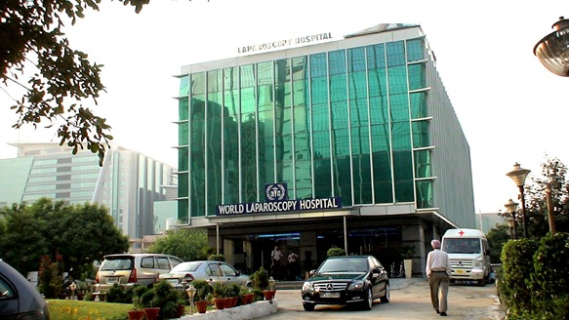
How To Reach World Laparoscopy Hospital
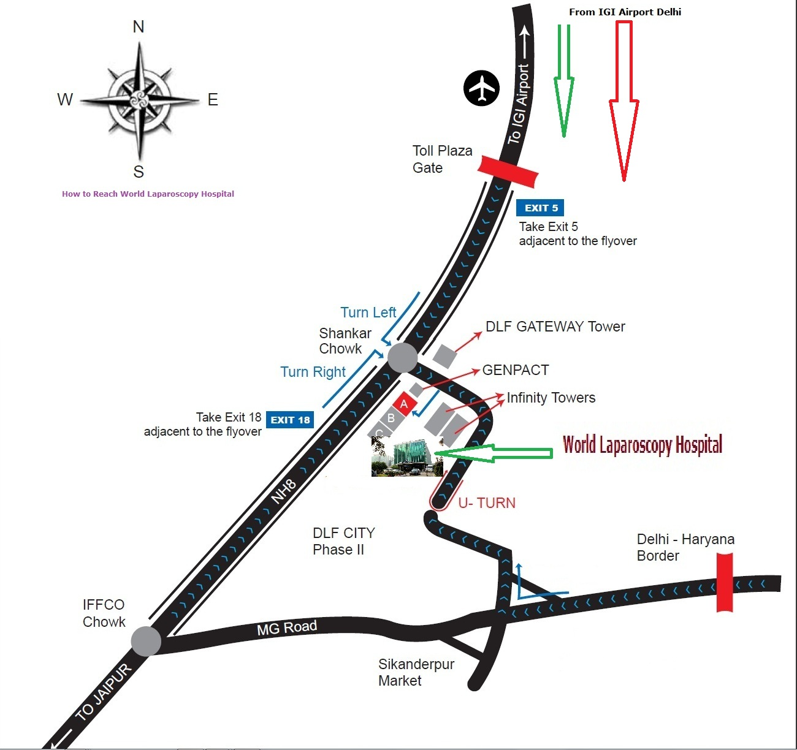
The day before start of course many surgeon comes from many countries from every corner of World. We are very busy and dedicated for laparoscopic treatment, training and research and we have the course going on every day, every week, every month and every year so we request our surgeon to take a prepaid taxi from the airport. Generally pickup and drop facility from airport we don't provide for our guest. The prepaid transport from airport is very safe and quicker way to reach us. These taxies are controlled by police and very reliable, you don't have to bargain. It will cost you approximately 500 rupees to come to World Laparoscopy Hospital, Gurgaon, from the airport.

World Laparoscopy Hospital
Cyber City, DLF Phase II, Gurgaon, NCR Delhi, 122 002, India
PHONES:
For Training: +91(0)9811416838, 9999677788
For Treatment: +91(0)9811912768
For General Enquiry: +91(0)124 - 2351555
Email: contact@laparoscopyhospital.com
http://www.laparoscopyhospital.com

