WORLD LAPAROSCOPY HOSPITAL
Cyberciti, DLF Phase II, NCR Delhi, Gurgaon, 122 002, India
Phone: +91(0)12- 42351555 Mobile: +91(0)9811416838, 9811912768,
Email: contact@laparoscopyhospital.com
Click here for training detail

Hand Assisted Laparoscopic Surgery

In hand-assisted surgery, the surgeon can insert a hand through the small incision via a special pressurized sleeve. In this procedure, the surgeon makes a small incision in the abdomen and inserts his hand into the patient’s body, using it for sensory perception and to guide the surgical instruments he manipulates with his other hand while observing the entire procedure on a TV screen overhead. With both a hand and laparoscopic instruments doing the work, the surgeon has more control over the operation and sense of depth and sensation of touch than can not be gained through the lens of a camera. The large organ can be removed intact, making it possible to evaluate the cancer. The hand-assisted approach is also considered better for surgeons who are still learning laparoscopic techniques.Hand-assisted laparoscopic surgery is the use of the non-dominant hand intra-abdominally, together with the laparoscopic instruments in the right hand.

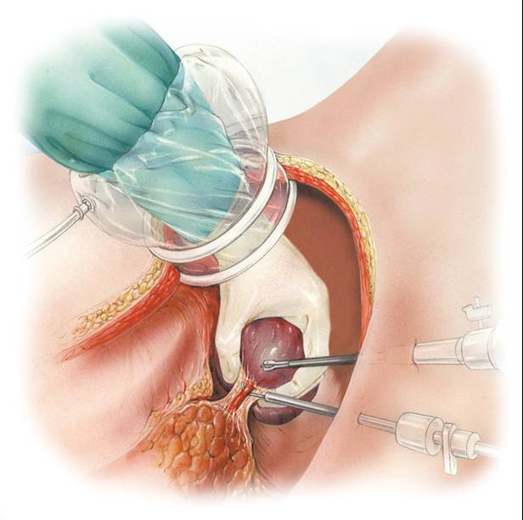

Some general points about anastomosis
It is important to take time to positively identify
- The optimum location of the enterotomy, in terms of anatomical position (distance distally).
- Position with regard to identification of the anti mesenteric border.
- Orientated in longitudinal axis
- Avoid both tension, and unnecessary redundancy.
- Ensure direction of flow (anti peristaltic)
- Remember the differential thickness of bowel wall.
- The anastomosis should be adequate (not too small and not too large).
- Haemostasis on enterotomy
- Security of closure, and prevention of anastomotic leakage.

Hand-assisted laparoscopic surgery:

Hand-assisted laparoscopic surgery (HALS) is the use of the non-dominant hand through a hand port device. It is an important adjunctive tool with other laparoscopic instruments. The hand port will be fixed via a mini-laparotomy incision, aiming for a safe maintenance of intra abdominal gas throughout the operative procedure. The main indication for HALS is in advanced and complex laparoscopic surgical procedures.

Rationale behind HALS:

Laparoscopic surgery in simple and complex procedures
Disadvantages of total laparoscopic surgery:
1. Loss of direct tactile sensation
2. Hand-eye coordination
3. Instrument changes
4. Conversion rate in complex intra
abdominal procedures.
What is Hand port:
"HandPort(TM)" system allows surgeons the ability to insert a hand into the patient to gain a tactile sense during laparoscopic surgical procedures. This is a real improvement over previous techniques which precluded a surgeon from gaining information through touch. Commercially available to date and approved by the FDA are Dexterity Device, Intromit, Hand port and Omni port. Omni port has been extensively studied by Europe University, Ninewells Hospital as well as being clinically applied with success in the repair of abdominal aortic aneurysms in Germany and USA. Pneumoaccess bubble is one of the great advances by Cuschieri and Shapiro 1995, allowing complete visual access with the hand inside and pneumoperitoneum safely maintained.

Hand port Devices:
Devices connected to abdomen by adhesive flange:
Dexterity (Inc., Roswell, GA, USA)
Intromit (Medtech Ltd., Dublin, Ireland)

Kissing balloon principle:
Hand port device (Smith-Nephew PLC, London, England)

Single piece devices:
Lapdisc ( Hakko Medical, Tokyo, Japan)
Omniport (Advanced Surgical Concepts Ltd., Dublin, Ire.)
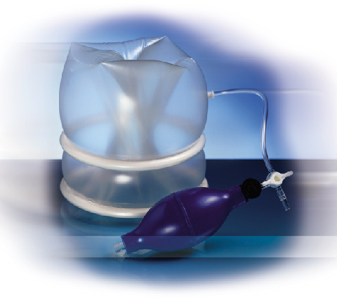
Omniport
Omniport is preferred device because it is:
- Single,
- Simple component,
- Easy to insert,
- Comfortable,
- Efficient pneumatic seal.
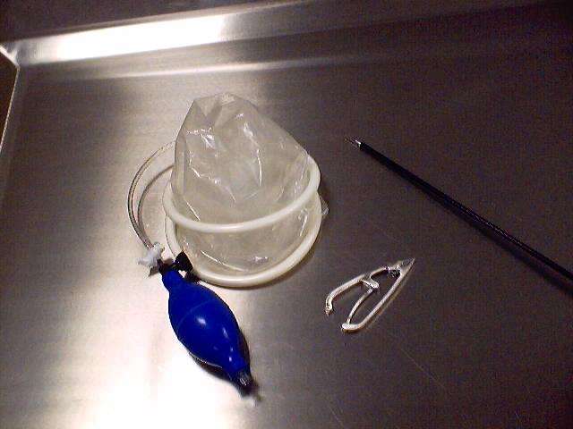

Advantage of HALS:
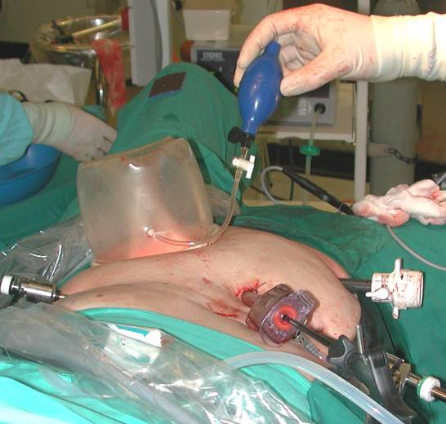
Pneumo-peritoneum is maintained with Omniport

Indication of HALS:
Hand assisted laparoscopic surgery is a new addition to minimal access surgery. It has a great potential. Many surgical operations, from the simplest to the very complicated, are greatly facilitated by the introduction of the hand into the laparoscopic arena. It is therefore purposefully designed in assisting the surgeon for complex intra-abdominal operation to be done with total laparoscopy. It stimulated many vascular surgeons throughout the world to reintroduce it into repair of complex and challenging abdominal vasculature. The Nephrectomy, Splenectomy, Colorectal surgeries are nicely performed through hand assisted technique.

Advantage of HALS?
- Restored tactile feedback.
- Preserving the main idea of Minimal Access Surgery (MAS).
- A mini-laparotomy hand Port incision.
- Reduced conversion rate in total laparoscopy.
- Enhanced safety and efficiency allowing the completion of the operation with a hand inside.
- Maintenance of the intra-abdominal pressure to facilitate the better view and magnification of laparoscopic telescope.
- Improving the steep learning curve for inexperienced surgeons.
- Promising reduced cost-benefit ratio

Future Prospect of HALS:

There are general and specific limitations, awaiting multi centre prospective randomized trials in order to compare HALS in various major intra-abdominal procedures with the traditional open surgery.

Limitations of HALS?
Limitations can be summarized to:
1. Fatigue,
2. Possible impaired tactile feedback through a lengthy complex procedure and
3. Minor ergonomic restriction is due to the crowdness of the hand with the instruments.
4. Not wells accepted by patient and surgeons because there is already a mini laparotomy.
5. Cosmetically inferior than total laparoscopic surgery.

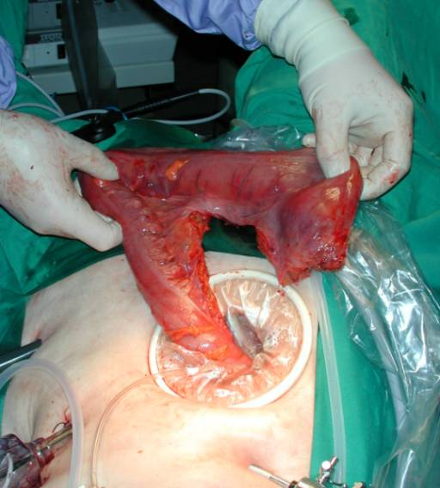
HALS and Colorectal Surgery
HALS can be used for all major complex abdominal surgeries like:
  - Splenectomy
  - Nephrectomy
  - Morbid obesity surgery
  - Pancreatectomy
  - Nissen fundoplication
  - Esophagectomy
  - Rectopexy
  - Repair of abdominal aortic aneurism

HALS is technically much easier than total laparoscopy in advanced abdominal procedures. It can help the beginning laparoscopic surgeon to practice such major operations.
Laparoscopic Hand Instruments:
For More Information Contact:
Laparoscopy Hospital
Unit of Shanti Hospital, 8/10 Tilak Nagar, New Delhi, 110018. India.
Phone:
+91(0)11- 25155202
+91(0)9811416838, 9811912768
Email: contact@laparoscopyhospital.com

Copyright © 2001 [Laparoscopyhospital.com]. All rights reserved.
Revised: .

