WORLD LAPAROSCOPY HOSPITAL
Cyberciti, DLF Phase II, NCR Delhi, Gurgaon, 122 002, India
Phone: +91(0)12- 42351555 Mobile: +91(0)9811416838, 9811912768,
Email: contact@laparoscopyhospital.com
Click here for training detail

Future of minimal access surgery:
Robotic Surgery
At present there are two instrument available which work on the principle of master slave manipulator.

The da Vinci system (Intuitive Surgical, Inc)
The Zeus system (Computer Motion, Inc)

These machines have interface for surgeon which deliver information through computer to robotic arm.

Recently Trans-Atlantic Surgery between USA and Strassbourg is a revolution in transatlantic minimal access surgery. Prof. Michael Gagner operated from 7000 kms away. In this surgery there was slight delay (66milli second) delay in transfer of data but in future this delay can easily minimized.

In the future remote handling technology will overcome the manipulative restriction in the current instruments. There is no doubt 10 years from now some surgeons will be operating exclusively via a computer interface controlling a master–slave manipulator. If computer-controlled machinery can mimic the awareness, adaptability and knowledge of a human surgeon, such a takeover in the operating theatre is actually realistic.
In the operating room of the future, physicians will use tiny high-tech tools to travel inside the body with dexterity and precision beyond imagining. The future is now but the future of any new technology depends upon how well the training is.
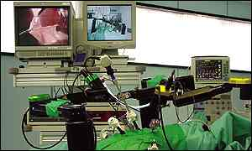
Robotic Surgery via Master Slave Manipulator
Although the potential of robotic surgery is just beginning but, progress may come quickly. Laparoscopic gallbladder surgery was first done 1987, but it became standard within five years. Just think about a surgeon! He picks up this black box and waves it over your body, and you're fixed. How's that going to happen? One day a surgeon may use robotic devices to enter the body through its own orifices. They could carry medical instruments inside the body, where they would be manipulated by simple computer commands.
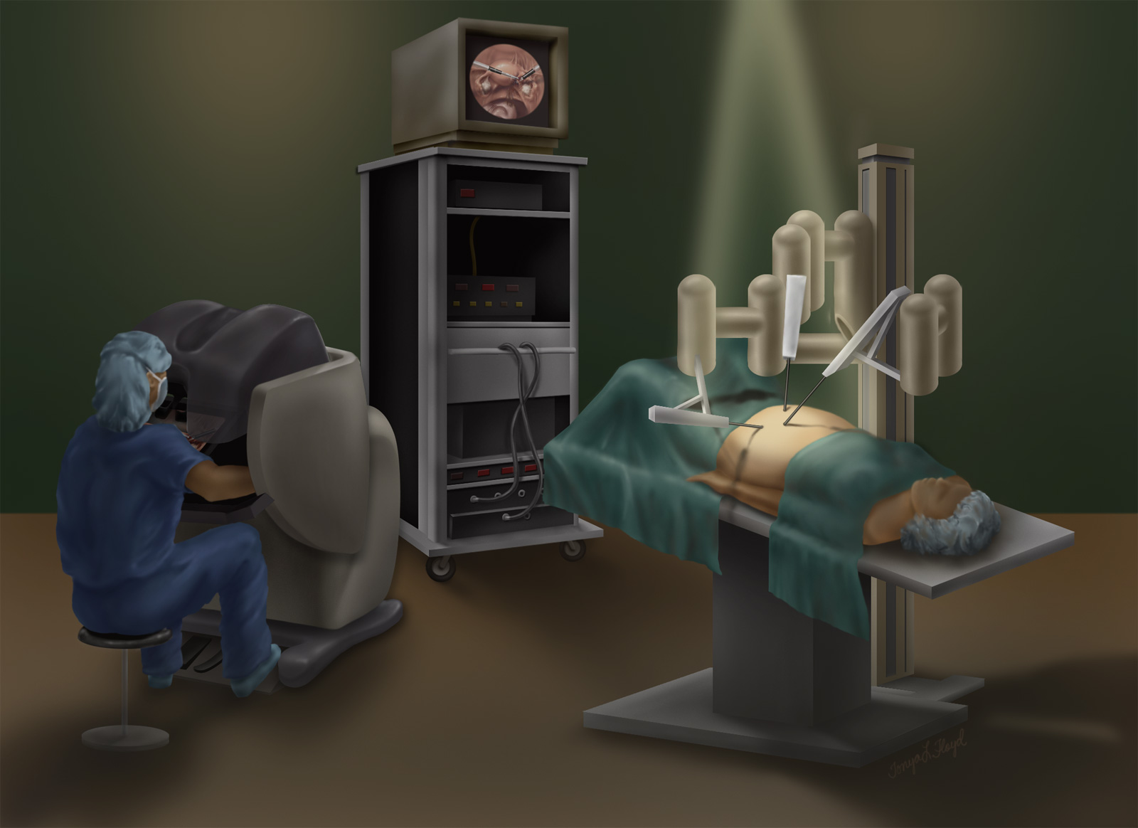
Master Slave Manipulator
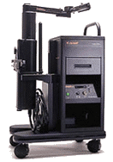
Robotic Console
In Minimal Access Surgery Robotic surgery is defined as a “ Powered computer controlled Master slave manipulator with artificial sensing that can be reprogrammed to move and position tools to carry out a range of surgical task. The robotic surgery is very useful in Minimal Access Surgery because steadiness in instrument handling of deeper structure is important. The first human use of robotic surgery was demonstrated for transurethral resection of prostate and was developed at Imperial college of London.

In Minimal Access Surgery, the two systems developed for clinical use are the Zeus system of Computer Motion Inc and the “da Vinci” system of Intutive Surgical Inc. Both these robotic system have a telescope with two separate manipulator arm. The “da Vinci” system has seven degree of freedom movement so it can perform more complex task. The “da Vinci” system has been used to perform a number of general surgical procedures like cholecystectomy and Fundoplication. Robotic Fundoplication allows easier passage around and behind the oesophagus during its dissection and easier mobilization of the curvature of the stomach. Suturing the wrap and the crural approximation are also easier with the help of these robots.



The robotic arm after addition of wrists permits the surgeon to mimic his own movements, rather than experience limitations of the rigid long cylindrical laparoscopic instrument and has obvious advantages in terms of dexterity and complexity of instrument.

At present there is limitation of use of Minimal Access Surgery techniques in cardiac surgery for beating heart but it is going to be started soon. Left anterior descending coronary artery is identified and robotic dissection mobilization of the left internal mammary artery graft anastomosis is performed. The first totally Minimal Access coronary artery bypass operation has been performed at the Imperial College (St. Mary’s) London.

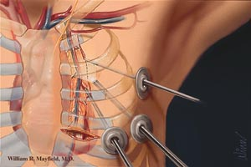

Four ports are used and robotic arm is introduced. One of the arms contains telescope which sends 12 to 15 time magnified clear image on the monitor. Another arm is for a stabilizer which is used to hold the diseased coronary artery in place while bypass is performed. The other two remaining right and left instrument is used to perform micro-vascular anastomosis. Currently robotic coronary bypass surgery should be considered only for the patient who has single vessel disease but in near future we have hope to perform double or even triple bypass surgery.
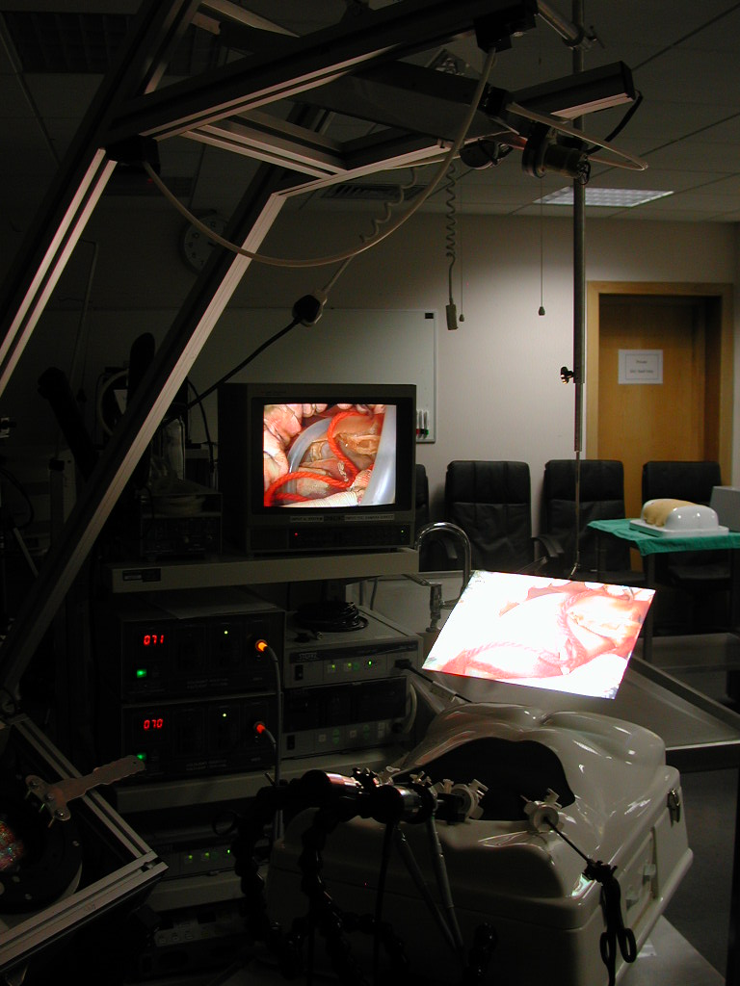
Hologram projection system
Laparoscopic surgery is growing in such a speed that 3d image projection system is going to replace the conventional monitor in near future and surgeon will get a virtual image in air just above the body of patient. This new projection system will abolish all the limitation of current two dimensional image without depth perception.
For More Information Contact:
Laparoscopy Hospital
Unit of Shanti Hospital, 8/10 Tilak Nagar, New Delhi, 110018. India.
Phone:
+91(0)11- 25155202
+91(0)9811416838, 9811912768
Email: contact@laparoscopyhospital.com

Copyright © 2001 [Laparoscopyhospital.com]. All rights reserved.
Revised: .

