WORLD LAPAROSCOPY HOSPITAL
Cyberciti, DLF Phase II, NCR Delhi, Gurgaon, 122 002, India
Phone: +91(0)12- 42351555 Mobile: +91(0)9811416838, 9811912768,
Email: contact@laparoscopyhospital.com

The Premier Laparoscopic Training Institute for Surgeon & Gynaecologist
Click here for training detail

Diagnostic Laparoscopy

Diagnostic laparoscopy is a minimally invasive surgical procedure that allows the visual examination of intra abdominal organs in order to detect pathology. The video image of the liver, stomach, intestines, gallbladder, spleen, peritoneum, and pelvic organs can be viewed on a monitor after insertion of a telescope into the abdomen. Manipulation and biopsy of the viscera is possible through additional ports.
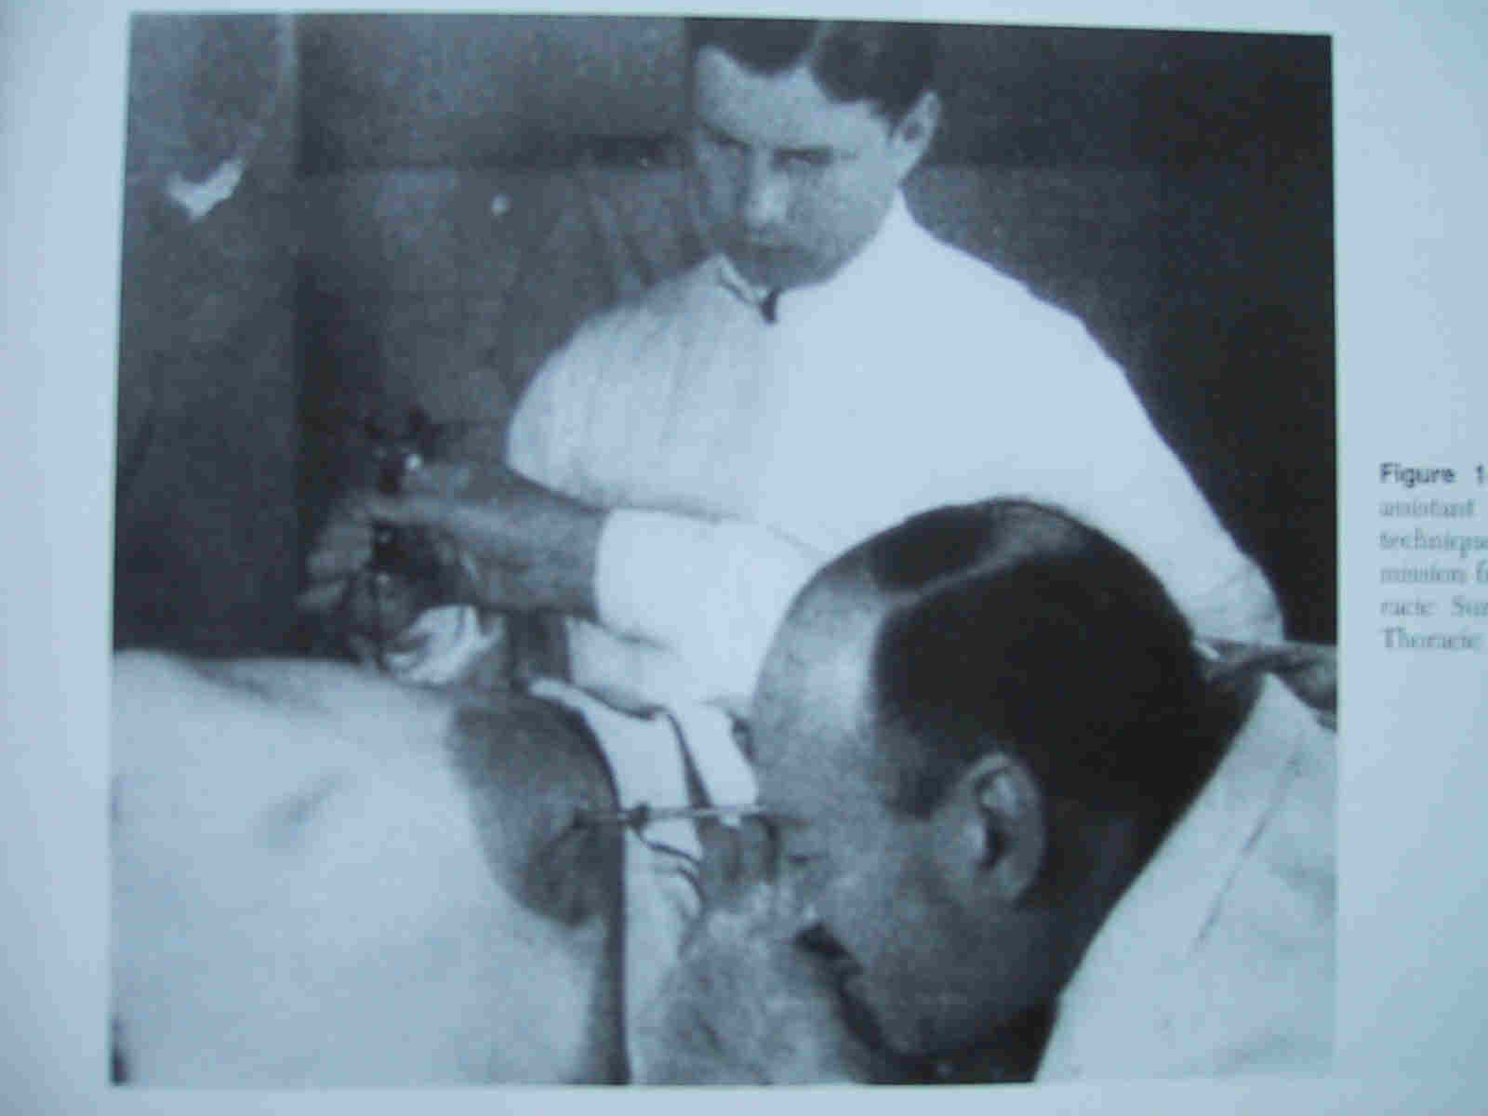
Diagnostic laparoscopy was first introduced in 1901, when Kelling, performed a peritoneoscopy in a dog and was called “celioscopy”. A Swedish internist named Jacobaeusc is credited with performing the first diagnostic laparoscopy on human in 1910. He described its application in patients with ascites and for the early diagnosis of malignant lesions.
Laparoscopy has evolved as an informative, important method of diagnosing a wide spectrum of both benign and malignant diseases. Elective diagnostic laparoscopy refers to the use of the procedure in chronic intra-abdominal disorders. Emergency diagnostic laparoscopy is performed in patients presenting with acute abdomen.
The indications for diagnostic laparoscopy can be divided into four main groups:
Non-traumatic, non-gynaecological acute abdomen like:
- Appendicitis
- Diverticulitis
- Duodenal perforation
- Mesenteric adenitis.
- Intestinal adhesion
- Omental necrosis.
- Intestinal infarction.
- Complicated Meckel’s diverticulum.
- Bedside Laparoscopy in the ICU.
- Torsion of intra-abdominal testis.
Gynaecological abdominal emergencies like:
- Ovarian cysts.
- Pelvic inflammatory diseases.
- Acute salpingitis.
- Ectopic pregnancy.
- Endometriosis.
- Perforated uterus due to criminal abortion
- Salpingitis
Abdominal trauma:
Advantages:
Diagnostic laparotomy for above mentioned abdominal condition is performed by general surgeon since long but laparoscopic diagnostic laparoscopy has following advantages:
  - Cosmetically better outcome.
  - Less tissue dissection and disruption of tissue planes
  - Less pain postoperatively.
  - Low intra-operatively and postoperative complications.
  - Early return to work.
  - Better visualization of Para-colic gutters and pelvic cavity which is not possible by diagnostic laparotomy
OPERATIVE TECHNIQUE
Patient Position
- The patient is placed on the operating table with the legs straight or lithotomy position if female.
- The operating table is tilted head up or down by approximately 15 degree depends on the main area of examination.
- Compression bandage may be used on leg during the operation to prevent thromboembolism especially if patient is in lithotomy position.
- The surgeon stands on left side of the patient.
- The first assistant, whose main task is to position the video camera, is also on the patient’s left side.
- The instrument trolley is placed on the patient’s left allowing the scrub nurse to assist with placing the appropriate instruments in the operating ports.
- Television monitors are positioned on either side of the top end of the operating table at a suitable height so surgeon, anesthetists, as well as assistant can see the procedure.
Anaesthesia:
Recently local anaesthesia (1% lidocaine) is favored by few surgeons. However, the majority uses general anaesthesia. General endotracheal anaesthesia is used. Each patient is injected in the pre-induction phase with 60mg IM Contramol, IV Metronidazole or Tinidazole and with 2grs. of Cefizox IV. The prophylactic antibiotic is generally not indicated in diagnostic laparoscopy but in tropical country like India it is advisable to use prophylactic antibiotic
Creation of Pneumoperitoneum.
Pneumoperitoneum, on average 8-10mmHg, is created using Veress needle. Trans-umbilical insertion of the Veress needle and optical port should be used. An extraumbilical placement may be used whenever surgical peri-umbilical scars were present or adhesions suspected.
  - Check Veress needle before insertion.
  - Check veress needle tip spring.
  - Confirm that gas connection is functioning.
  - Ensure flushing with saline does not block that needle.
  - Make a small incision just above the umbilicus.
  - Lift up abdominal wall and gently insert Veress needle till a feeling of giving way.
  - Confirm position of needle by saline drop method.
  - Connect CO2 tube to needle.
  - Switch off gas when desired pneumoperitoneum is created and remove the Veress needle
The open technique for trocar insertion is recommended if patient presents with severe abdominal distension. Nitrous oxide is used if diagnostic laparoscopy is performed in local anaesthesia because Nitrous oxide has its own analgesic effect. Carbon dioxide is the proffered gas if diagnostic laparoscopy is performed under general anaesthesia. Insufflation should be very slow and with care taken not to exceed 12.0 mmHg.
Port location:
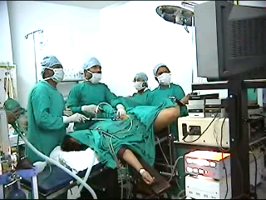
Generally one optical port in umbilicus and one 5mm port in left iliac fossa are required
A three-port approach should be used if there is any difficulty in manipulation.
- 10mm umbilical (optical),
- 5 mm suprapubic and
- 5 mm right hypochondrium.
A 30° telescope is employed in most instances, as this facilitates easier inspection of the peritoneal cavity and abdominal organs. The secondary ports are inserted under laparoscopic vision. The selected site on the abdominal wall is identified by finger indentation of the parietal peritoneum.
Inspection:
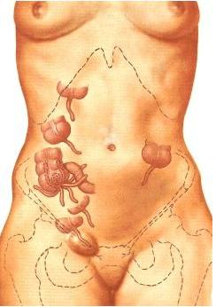
Systemic plan of inspection of upper abdomen
Patient in steep trendelenberg position
Caecum and Appendix
Right side of ascending colon
Hepatic flexure
Structure just below umbilicus
Start
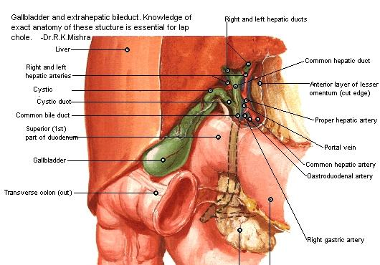
Systemic plan of inspection in mid abdomen
Reverse the Trendelenberg tilt

Right lobe of the liver and gall bladder
Telescope should then be withdrawn a little to cross falciform ligament
Left lobe of the liver.
Descending colon
Sigmoid colon
Transverse colon
Spleen
Walk over to Small Intestine
Inspection of Pelvis
Patient should again positioned in steep trendelenberg position
Uterus
Anterior cul de sac
The round ligament
The full length of fallopian tube
From cornua to fimbriae

Some snap shots of Diagnostic Laparoscopy:
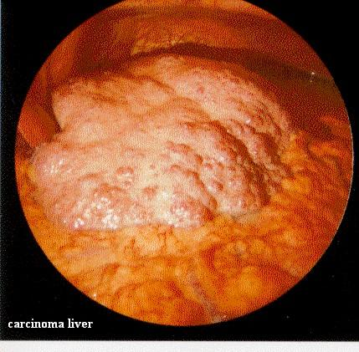
Carcinoma liver

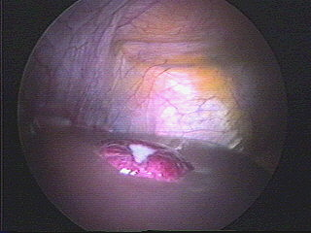
Haemangioma

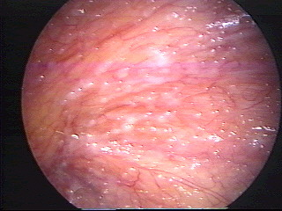
Carcinomatosis

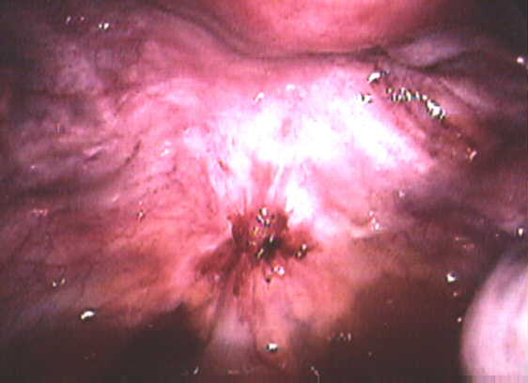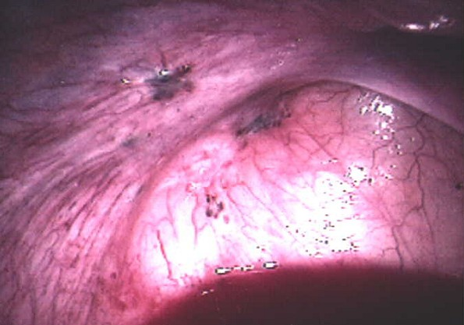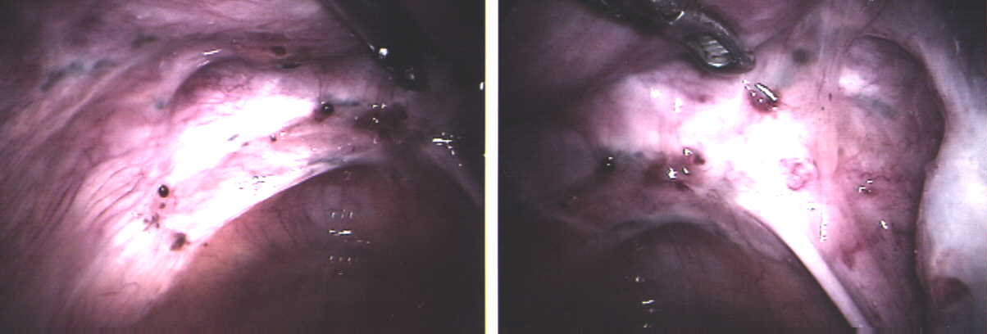
Endometriosis
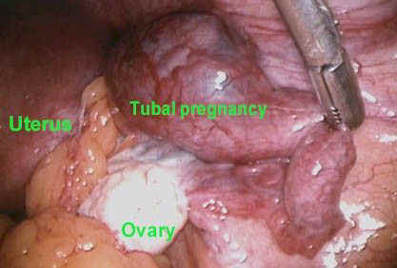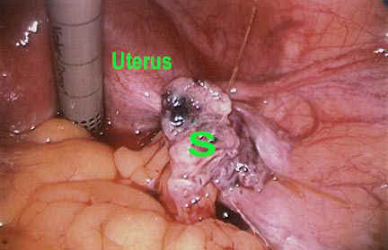
Ectopic pregnancy

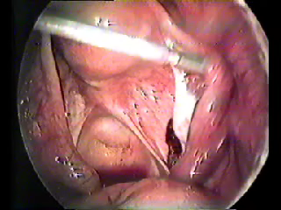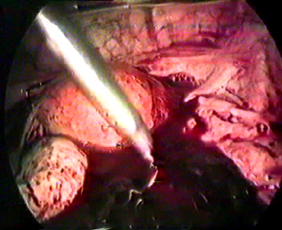

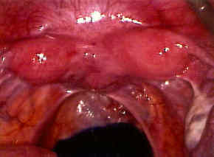
Bicornuate uterus

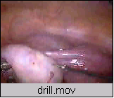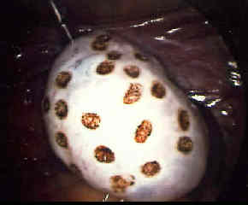
Polycystic ovary

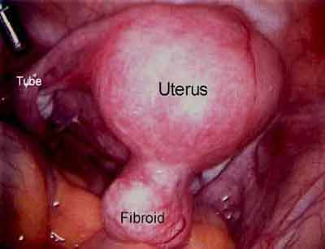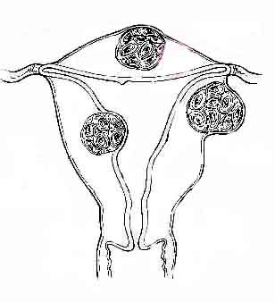
Fibroid

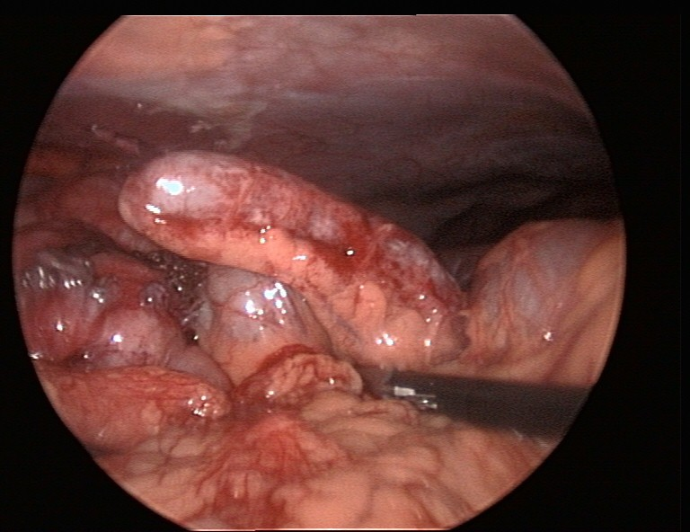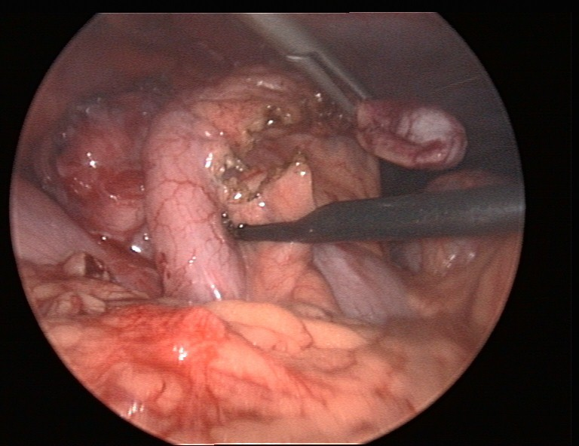
Adhesion of Appendix

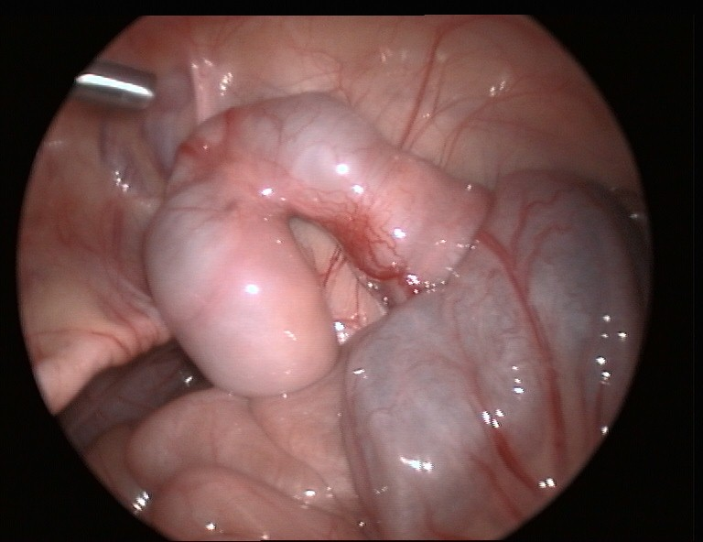
Diverticulum

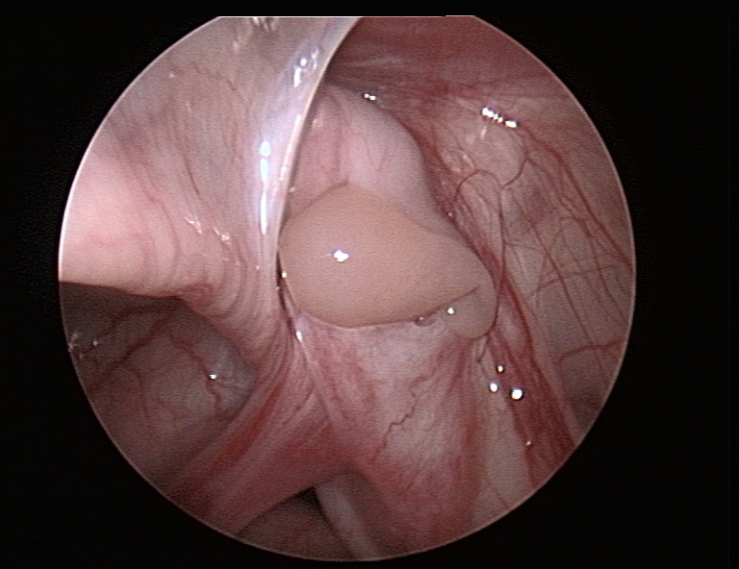
Impalpable Testes
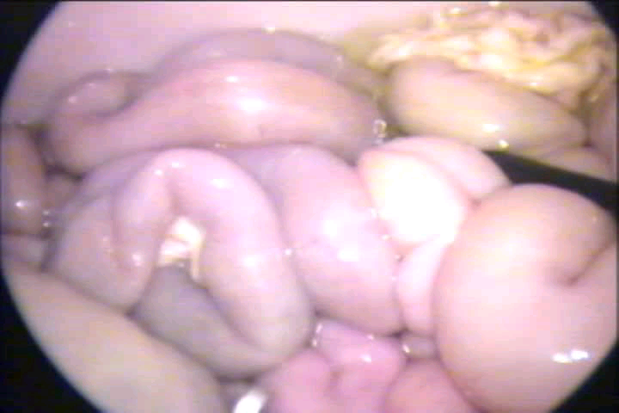
Perforation
- Abdominal organs are inspected for any pathology
- Abdominal cavity is inspected for fluids.
- Samples are taken if free fluid is present for laboratory tests (chemistry, cytology or bacteriology).
- Peritoneal lavage and adhesiolysis may need to be performed to improve visualisation of organs.
- Therapeutic laparoscopy is then undertaken, if indicated and surgeon is experienced enough.
Ending of the operation.
- Examine the abdomen for any possible bowel injury or haemorrhage.
- Remove the Instrument and then port.
- Remove telescope leaving gas valve of umbilical port open to let out all the gas.
- Close the wound with Suture.
- Use vicryl for rectus and Un-absorbable intra-dermal or Stapler for skin.
- Apply adhesive sterile dressing over the wound.
The usual site of insertion of the trocar/cannula for diagnostic laparoscopy is below or to the side of the umbilicus. This position may require to be altered in the presence of abdominal scars. The use of a 30 degree forward oblique telescope is preferable for viewing the surface architecture of organs. By rotation of the telescope, different angles of inspection can be achieved.
The first important step after access to the abdomen has been gained is to check for damage caused by trocar insertion. A second 5 mm port may then be inserted under vision in an appropriate quadrant to take a palpating rod.
A systematic examination of the abdomen must then be performed just as in laparotomy. We begin at the left lobe of the liver but any scheme can be used as long as it is consistent. Next, check around the falciform ligament to the right lobe of liver, gallbladder and hiatus. After checking the stomach, move on to the caecum and appendix and check the terminal ileum. Follow the colon round to the sigmoid colon, and then check the pelvis. You should be conversant with sampling and biopsy techniques, and the use of position and manipulation to aid vision. This is the first procedure to be mastered when learning laparoscopic surgery.
When performing a diagnostic laparoscopy to confirm appendicitis, a five mm port is placed in the left iliac fossa to facilitate manipulation. The patient is placed head down and rotated to the left to displace the small bowel from the pelvis and allow the uterus and ovaries to be checked. This however should be limited to avoid contamination of subphrenic spaces if this is not already present.
Patient may be discharged on the same day after operation if every thing goes well. The patient may have slight pain initially but usually resolves. Diagnostic laparoscopic is a useful method for reducing hospital stay, complications and return to normal activity if carried on in proper manner. With better training in minimal access surgery and better ergonomics now available the time has arrived for it to take its place in the surgeon’s repertoire.
For More Information Contact:
Laparoscopy Hospital
Unit of Shanti Hospital, 8/10 Tilak Nagar, New Delhi, 110018. India.
Phone:
+91(0)11- 25155202
+91(0)9811416838, 9811912768
Email: contact@laparoscopyhospital.com

Copyright © 2001 [Laparoscopyhospital.com]. All rights reserved.
Revised: .

