WORLD LAPAROSCOPY HOSPITAL
Cyberciti, DLF Phase II, NCR Delhi, Gurgaon, 122 002, India
Phone: +91(0)12- 42351555 Mobile: +91(0)9811416838, 9811912768,
Email: contact@laparoscopyhospital.com
Click here for training detail

Complications of Laparoscopic hernia repair

Like all laparoscopic procedures, complications have been recorded during the learning curve. The major problems are:
- Recurrence,
- Neurovascular injury,
- Urinary tract injury,
- Injury to vas,
- Testicular complications and
- Problems due to mesh.

The mechanism of recurrence can be related to lack of understanding of the difficult laparoscopic anatomy, wrong hernia repair technique or the wrong prosthesis. These include incomplete dissection without proper pocket formation, missed sac, migration of mesh due to small sized mesh which may be prone to displaced once fixed, inadequate fixation with rolling up of the mesh and haematoma formation leading to infection.

The complication of laparoscopic hernia repair can be summarized as follow:
- Immediate
  - Visceral Injury
  - Vascular Injury
  - Injury to Vas, Spermatic vessels
- Late
  - Bowel Adhesions to mesh
  - Intestinal Obstruction
  - Fistulisation
  - Orchitis
  - Testicular atrophy
  - Nerve entrapment
  - Incisional Hernia
  - Recurrence
Vascular Injury
The incidence of vascular injury has been documented to be about 0.5-1 per cent and inferior epigastric artery is the one most commonly traumatized.
  - Injury to Iliac Vessels: Chances of Mortality
  - Inferior Epigastric Vessel: Haematoma
  - Iliopubic vein and artery which traverse the lacunar ligament: Haematoma
  - Injury to Spermatic vessels: Postoperative scrotal haematoma
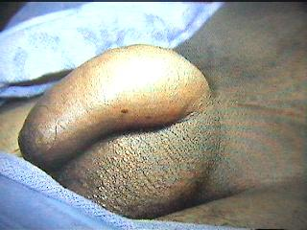
Post-operative scrotal haematoma
Nerve entrapment and Injury:
The lateral cutaneous nerve of thigh and the femoral branch of genitofemoral nerve are the two nerves vulnerable to trauma due to indiscriminate placement of staplers lateral to the spermatic cord on the iliopubic tract.
- Injury of Lateral cutaneous nerve Injury
  - Most common nerve injured is lateral femoral cutaneous nerve (2%): Hyperesthesia or Paraesthesia of upper aspect of thigh and hip.
  - If pain start days after surgery will recover within 2-4 weeks (or percutaneous steroid)
  - If pain starts within 24 hour of surgery there is permanent nerve damage
  - Cryotherapy with destruction of sensory branch is indicated
  - Lifelong numbness
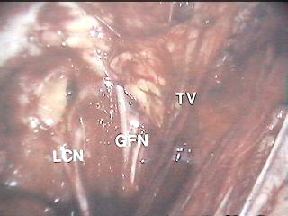
Nerve entrapment should be avoided in laparoscopic repair of Hernia
- Genitofemoral nerve injury
  - Genitofemoral nerve injury (1%): Hyperesthesia or Paraesthesia of scrotum
  - Not significant
  - With time it will subside
Other complication:
  - Migration of Mesh
  - Rejection of Mesh (Rare)
  - Bowel adhesion
Complete transaction of vas requires immediate anastomosis. Other complications include testicular pain, orchitis, epididymitis, swelling due to seromas or haematoma. The treatment is supportive and incidence of all these complications is similar to that in conventional surgery.

Future prospect of Laparoscopic hernia repair:

After some experience most cases of inguinal hernia can be treated laparoscopically. Several prospective randomized trials comparing open vs laparoscopic repair have reported reduced postoperative pain, earlier return to work and fewer complications and less chance of recurrences for the laparoscopic approach. Although the procedural cost for laparoscopic hernia repair is more compared to conventional repair but overall expense for open repair is high if we calculate number of working days lost and medication is taken into consideration. Data is now available which documents the totally extraperitoneal repair to have distinct advantage over the Trans-abdominal preperitoneal repair in terms of lesser postoperative complications and lower recurrence rate. TAPP has been stated to violate the peritoneal cavity with all its known possible complication of pneumoperitoneum, vessel or bowel injury. There is no doubt that laparoscopic hernia repair is a proven technique and will become more popular over a period of time.

For More Information Contact:
Laparoscopy Hospital
Unit of Shanti Hospital, 8/10 Tilak Nagar, New Delhi, 110018. India.
Phone:
+91(0)11- 25155202
+91(0)9811416838, 9811912768
Email: contact@laparoscopyhospital.com

Copyright © 2001 [Laparoscopyhospital.com]. All rights reserved.
Revised: .

