WORLD LAPAROSCOPY HOSPITAL
Cyberciti, DLF Phase II, NCR Delhi, Gurgaon, 122 002, India
Phone: +91(0)12- 42351555 Mobile: +91(0)9811416838, 9811912768,
Email: contact@laparoscopyhospital.com
Click here for training detail

Complications of Laparoscopic Cholecystectomy

Early complication:

- Common bile duct injury
- Bile leak
- Injury to viscera
- Hemorrhage
- Retained stones and abscess formation

Late complication:

- Biliary strictures
- Cystic duct clip stones
- Hemorrhage

Lap Chole and CBD injury

Please!
“Revert to open if unsure about Anatomy”

Incidence of Iatrogenic CBD injury is 0.12% and 0.55% during open and laparoscopic cholecystectomy respectively

Common cause of CBD injury:

- Misinterpretation of anatomy 70%
- Technical Errors
- Risk factors
- Surgeon operates on image rather than reality
- Visual psychological studies has shown that laparoscopic surgeon works on snap interpretation by brain and success or disaster depends on whether snaps are right or wrong
- Snap interpretation will be wrong if there is:
  - Eye ball degradation
  - Lack of Initial identification and memory of key structure to the point of absolute certainty.
  - Most important technical error is hilar bleeding and frantic attempts are made to control bleeding by electrosurgery.

In case of bleeding

- First apply pressure
- Take suction irrigation and atraumatic grasper
- Apply electrocautery only when bleeding point is identified

Type of CBD Injury

BISMUTH CLASSIFICATION
    - Type 1 - CHD stump > 2 cm.
    - Type 2 - CHD stump < 2 cm.
    - Type 3 - Hilar, Rt. and Lt. duct confluence intact
    - Type 4 – Hilar, separation of Rt. and Lt. ducts
    - Type 5 - Injury to aberrant Rt. duct ± CBD injury

If complication recognized intra operatively:

- For high complete transaction Roux-en-Y hepaticojejunostomy
- For lower complete injuries primary suture repair over T tube
- Long end of T tube must not be exteriorized from same site
- For partial injuries Insertion of T tube and Roux-en-Y serosal patch

Strategy to handle complication recognised post operatively:

- USG + ERCP + MRCP
- Fluid + Electrolyte + systemic antibiotic
- Conservative treatment and biliary drainage for 6 weeks by ERCP stent insertion or
- PTBD (Percutaneous trans hepatic biliary drainage) if Endoscopic stent application is not possible
- After Several weeks Reconstructive surgery
- Roux-en-Y Choledocoduodenostomy or Hepatojejunostomy

All the variation of Cystic duct and artery should be memorized to avoid inadvertent injury of CBD

Variation in Cystic Artery:

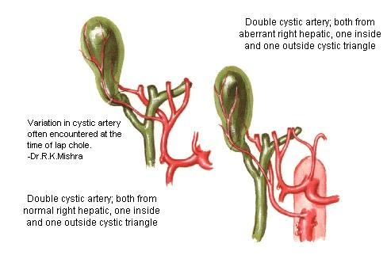

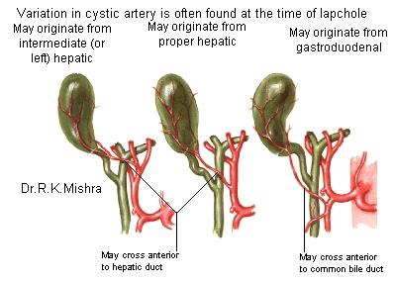

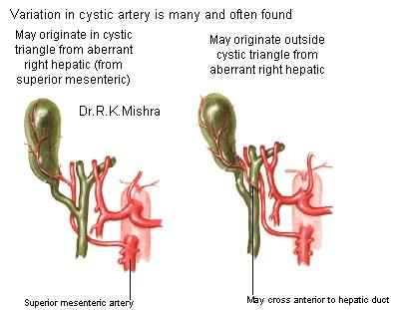

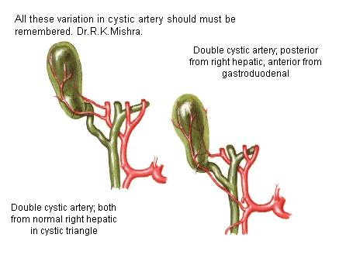

Variation in Cystic Duct

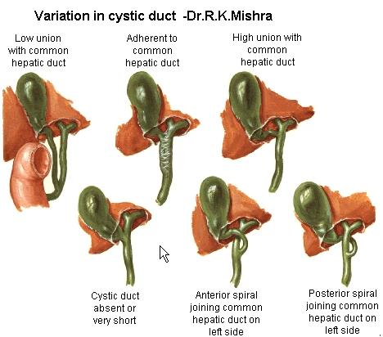
How to avoid injury?
- Try to memorise initial anatomy of Calot’s triangle
- A large distended Gall bladder should be aspirated and lifted rather than grasped
- Antero-lateral traction is better than fundus pull to avoid tenting of CBD
- Avoid meticulous dissection by energized instrument
- Better to do skeletanization through pledget
- During detachment of gallbladder from liver bed maintain plane of adipose tissue
- Use Suction Irrigation frequently

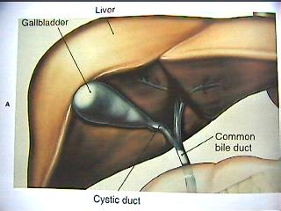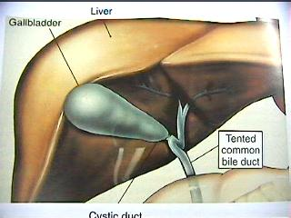

Tenting of the CBD should always kept in mind at the time of dissection to avoid injury.
For More Information Contact:
Laparoscopy Hospital
Unit of Shanti Hospital, 8/10 Tilak Nagar, New Delhi, 110018. India.
Phone:
+91(0)11- 25155202
+91(0)9811416838, 9811912768
Email: contact@laparoscopyhospital.com

Copyright © 2001 [Laparoscopyhospital.com]. All rights reserved.
Revised: .

